Reporting
Hermes.Net V5


Author: Roussis Nakos
Date: 02/12/2013

LEGAL STATEMENT

This documentation is protected by national and international copyright laws.

The VOCALCOM® name and its logo are registered trademarks of VOCALCOM S.A. with its corporate head office at 7 rue de Tilsitt, 75017 Paris, France. The HERMES PRO™ name is protected by national and international usage rights for a trade name and more generally, by national and international software protection legislation. The other names, brands and trade names mentioned belong to their respective owners.

Reproducing all or part of this documentation on any media whatsoever is forbidden without the express prior approval of the publisher (art. L122-4 and L122-5 of the French Intellectual Property Code).

The publisher cannot accept liability for any typographical errors, picture printing errors or any other symbol error nor can it accept liability for consequences arising from the incorrect use of this documentation.

The sole purpose of this documentation is to educate and train individuals. It cannot in any way be interpreted as a contract, agreement (including sui generis), an advertising and/or promotional media, in any form whatsoever.

© 1996-2013 VOCALCOM S.A. – All rights reserved

Table of contents

1 Introduction 5
1.1 General Information 6
1.2 First Steps 6
1.3 The application selection screen 8
1.4 The Main screen 9
1.5 General information on “options” and “filter screen” 9
1.5.1 Date range 9
1.5.2 Filters 10
1.5.3 Report export format 10
1.6 Report Generation 11
2 Outbound Campaigns 13
2.1 Call file progress report 14
2.2 Call status report 15
2.3 Call status by agent report 16
2.4 Call status distribution report 18
2.5 Call status by agent distribution report 19
3 Inbound calls campaign 21
3.1 Campaigns overview 22
3.2 Campaigns report 23
3.3 Calls distribution report 25
3.4 Waiting time report 27
3.5 Calls call status report 30
3.6 Calls call status by agent report 31
3.7 Call status distribution report 33
3.8 Call status by agent distribution report 35
4 Manual Calls 37
4.1 Manual calls report 38
4.2 Calls call status by agent report 39
4.3 Calls status by agent distribution report 40
5 E-Mails Campaigns 42
5.1 E-Mails distribution report 43
5.2 E-Mails call status report 44
5.3 E-Mails call status by agent report 46
5.4 E-Mails status distribution report 47
5.5 E-Mails status by agent distribution report 48
6 Chat/Web campaigns reports 50
6.1 Chats distribution reports 50
6.2 Chat campaigns reports 52
6.3 Chats distribution reports per country 53
6.3 Chat status 54
6.4 Chat status per agent 54
6.5 Chat status distribution 55
6.6 Chat status by agent distribution 56
6.7 Proactive chat 56
6.8 Sequences of pages 57
6.9 Fax status by agent distribution 58
7 Agent activities 59
7.1 Agents report 60
7.2 Activities by agent 61
7.3 Activities by date 62
7.4 Agents state distribution 63
7.5 Agents state distribution (with e-mails) 65
7.6 Billing by agent report 66
7.7 Billing by date report 67
7.8 Agent production report 68
7.9 Agent pause report 69
8 IVR REPORTS 71
8.1 IVR Distribution report 71
8.2 IVR Message report 72
8.3 IVR durations report 72
9 Scheduling reports 73
9.1 Setup &Save report 73
9.2 Schedule report 74
9.3 Send report via Email 74
9.4 Open generated reports 75
10 Custom reports 76

Introduction
This chapter provides a general overview of the Reporting.Net application and how to launch it.

General Information
Hermès.Net Edition and its applications provide a report creation tool called « Reporting ». This document explains in detail all it’s available functions. This application allows a user to customize reports or view pre-defined reports relative to calls, mails, chats, social media, ivr and agent activities.

First Steps
Once the application is installed, it can be accessed through the following URL:

http://localhost/hermes_net_v5/

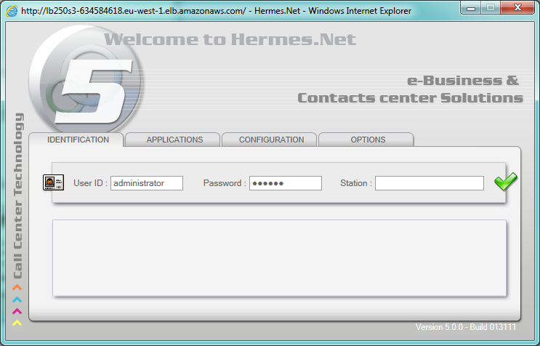

In this window, the user has to enter his identification information before starting using the application.
The language field in the options tab allows selecting the language displayed in the application.

After entering the necessary information, the user presses the enter button, or clicks on the button.

Note: if you add the URL listed in the trusted sites of Internet Explorer of the workstation on which the application is running, the status bar at the bottom of the screen does not appear.

The application selection screen
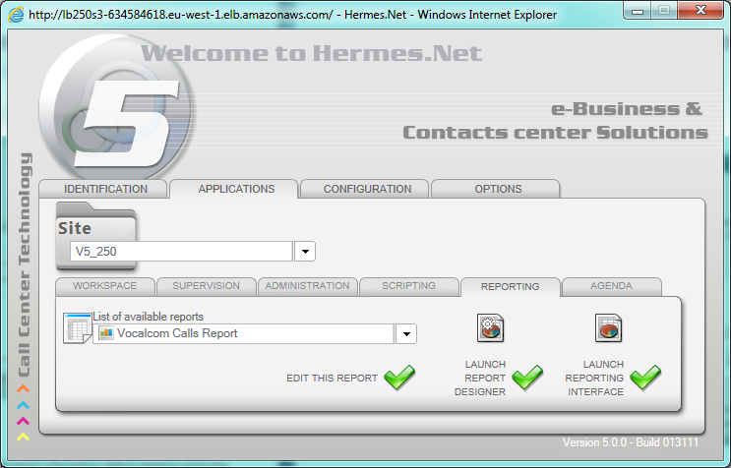

In this window the user can launch one of the following applications:

- Workspace
- Supervision
- Administration
- Scripting
- Reporting
- Agenda

These applications are available depending on the rights given to the identified user. If only one application is granted to the user, the system will automatically launch it. If not, the user must press the button next to the application he wants to start.

This document only explains the Reporting application. Please refer to other documents for other applications.

The Main screen
When launched, the application shows a screen with the first kind of report ready to be configured: Inbound Campaigns overview.
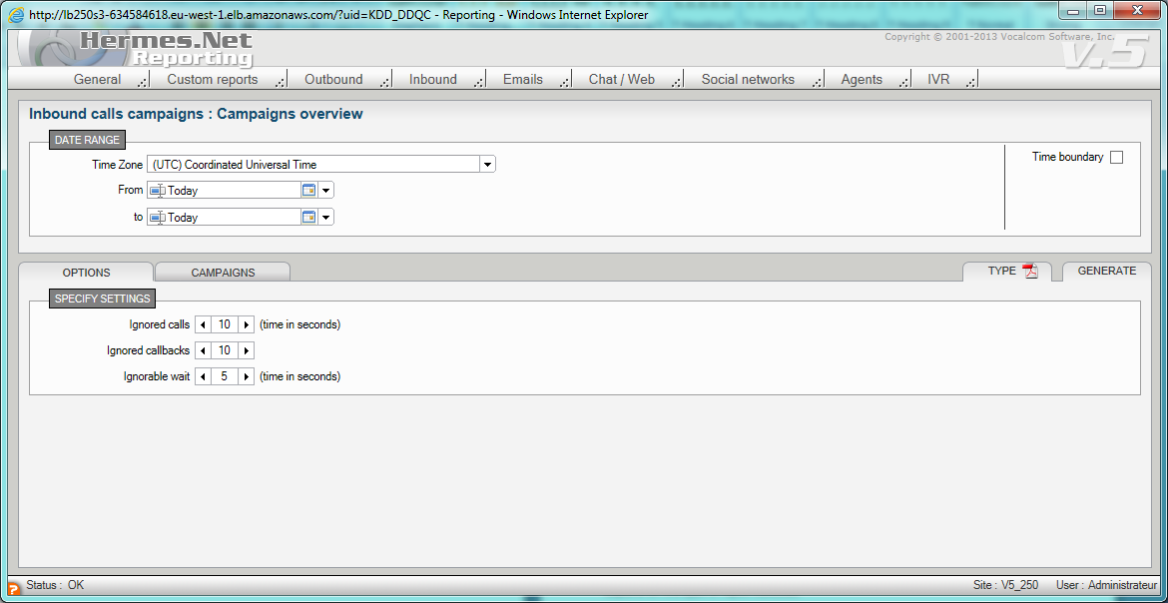

In the main menu, all the reports are grouped by data type.

Custom Reports, Outbound, Inbound, Manuals, E-mails, Chat/Web, Social networks, Aents and IVR.

Select a report to open the configuration window of the selected report.

Each report requires a start and end date. The report options, underneath the date area, depend on the type of report.

General information on “options” and “filter screen”

Date range
In general, the first part of the screen allows selecting the date range to take into account for generating the report information.
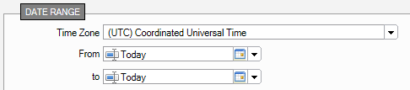

Choose here the date period desired. By clicking on the button, the calendar in which you may select the dates will pop up.

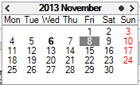

Today’s date is highlighted in bold.
The date selected is marked by a grey square.

The other months and years are accessible using the , , and , arrows.

By un-checking the box From, you indicate that your report must take all data into account, without any starting date.
By un-checking the box To, you indicate that your report must take into account all data recorded up to this date.

Filters
Other filtering options are presented through specific tabs on the below part of the screen. (In this example, a tab is related to the Campaigns but it’s also applicable to agents and supervision groups).

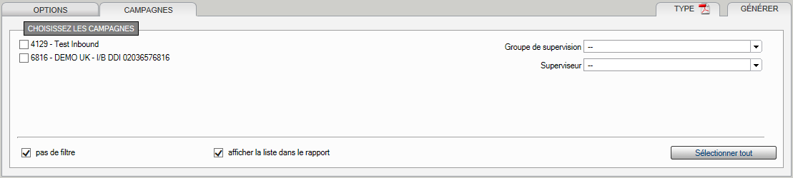

The button allows checking all of the campaign boxes at once.

The checkbox allows specifying that the user wants to cancel all filters to select all the data in the database, including the campaigns (or agents) that have been eliminated, but existed before and were active during the time period selected.

An extra filter based on supervisor groups and names is also proposed at the right of the tab.

Report export format
At the top of the tab, Type can be used to select the report export format.

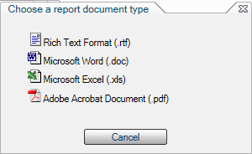

Once the type has been selected, it’s indicated by an icon and it‘s used for every future report generation.

Report Generation
The Generate button allows generating the current report.

The Generated reports list window opens and lists all the generated report.
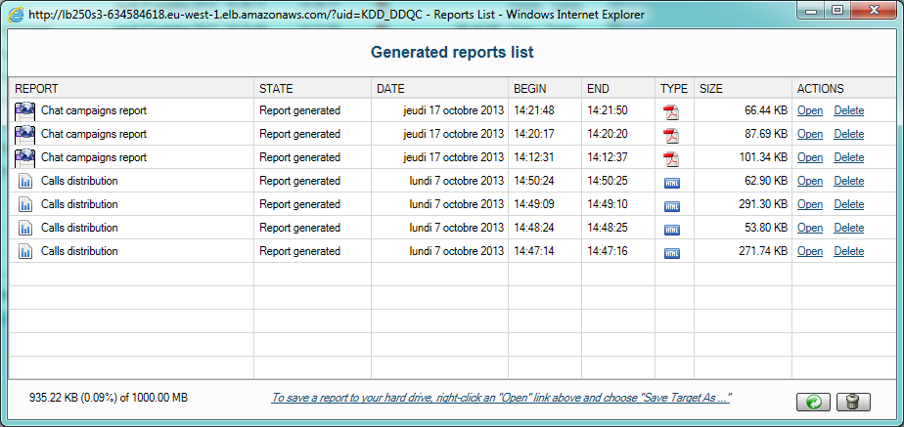

Each report remains available and can be opened later by clicking on Open.

Report opens in an Internet Explorer window, and can be saved locally under the corresponding format, using the option File -> Save as.

Report can also be deleted.

Note that this window can also be opened at any moment via the General menu, by clicking on the Generated reports list item.

Outbound Campaigns
This set of reports is based on the outbound campaigns activities and on the distribution of their calls.

5 predefined reports are proposed and detailed in this chapter:
- Manual calls report
- Call file progress report
- Call status report
- Call status by agent report
- Call status distribution report
- Call status by agent distribution report

Call file progress report
This report allows visualizing the distribution of records in calls files based on their progression status.

Options tab
Data: allows choosing between a detailed or summarized report.
Show: allows choosing if you want to visualize the data for:
- All call files and summary
- Only currently used call file
- Currently used call file and summary
- All call files

If you choose the summarized display, the data of all selected campaigns is summed up on a single page.
If you choose the detailed and summarized display, then the campaign pages are followed by a summarized page.
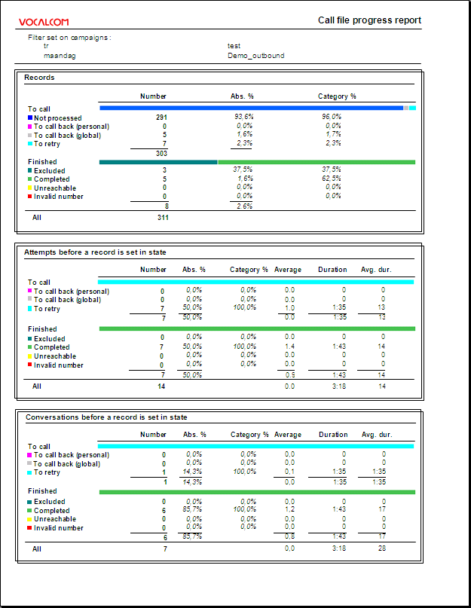

The report is divided into 3 frames.
Records
Attempts before a record is set in state
Conversations before a record is set in state

In these three areas the records are divided in the following categories: « to call » and « finished ».
Next to each category, the distribution of records is represented graphically.

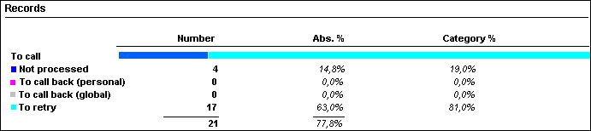
In this example, the blue-cyan line in interpreted as follows:
Not processed (blue): 4 (19%)
To retry (cyan): 17 (81%)

In this report, the percentages of the number of calls by call result and in comparison to the total number of calls are also shown.
The last two areas also show the average quantity and the average duration of calls by result.

The second area gives the total number of attempts done by the system sorted by final result. This number must be divided by the number of file record having the same result (this information can be found in the first table) to find the average of attempts by records.
Note that recycling process will always cause abnormal results into this report: the number of attempts will increase at each file processing, and not the number or physical records.

Call status report
This report gives an overview of the number of calls, the durations of calls, wrap-up and handling time of inbound calls based on their call status, for campaigns and agents selected, in a defined time period (detailed by campaign).

Options tab
This part allows defining additional parameters to filter the report data.
Lost time: Enter here the duration below which the call is accounted for in lost or abandoned calls.
Data: allows choosing if you want to see the details per campaign and/or the recapitulative summary.

Call status tab
On this tab, you choose to take into account or not the standard call status, and to take into account or not the non qualified calls.
You can also indicate that you want only take the last call result into account concerning a client record.

Add call status: allows indicating that you also want to take into account the call status not used for this report.
None
Standard
Custom (these call status have been created by way of a personal call status creation function in the Administration application)
All (the standard and personalized call status)

If you have chosen the detailed display, a page shows the data of a single campaign.
If you choose the summarized display, the data of all selected campaigns is summed up on a single page.
If you choose the detailed and summarized display, then the campaign pages are followed by a summarized page.

The report is divided into several columns.
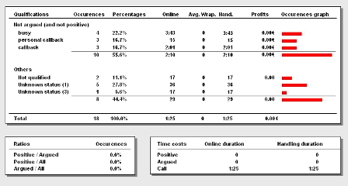

Occurrences and percentage of calls,
Average duration of communications,
Average Wrap-up and handling,
Provisional profits,
Graphical representations
by call status
and by category of call status (positive, argued).

Distribution of occurrences of calls (positive and argued in comparison to the totality, and positive in comparison to argued).

Total duration of communications and treatment by type of call status (positive, argued and not qualified)

Call status by agent report
This report gives an overview of the number of calls, the durations of communications, wrap-up and handling of inbound calls based on their call status, for campaigns and agents selected, in a defined time period (detailed by agent).

Options tab
This part allows defining additional parameters to filter the report data.
Lost time: Enter here the duration below which the call is accounted for in lost or abandoned calls.
Data: allows choosing if you want to see the details per agent and/or the recapitulative summary.

Call status tab
On this tab, you choose to take into account or not the standard call status, and to take into account or not the non qualified calls.
You can also indicate that you want only take the last call result into account concerning a client record.

Add call status: allows indicating that you also want to take into account the call status not used for this report.
None
Standard
Custom (these call status have been created by way of a personal call status creation function in the Administration application)
All (the standard and personalized call status)

If you have chosen the detailed display, a page shows the data of a single agent.
If you choose the summarized display, the data of all selected agents is summed up on a single page.
If you choose the detailed and summarized display, then the agents pages are followed by a summarized page.

The report is divided into several frames.
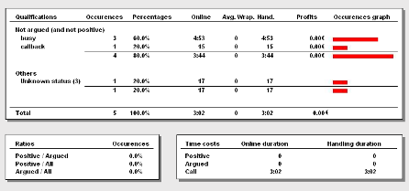

Occurrences and percentage of calls, average duration of communications, Wrap-up and handling,
estimates of the profits,
graphic representations of occurrences
by call status
and by type of call status (positive, argued).

Distribution of occurrences of calls (positive and argued in comparison to the totality, and positive in comparison to argued).

Total duration of communications and treatment by type of call status (positive, argued and not qualified)

Call status distribution report
This report gives the detail of calls quantity done by hour, grouped by result type, for campaigns and agents selected, in a defined time period (detailed by campaign).
A graphical view is also generated.

Options tab
This part allows defining additional parameters to filter the report data.
Lost time: Enter here the duration below which the call is accounted for in lost or abandoned calls.
Data: allows choosing if you want to see the details per campaign and/or the recapitulative summary.

Call status tab
On this tab, you choose to take into account or not the standard call status, and to take into account or not the non qualified calls.
You can also indicate that you want only take the last call result into account concerning a client record.

Add call status: allows indicating that you also want to take into account the call status not used for this report.
None
Standard
Custom (these call status have been created by way of a personal call status creation function in the Administration application)
All (the standard and personalized call status)

If you have chosen the detailed display, a page shows the data of a single campaign.
If you choose the summarized display, the data of all selected campaigns is summed up on a single page.
If you choose the detailed and summarized display, then the campaigns pages are followed by a summarized page.

The report is divided into several tables followed by a graphic.
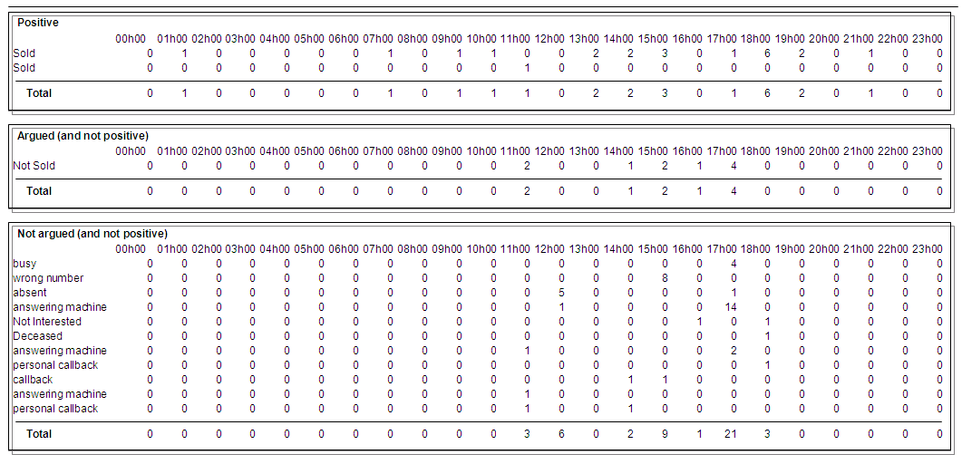
The tables show calls hour distribution for results types Positive, Argued and Not Argued.
Under the tables, a graph of the data is displayed.
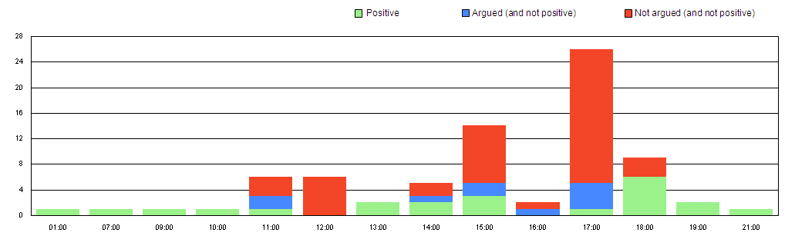

Call status by agent distribution report
This report gives the detail of calls quantity done by hour, grouped by result type, for campaigns and agents selected, in a defined time period (detailed by agent).
A graphical view is also generated.

Options tab
This part allows defining additional parameters to filter the report data.
Lost time: Enter here the duration below which the call is accounted for in lost or abandoned calls.
Data: allows choosing if you want to see the details per agent and/or the recapitulative summary.

Call status tab
On this tab, you choose to take into account or not the standard call status, and to take into account or not the non qualified calls.
You can also indicate that you want only take the last call result into account concerning a client record.

Add call status: allows indicating that you also want to take into account the call status not used for this report.
None
Standard
Custom (these call status have been created by way of a personal call status creation function in the Administration application)
All (the standard and personalized call status)

If you have chosen the detailed display, a page shows the data of a single agent.
If you choose the summarized display, the data of all selected agents is summed up on a single page.
If you choose the detailed and summarized display, then the agent’s pages are followed by a summarized page.

The report is divided into several tables followed by a graphic.

The tables show calls hour distribution for results types Positive, Argued and Not Argued.

Under the tables, a graph of the data is displayed.

Inbound calls campaign
This set of reports is based on the activities of inbound call campaigns and on the distribution of calls.

8 predefined reports are available and detailed in this chapter:

- Campaigns overview
- Campaigns report
- Calls distribution report
- Waiting time report
- Calls call status report
- Calls call status by agent
- Call status distribution report
- Call status by agent distribution report

Campaigns overview
This first report gives you an overview of inbound calls and their status, within the frame of selected campaigns in a defined time period.

Options tab
This tab allows defining additional parameters to filter the report data.
Lost time: Enter here the duration below which the call is accounted for in lost or abandoned calls.
Ignorable wait: Enter here the maximum duration of queuing time below which calls are considered as immediately answered (ie. If Ignorable wait = 5 seconds, the calls answered with a waiting time of maximum 5 seconds are considered as calls treated immediately).
These delays are expressed in seconds.

Once created, the report is presented in a separate window.
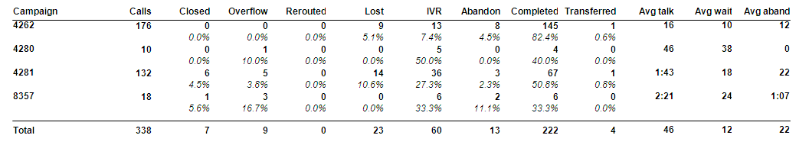
The time and date range as well as the filtering parameters are noted in the above table.

In this table, the campaigns selected are listed on the left. For each one, it is possible to view the total number of calls, and then their status. (The fields listed are presented with their formulas in parentheses.)
Calls (@IsACall): all calls arriving at the Call Center.
Closed (@IsClosed): calls that arrived at the Call Center outside opening hours.
Overflow (@IsOverflow): calls that are redirected to the overflow procedure.
Rerouted (@IsRerouted): calls redirected to another destination.
Lost (@IsLost): calls that arrived during opening hours, which are not redirected to the overflow procedure, with duration inferior to the Lost time parameter.
IVR (@IsLostInIVR) : calls that are redirected to the IVR and hung up.
Abandon (@IsAbandoned): calls that are not lost, that have arrived during opening hours, which are not redirected to the overflow procedure and not treated by an agent.
Completed (@IsAnsweredWithoutTransf): calls that are not lost and treated by an agent (non transferred).
Transferred (@IsAnsweredWithTransfer): calls that are transferred from one agent to another.
Then, the average durations are detailed per campaign:
Avg. Talk. (@AvgConvDuration): average conversation time
Avg Wait (@AvgAnsweredWaitDuration): average queuing time.
Avg. Aband (@AvgAbandonWaitDuration): average abandon time. A call is abandoned if it is neither lost, nor outside opening hours, nor redirected to the overflow procedure, nor treated by an agent. It is the queuing time of this call that is used here.

Under each value shown in this table, the percentage compared to the total number of inbound calls by campaign is displayed.

Under this table, the total of all campaigns is shown.

Campaigns report
This report gives an overview of inbound calls and their status, within the framework of selected campaigns in a defined time period.

Options tab
This tab allows defining the additional parameters to filter the report data.
Lost time: Enter here the duration below which the call is accounted for in lost calls.
Service level: Enter here a time reference used to compare the queuing times of calls.
Ignorable wait: Enter here the maximum queuing duration under which a call is considered as immediately handled (as if there was no queuing time).
Data: allows choosing if you want to see the details per campaign and/or the recapitulative summary.

If you have chosen the detailed display, a page shows the data of a single campaign.
If you choose the summarized display, the data of all selected campaigns is summed up on a single page.
If you choose the detailed and summarized display, then the campaign pages are followed by a summarized page.

The report is divided into three frames:
The graphical distribution of call results.
The list of call durations classified by results.
The ratio of calls in comparison to the defined service level.

The date and filtering parameters are recalled at the top of the table.

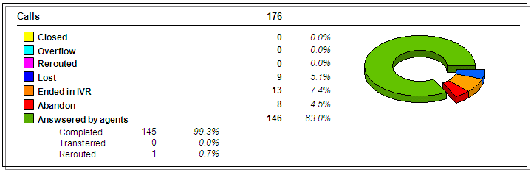
In the Calls frame, the data presented are the following.

Closed (@IsClosed): calls that arrived at the Call Center outside opening hours.
Overflow (@IsOverflow): calls that are redirected to the overflow procedure.
Rerouted (@IsRerouted): calls that are redirected by the IVR to another destination. Don’t confuse this value with the value Rerouted under Answered by agents, which concerns calls transferred by agents to an external destination, not by IVR.
Lost (@IsLost): calls that arrived during opening hours, which are not redirected to the overflow procedure, with duration inferior to the Lost time parameter.
Ended in IVR (@IsLostInIVR): calls that are redirected to the IVR and hung up.
Abandon (@IsAbandoned): calls that are not lost, that arrived during opening hours, which are not redirected to the overflow procedure and not treated by an agent.

Remark :
Calls not closed by agent and not redirected to the overflow or rerouted, get to 3 different categories:
- if the handling duration is less than the Lost time value, the call gets to the Lost category.
- else, if the call was hanged up in the waiting queue, it gets to the Abandon category.
- else, if it was hanged up during IVR handling, it gets to the Ended in IVR category.

Answered by agents (@SumIsAnswered): calls that are treated by an agent (completed and transferred).
Completed (@IsAnsweredWithoutTransf): calls that are not lost and treated by an agent (not transferred).
Transferred (@IsAnsweredWithTransfer): calls that are transferred by one agent to another.
Rerouted (@IsAnsweredWithRerout) : calls transferred by the first agent to an external destination. Don’t confuse this value with the value Rerouted at the previous level, which concerns calls transferred by the IVR, not by agents.
Top 3 queues : this part allows viewing the 3 most used queues linked to the campaign (an agent personal queue will be notified by the agent id).
Next to each value, the percentage in comparison to the total number of calls is displayed.

To the right of the frame, a graph shows the distribution of calls by results.


This graph, illustrated as a pie, allows visualizing the distribution of the percentage in time of call results (or recapitulative on the last page).

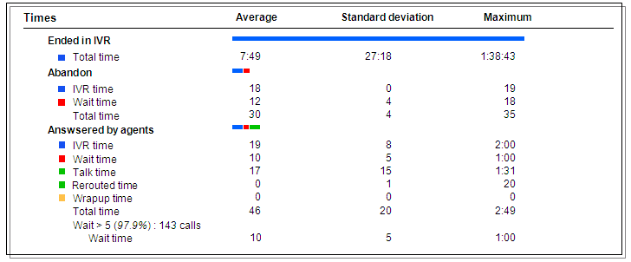
In the Times frame, the data presented are the following.

The various call results are presented vertically:
Closed
Overflow
Ended in IVR
Abandon
Answered by agents
For each result, the call durations (in seconds) are detailed by steps:
IVR time
Wait time
Talk time
Wrap-up time

For each step, the average and maximum durations and standard deviation are shown.
Next to each result, the distribution by step is represented as a graph.
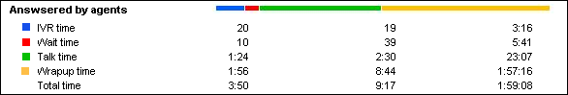
In this example, the blue-red-green-yellow line represents the distribution of average wait time:
IVR time (blue): 20 seconds
Wait time (red) : 10 seconds
Talk time (green): 1:24 seconds
Wrap-up time (yellow): 1:56 sec

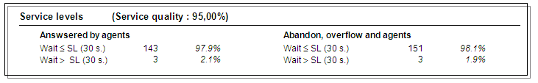
In the Service Levels frame, the data presented are the following.
A total quality service appreciation in percent.

For the calls Answered by agents:
The quantity and percentage of calls per report at the defined service level (comparison of queuing time)
For Abandon, overflow and agents:
The quantity and percentage of calls per report at the defined service level (comparison of queuing time)

Calls distribution report
This report gives an overview of inbound calls and their status, in the frame of selected campaigns in a defined time period.

Options tab
This tab allows defining the additional parameters to filter the report data.
Lost time: Enter here the duration below which the call is accounted for in lost or abandoned calls.
Ignorable wait: Enter here the maximum queuing duration under which it is considered that there was no queuing period.
These delays are expressed in seconds.
Data: allows choosing if you want to see the details per campaign and/or the recapitulative summary.
Distribution: allows selecting the type of call distribution (per month, day, hour, ½ hour, ¼ hour, or no distribution at all).
Begin/End hour : Enter here the common minimal hour of begin and end of the report (in case of distribution by hour, ½ hour or ¼ hour).

Once created, the report is presented in a separate window.
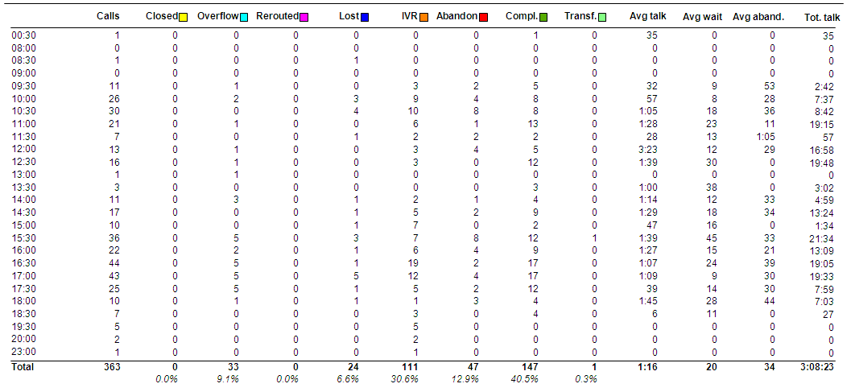
The time and date period as well as the filtering parameters are noted in the above table.

In this table, the distribution parameter is displayed vertically on the left:
The months of the year, the weeks, days of the week, hours, ½ hours¼ hours of the day. (in this example, the distribution per 1/2h has been chosen.)

The details of the figures are presented in a table per call type:
Calls (@IsACall): all calls arriving at the Call Center.
Closed (@IsClosed): calls that have arrived at the Call Center outside opening hours.
Overflow (@IsOverflow): calls that are redirected to the overflow procedure.
Rerouted (@IsRerouted): calls having been redirected to another destination.
lost (@IsLost): calls that have arrived during opening hours, which are not redirected to the overflow procedure, with duration inferior to the Lost time parameter.
IVR (@IsLostInIVR): calls that are redirected to the IVR and hung up.
Abandon (@IsAbandoned): calls that are not lost, that have arrived during opening hours, which are not redirected to the overflow procedure and not treated by an agent.
Compl. (@IsAnsweredWithoutTransf): calls that are not lost and treated by an agent (not transerred).
Transf. (@IsAnsweredWithTransfer): calls that are transferred by the first agent to another agent.
Then, the average duration times are detailed by campaign:
Avg. Talk. (@AvgConvDuration): average conversation time
Avg. Wait (@AvgAnsweredWaitDuration): average queuing time.
Avg. Aband. (@AvgAbandonWaitDuration) : average abandons time. A call is abandoned if it is neither lost, nor outside opening hours, nor redirected to the overflow procedure, nor treated by an agent. It is the queuing time of this call that is used here.
Tot. Talk : total talk duration for all the calls found in this interval. Note that the values have been rounded and that the calculations nb of completed and transferred calls multiplied by the average talk duration can differ from the indicated value.

Under each column of the table, the total and the percentage in comparison to the total number of inbound calls are displayed.
Each value is also identified by a formula that can be viewed by placing the mouse cursor on the said percentage.
Under the table, a graph of the data is displayed.

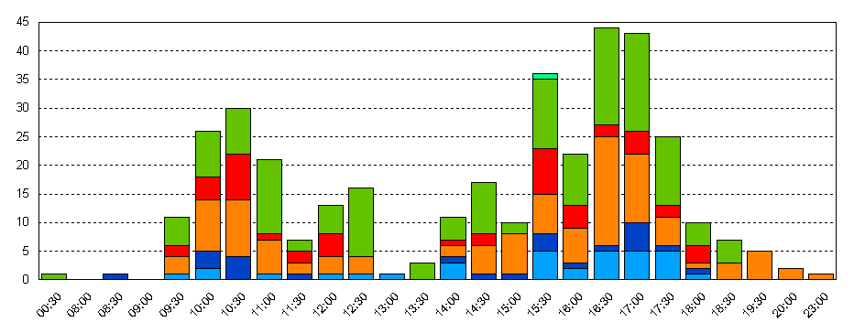

The colors used for the distribution of data are indicated next to each type of call, above the table.
The number of calls is displayed vertically; the unit of distribution is displayed horizontally.

Waiting time report
This report gives an overview of the waiting time of inbound calls based on their status, in the frame of selected campaigns in a defined time period.

Options
This tab allows defining the additional parameters to filter the report data.
Lost time: Enter here the duration below which the call is accounted for in lost or abandoned calls.
Data: allows choosing if you want to see the details per campaign and/or the recapitulative summary.

Graphics
This tab allows defining which kind of data must be visible on the graphic.

Show graphics : this list can be used to select the graphic that you want to see: the first (red bars), the second (blue shapes), or both of them.
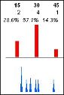

Once created, the report is presented in a separate window.
If you have chosen the detailed display, a page shows the data of a single campaign.
If you choose the summarized display, the data of all selected campaigns is summed up on a single page.
If you choose the detailed and summarized display, then the campaign pages are followed by a summarized page.

The report is divided into several frames.
The distribution of calls based on their result.
The average, minimum and maximum values of duration of calls redirected to the IVR, waiting time and talk time.
A graph of the distribution of the number of calls ended in the IVR, abandoned and handled by agents during the specified time period.

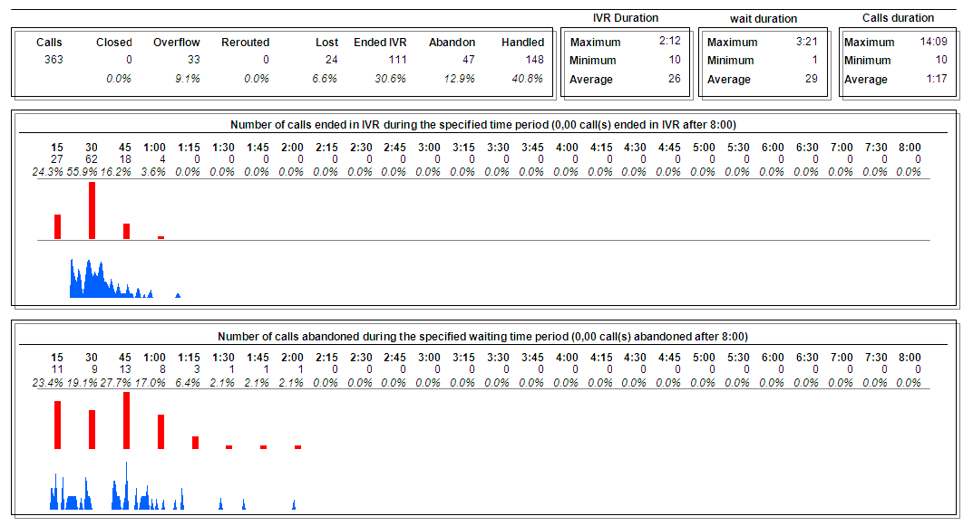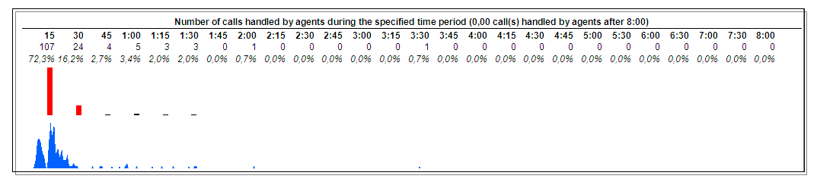
The time and date period as well as the filtering parameters are noted in the above table.

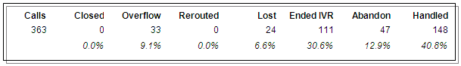
In the first frame, the data presented are the following.

Calls (@IsACall) : all calls arriving at the Call Center.
Closed (@IsClosed) : calls that arrived at the Call Center outside opening hours.
Overflow (@IsOverflow) : calls that are redirected to the overflow procedure.
Rerouted (@IsRerouted) : calls redirected to another destination.
Lost (@IsLost) : calls that arrived during opening hours, that are not redirected to the overflow procedure, with a duration inferior to the Lost time parameter.
Ended IVR (@IsLostInIVR) : calls that are redirected to the IVR and hung up.
Abandon (@IsAbandoned) : calls that are not lost, that arrived during opening hours, that are not redirected to the overflow procedure and not treated by an agent.
Handled (@IsAnswered) : calls that are treated by an agent (completed and transferred).
Under each value, the percentage in comparison to the total number of calls is shown.

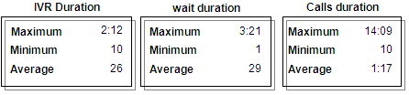
In the IVR Duration, Wait duration, and Calls duration frames, the data is presented as follows.

IVR Duration
Wait Duration
Calls Duration

For each type, the average, maximum and minimum durations are given.

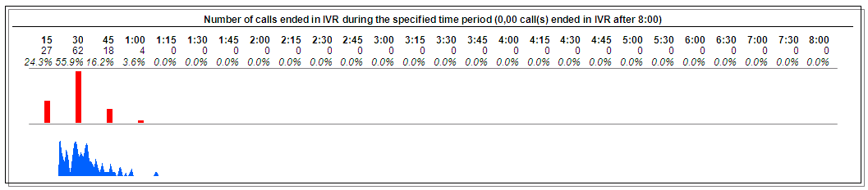

In the 3 next graphic windows, the data presented is as follows.
The distribution of the number of calls
- ended in IVR
- abandoned
- handled by an agent
by period of 15 seconds.
Under the number of calls is indicated the percentage in comparison to the total number of calls. In blue is shown the detail per second.
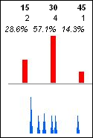
In this example, 2 calls (28,6%) were hung up between the 1st and 15th seconds.
4 calls (57,1%) were hung up between the 16th and 30th second.
1 call (14,3%) was hung up between the 31st and 45th second.

Calls call status report
This report gives an overview of the number of calls, the duration of the communications, the wrap-up and handling of inbound calls based on their call status, for campaigns and agents selected, in a defined time period (detailed by campaign).

Options tab
This tab allows defining the additional parameters to filter the report data.
Lost time: Enter here the duration below which the call is accounted for in lost or abandoned calls.
Data: allows choosing if you want to see the details per campaign and/or the recapitulative summary.

Call status tab
On this tab, you choose to take into account or not the standard call status, and to take into account or not the non qualified calls.

Add call status: allows indicating that you also want to take into account the call status not used for this report.
None
Standard
Custom (these call status have been created by way of a personal call status creation function in the Administration application)
All (the standard and personalized call status)

Once created, the report is presented in a separate window.
If you have chosen the detailed display, a page shows the data of a single campaign.
If you choose the summarized display, the data of all selected campaigns is summed up on a single page.
If you choose the detailed and summarized display, then the campaign pages are followed by a summarized page.

The report is divided into several frames.
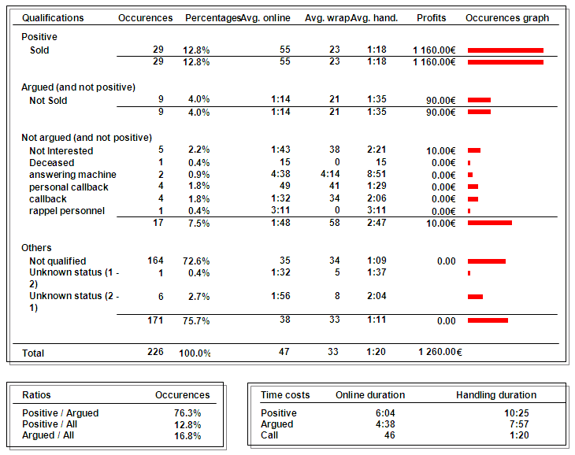
Occurrences and percentage of calls, average duration of calls,
Wrap-up and handling,
estimates of the profits,
graphic representations of occurrences

by call status
and by type of call status (positive, argued).

Distribution of occurrences of calls (positive and argued in comparison to the totality, and positive in comparison to argued).

Total duration of communications and handling by type of call status (positive, argued and not qualified)

Calls call status by agent report
This report gives an overview of the number of calls, the duration of the communications, the wrap-up and handling of inbound calls based on their call status, for campaigns and agents selected, in a defined time period (detailed by agent).

Options tab
This tab allows defining the additional parameters to filter the report data.
Lost time: Enter here the duration below which the call is accounted for in lost or abandoned calls.
Data: allows choosing if you want to see the details per agent and/or the recapitulative summary.

Call status tab
On this tab, you choose to take into account or not the standard call status, and to take into account or not the non qualified calls.

Add call status: allows indicating that you also want to take into account the call status not used for this report.
None
Standard
Custom (these call status have been created by way of a personal call status creation function in the Administration application)
All (the standard and personalized call status)

Once created, the report is presented in a separate window.
If you have chosen the detailed display, a page shows the data of a single agent.
If you choose the summarized display, the data of all selected agents is summed up on a single page.
If you choose the detailed and summarized display, then the agents pages are followed by a summarized page.

The report is divided into several frames.

Occurrences and percentage of calls, average duration of calls,
Wrap-up and handling,
estimates of the profits,
graphic representations of occurrences

by call status
and by type of call status (positive, argued).

Distribution of occurrences of calls (positive and argued in comparison to the totality, and positive in comparison to argued).

Total duration of communications and handling by type of call status (positive, argued and not qualified)

Call status distribution report
This report gives the detail of calls quantity received by hour, grouped by result type, for campaigns and agents selected, in a defined time period (detailed by campaign).
A graphical view is also generated.

Options tab
This part allows defining additional parameters to filter the report data.
Lost time: Enter here the duration below which the call is accounted for in lost or abandoned calls.
Data: allows choosing if you want to see the details per campaign and/or the recapitulative summary.

Call status tab
On this tab, you choose to take into account or not the standard call status, and to take into account or not the non qualified calls.

Add call status: allows indicating that you also want to take into account the call status not used for this report.
None
Standard
Custom (these call status have been created by way of a personal call status creation function in the Administration application)
All (the standard and personalized call status)

Once created, the report is presented in a separate window.
If you have chosen the detailed display, a page shows the data of a single campaign.
If you choose the summarized display, the data of all selected campaigns is summed up on a single page.
If you choose the detailed and summarized display, then the campaigns pages are followed by a summarized page.

The report is divided into several tables followed by a graphic.
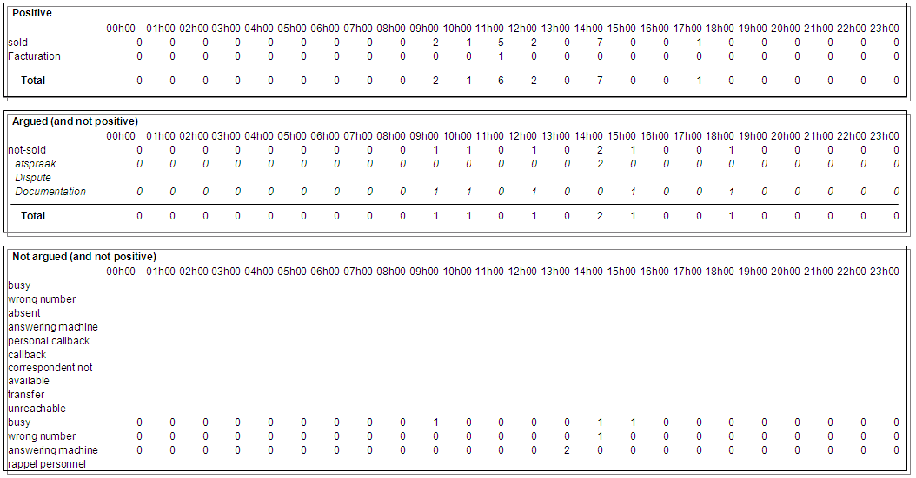
The tables show calls hour distribution for results types Positive, Argued and Not Argued.
Under the tables, a graph of the data is displayed.
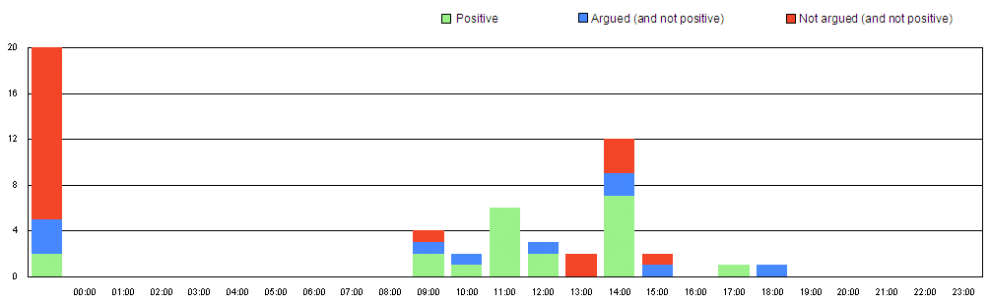

Call status by agent distribution report
This report gives the detail of calls quantity received by hour, grouped by result type, for campaigns and agents selected, in a defined time period (detailed by agent).
A graphical view is also generated.

Options tab
This part allows defining additional parameters to filter the report data.
Lost time: Enter here the duration below which the call is accounted for in lost or abandoned calls.
Data: allows choosing if you want to see the details per agent and/or the recapitulative summary.

Call status tab
On this tab, you choose to take into account or not the standard call status, and to take into account or not the non qualified calls.

Add call status: allows indicating that you also want to take into account the call status not used for this report.
None
Standard
Custom (these call status have been created by way of a personal call status creation function in the Administration application)
All (the standard and personalized call status)

Once created, the report is presented in a separate window.
If you have chosen the detailed display, a page shows the data of a single agent.
If you choose the summarized display, the data of all selected agents is summed up on a single page.
If you choose the detailed and summarized display, then the agent’s pages are followed by a summarized page.

The report is divided into several tables followed by a graphic.
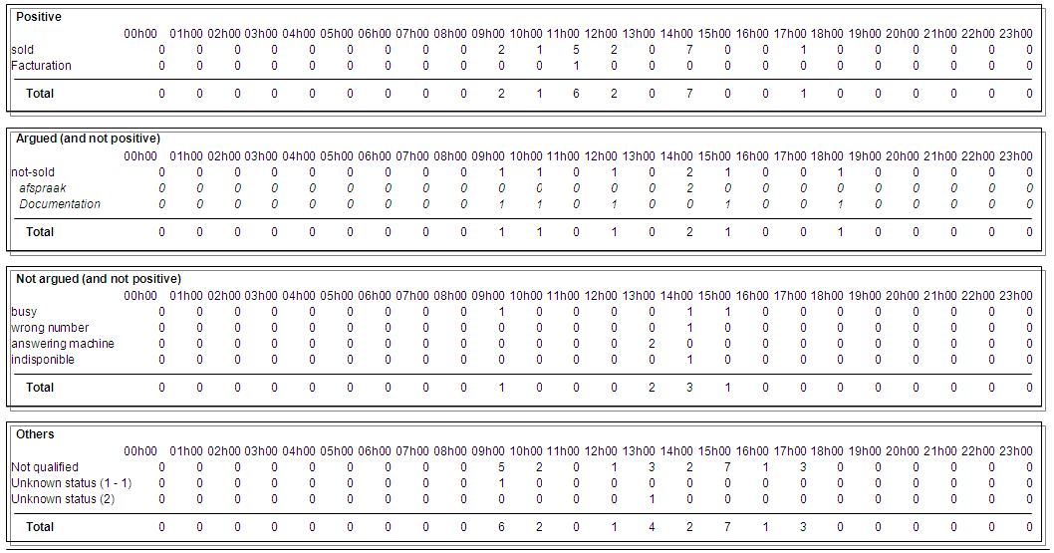
The tables show calls hour distribution for results types Positive, Argued and Not Argued.
Under the tables, a graph of the data is displayed.
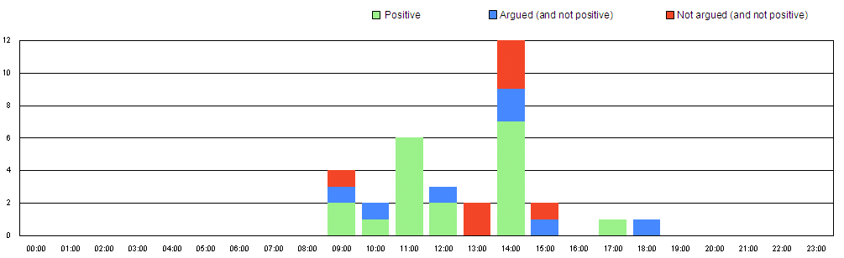

Manual Calls
This set of reports is based on the manual calls done by the agents.

3 predefined reports are available and detailed in this chapter:

- Manual calls report
- Calls call status by agent report
- Call status by agent distribution report

Manual calls report
This first report gives the list of manual calls made by the selected agents in a defined time period.

Once created, the report is presented in a separate window.
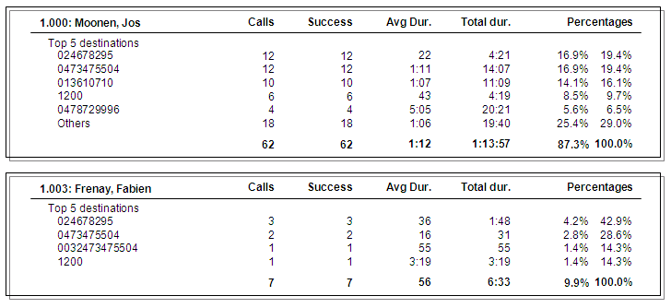

Each agent who has made manual calls, his/her data is indicated in a separate frame.
In this frame, you will see the number of calls per destination and among these calls, the number of successful calls.
It is also possible to see the average duration per destination, and the total duration.
At the bottom of the table, are also calculated for each destination number:
The percentage of how many times that number appears in the total number of manual calls made by all the agents.
The percentage of how many times that number appears in the total of manual calls made by that agent.
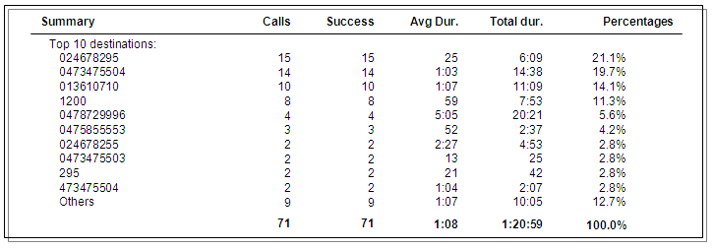
The last frame presents the summary of all the manual calls per destination and their total:
Number of manual calls made
Number of successful calls
Average duration of calls
Total duration of calls
Percentage of how many times a number appears in the total of manual calls

Calls call status by agent report
This first report gives the list of manual calls made by the selected agents in a defined time period.

Options
This tab allows defining the additional parameters to filter the report data.
Lost time: Enter here the duration below which the call is accounted for in lost or abandoned calls.
Data: allows choosing if you want to see the details per agent and/or the recapitulative summary.

Call status
On this tab, you choose to take into account or not the standard call status, and to take into account or not the non qualified calls.

Add call status: allows indicating that you also want to take into account the call status not used for this report.
None
Standard
Custom (these call status have been created by way of a personal call status creation function in the Administration application)
All (the standard and personalized call status)

Once created, the report is presented in a separate window.
If you have chosen the detailed display, a page shows the data of a single agent.
If you choose the summarized display, the data of all selected agents is summed up on a single page.
If you choose the detailed and summarized display, then the agent’s pages are followed by a summarized page.

The report is divided into several frames.

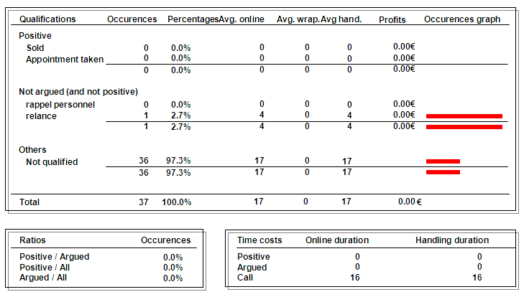
Occurrences and percentage of calls, average duration of calls,
Wrap-up and handling,
profit estimation,
graphical view of occurrences

by call status
and by type of call status (positive, argued, not argued).

Distribution of occurrences of calls (positive and argued in comparison to the totality, and positive in comparison to argued).

Total duration of communications and handling by type of call status (positive, argued and not qualified)

Calls status by agent distribution report
This report gives the detail of calls quantity received by hour, grouped by result type, for campaigns and agents selected, in a defined time period (detailed by agent).
A graphical view is also generated.

Options tab
This tab allows defining the additional parameters to filter the report data.
Lost time: Enter here the duration below which the call is accounted for in lost or abandoned calls.
Data: allows choosing if you want to see the details per agent and/or the recapitulative summary.

Call status
On this tab, you choose to take into account or not the standard call status, and to take into account or not the non qualified calls.

Add call status: allows indicating that you also want to take into account the call status not used for this report.
None
Standard
Custom (these call status have been created by way of a personal call status creation function in the Administration application)
All (the standard and personalized call status)

Once created, the report is presented in a separate window.
If you have chosen the detailed display, a page shows the data of a single agent.
If you choose the summarized display, the data of all selected agents is summed up on a single page.
If you choose the detailed and summarized display, then the agent’s pages are followed by a summarized page.

The report is composed into table followed by a graphic.
The tables show calls hour distribution for results types Positive, Argued and Not Argued.
Under the tables, a graph of the data is displayed.

E-Mails Campaigns

This set of reports is based on the e-mails handling done by the agents.

5 predefined reports are available and detailed in this chapter:

- E-mails distribution report
- E-Mails call status report
- E-Mails call status by agent report
- E-Mails status distribution report
- E-Mails status by agent distribution report

E-Mails distribution report
This report gives an overview of inbound e-mails and their status, in the frame of selected campaigns in a defined time period.

Options tab
This tab allows defining the parameters linked to the report layout.
Data: allows choosing if you want to see the details per campaign and/or the recapitulative summary.
Distribution: allows selecting the type of call distribution (per month, day, hour, ½ hour, ¼ hour, or no distribution at all).
Begin/End hour: Enter here the common minimal hour of begin and end of the report (in case of distribution by hour, ½ hour or ¼ hour).

Once created, the report is presented in a separate window.
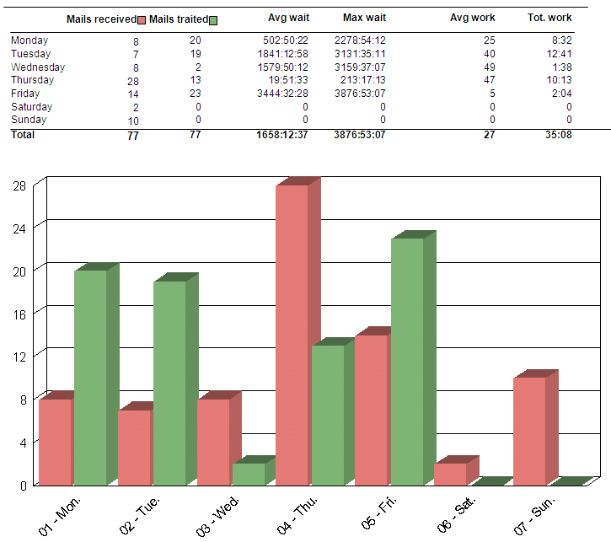

Received e-mails are shown in red, handled e-mails are shown in green.
Note that it’s possible to have more handled e-mails than received e-mails, which indicate that received e-mails were not immediately handled. The handling of these e-mails is thus counted in a later period.

E-Mails call status report
This report gives an overview of the number of e-mails, the duration of the handling and the wrap-up of inbound e-mails based on their call status, for campaigns and agents selected, in a defined time period (detailed by campaign).

Options
This tab allows defining the parameters linked to the report layout.
Data: allows choosing if you want to see the details per campaign and/or the recapitulative summary.

Call status
On this tab, you choose to take into account or not the standard call status, and to take into account or not the non qualified e-mails.

Add call status: allows indicating that you also want to take into account the call status not used for this report.
None
Standard
Custom (these call status have been created by way of a personal call status creation function in the Administration application)
All (the standard and personalized call status)

Once created, the report is presented in a separate window.
If you have chosen the detailed display, a page shows the data of a single campaign.
If you choose the summarized display, the data of all selected campaigns is summed up on a single page.
If you choose the detailed and summarized display, then the campaign pages are followed by a summarized page.

The report is divided into several frames.
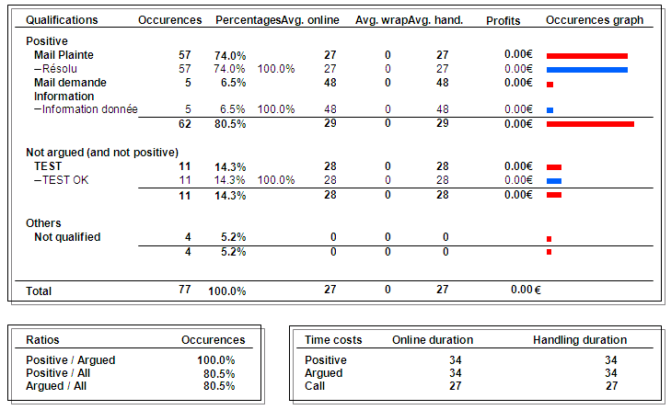
Occurrences and percentage of e-mails, average duration of e-mails handling
And Wrap-up,
Estimates the profits,
Graphical representations of occurrences

by call status
and by type of call status (positive, argued).

Distribution of occurrences of e-mails (positive and argued in comparison to the totality, and positive in comparison to argued).

Total duration of communications and handling by type of call status (positive, argued and not qualified)
Note that for e-mails, there is no distinction between communication and handling durations.

E-Mails call status by agent report
This report gives an overview of the number of e-mails, the duration of the handling and the wrap-up of inbound e-mails based on their call status, for campaigns and agents selected, in a defined time period (detailed by agent).

Options
This tab allows defining the parameters linked to the report layout.
Data: allows choosing if you want to see the details per agent and/or the recapitulative summary.

Call status
On this tab, you choose to take into account or not the standard call status, and to take into account or not the non qualified e-mails.

Add call status: allows indicating that you also want to take into account the call status not used for this report.
None
Standard
Custom (these call status have been created by way of a personal call status creation function in the Administration application)
All (the standard and personalized call status)

Once created, the report is presented in a separate window.
If you have chosen the detailed display, a page shows the data of a single agent.
If you choose the summarized display, the data of all selected agents is summed up on a single page.
If you choose the detailed and summarized display, then the agent’s pages are followed by a summarized page.

The report is divided into several frames.
Occurrences and percentage of e-mails, average duration of e-mails handling
and Wrap-up,
estimates of the profits,
graphic representations of occurrences

by call status
and by type of call status (positive, argued).

Distribution of occurrences of e-mails (positive and argued in comparison to the totality, and positive in comparison to argued).

Total duration of communications and handling by type of call status (positive, argued and not qualified)
Note that for e-mails, there is no distinction between communication and handling durations.

E-Mails status distribution report
This report gives the detail of e-mails quantity received by hour, grouped by result type, for campaigns and agents selected, in a defined time period (detailed by campaign).
A graphical view is also generated.

Options
This tab allows defining the parameters linked to the report layout.
Data: allows choosing if you want to see the details per campaign and/or the recapitulative summary.

Call status
On this tab, you choose to take into account or not the standard call status, and to take into account or not the non qualified e-mails.

Add call status: allows indicating that you also want to take into account the call status not used for this report.
None
Standard
Custom (these call status have been created by way of a personal call status creation function in the Administration application)
All (the standard and personalized call status)

Once created, the report is presented in a separate window.
If you have chosen the detailed display, a page shows the data of a single campaign.
If you choose the summarized display, the data of all selected campaigns is summed up on a single page.
If you choose the detailed and summarized display, then the campaign pages are followed by a summarized page.

The report is divided into several frames.
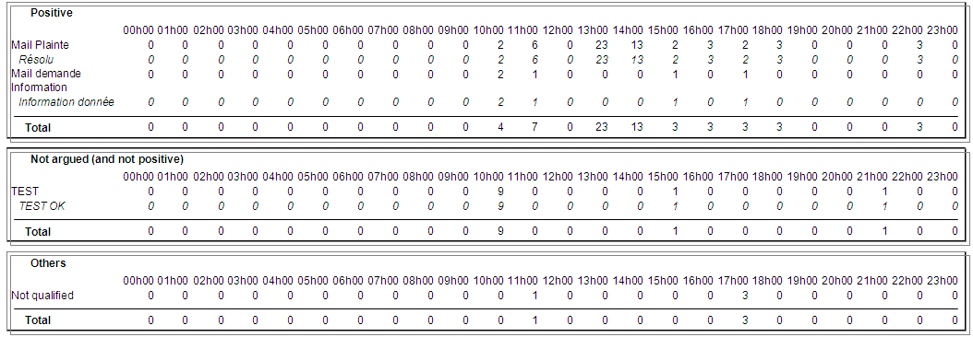
The tables show e-mails hour distribution for results types Positive, Argued and Not Argued.
Under the tables, a graph of the data is displayed.

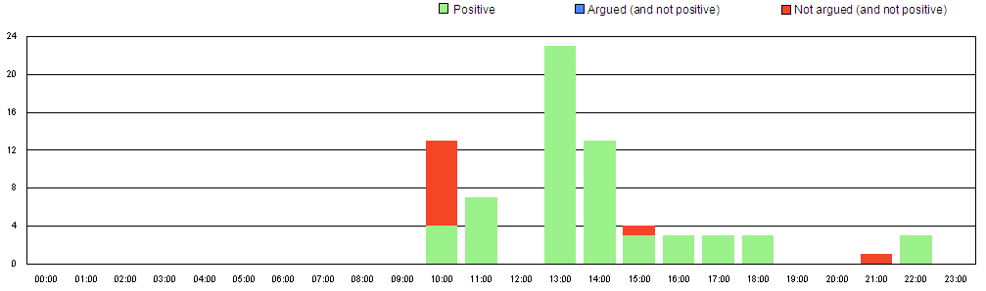

E-Mails status by agent distribution report
This report gives the detail of e-mails quantity received by hour, grouped by result type, for campaigns and agents selected, in a defined time period (detailed by agent).
A graphical view is also generated.

Options
This tab allows defining the parameters linked to the report layout.
Data: allows choosing if you want to see the details per agent and/or the recapitulative summary.

Call status
On this tab, you choose to take into account or not the standard call status, and to take into account or not the non qualified e-mails.

Add call status: allows indicating that you also want to take into account the call status not used for this report.
None
Standard
Custom (these call status have been created by way of a personal call status creation function in the Administration application)
All (the standard and personalized call status)

Once created, the report is presented in a separate window.
If you have chosen the detailed display, a page shows the data of a single agent.
If you choose the summarized display, the data of all selected agents is summed up on a single page.
If you choose the detailed and summarized display, then the agent’s pages are followed by a summarized page.

The report is divided into several frames.

The tables show e-mails hour distribution for results types Positive, Argued and Not Argued.
Under the tables, a graph of the data is displayed.

Chat/Web campaigns reports
This set of reports is based on Chat and Web activities.

Following reports are available and detailed in this chapter:

- Chats distribution reports
- Chat campaigns reports
- Chats distribution reports per country
- Chat status
- Chat status per agent
- Chat status distribution
- Chat status by agent distribution
- Proactive Chat
- Sequences of pages
- Fax status by agent distribution

Chats distribution reports
This report gives an overview of the chat requests and visits of the internet site, in the frame of selected campaigns in a defined time distribution (month, day, hour, ½ hour, and ¼ hour).
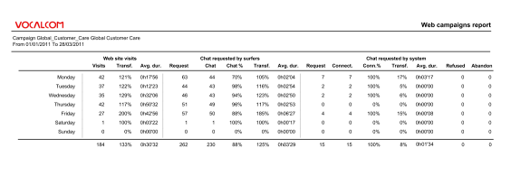
According to the hour distribution chosen in the options, this report will show you the activity of your web campaigns, per interval. 3 areas are visible:
- Web site visits: indicates the total number of visits on the website; the transformation rate (also known as conversion rate) as well as the average duration of a chat session.
Conversion rate = amount of chat sessions requested by surfer + chat sessions requested by system (DIVIDED BY) / amount of visits on site.
- Chat requested by surfer: indicates the total number of chat sessions requested by the surfer; the actual amount of connected chat sessions; chat reachability rate; transformation rate (=connected chat sessions compared to site visits) as well as the average duration of a chat session.
- Chat requested by system: indicates the total number of chat sessions requested by the system; the actual amount of connected chat sessions; connection rate; transformation rate (=connected chat sessions compared to site visits); the average duration of a chat session; the chat sessions refused by surfer; the chat sessions abandoned by surfer.

A graphical view is also generated.
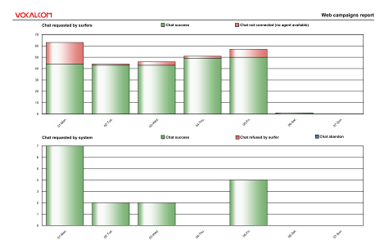
The first graph indicates in green the connected chat sessions and in red the chat sessions which weren’t connected to an agent (no agent available).
The second graph indicated in green the connected chat sessions, chat refused by surfer, chat abandon.

Chat campaigns reports
The options tab allows choosing between different criteria to be shown in the report:
Surfer language: indicates the language chosen on the site.
Referrer: indicates the referring site.
New surfer: registers when a new IP address is detected on the site.
Keywords: link with keywords added to search engine of the site.
Page name: indicates the amount of visits for each page of the site.
Page group: indicates the visit of one or more pages of a same group of pages.
Previous page: indicates the pages to which the surfer came back to.

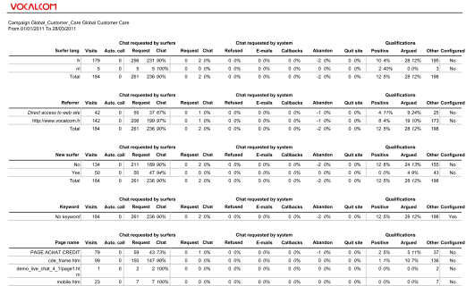
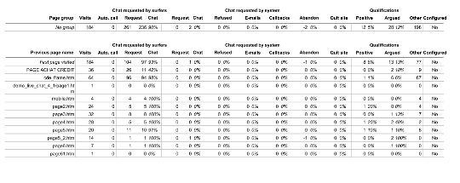

Each of these categories is separated in 3 sections:
Chat requested by surfer: displays visits, the Auto call, Requests, Connected chat.
Chat requested by system: displays Chat Requests, Connected chats, Refused, Emails sent from page, callbacks (amount of web callback requests), Abandon, and Quit site (when the surfer quits the site while being on a certain page).
Call status: indicates which category of call status has been registered for the chat session (positive, argued, not argued).

Chats distribution reports per country
This report gives an overview of the chat requests and visits of the internet site per country identified, in the frame of selected campaigns in a defined time distribution (month, day, hour, ½ hour, and ¼ hour).
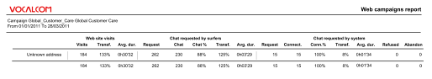
According to the hour distribution chosen in the options, this report will show you the activity of your web campaigns, per interval and per country. 3 areas are visible:

- Web site visits: indicates the total number of visits on the website; the transformation rate (also known as conversion rate) as well as the average duration of a chat session.
Conversion rate = amount of chat sessions requested by surfer + chat sessions requested by system (DIVIDED BY) / amount of visits on site.
- Chat requested by surfer: indicates the total number of chat sessions requested by the surfer; the actual amount of connected chat sessions; chat reachability rate; transformation rate (=connected chat sessions compared to site visits) as well as the average duration of a chat session.
- Chat requested by system: indicates the total number of chat sessions requested by the system; the actual amount of connected chat sessions; connection rate; transformation rate (=connected chat sessions compared to site visits); the average duration of a chat session; the chat sessions refused by surfer; the chat sessions abandoned by surfer.

A graphical view is also generated:
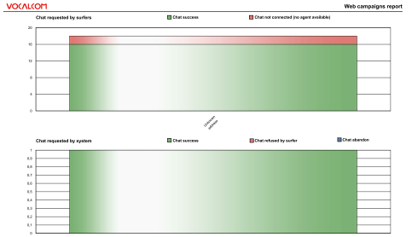

The first graph indicates in green the connected chat sessions and in red the chat sessions which weren’t connected to an agent (no agent available).
The second graph indicated in green the connected chat sessions, chat refused by surfer and chat abandon.

Chat status
This report gives an overview of the number of chat sessions, the duration of the handling and the wrap-up of the chat based on their call status, for campaigns and agents selected, in a defined time period (detailed by campaign).

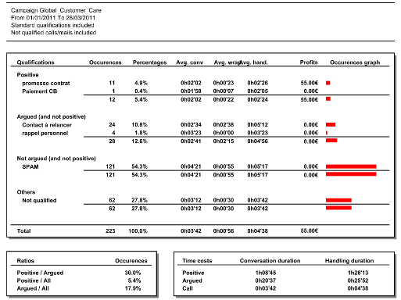

This report also displays profits depending on the call status value configured in the administration module as well as a graph that compares the occurrence related to the category.

Chat status per agent
This report gives an overview of the number of chat sessions, the duration of the handling and the wrap-up of inbound chat sessions based on their call status, for campaigns and agents selected, in a defined time period (detailed by agent).

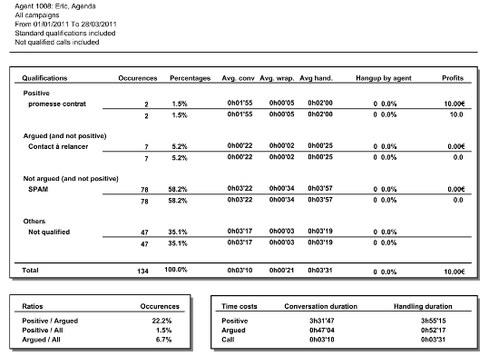

This report also displays profits depending on the call status value configured in the administration module as well as a graph that compares the occurrence related to the category.

Chat status distribution
This report gives the detail of chat sessions quantity received by hour, grouped by result type, for campaigns and agents selected, in a defined time period (detailed by campaign).
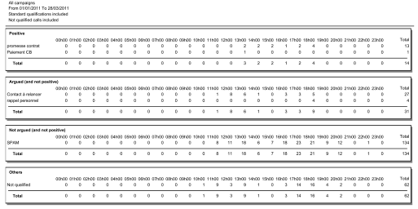

A graphical view of these data is also generated:
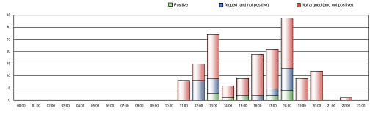

Chat status by agent distribution
This report gives the detail of chat sessions quantity received by hour, grouped by result type, for campaigns and agents selected, in a defined time period (detailed by agent).

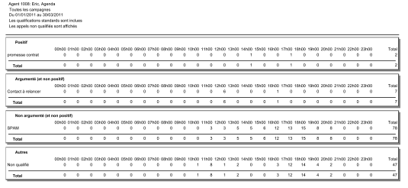
A graphical view of these data is also generated that the proportions between Positive, Argued, No argued categories:
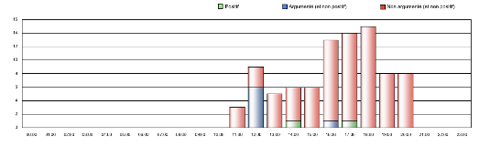

Proactive chat
This report is designed to present statistics about the proactive chats activities.
The option tab of this report allows the user to have a “page break after each campaign” or sum all the campaigns in one page. The campaigns tab is used to filter the campaigns shown in the report.

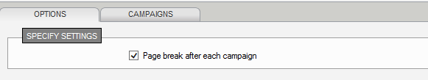

The first column (on the left) shows the Proactive rules set up on the chat campaign.
In the “Proactive chat” section as well as “Proactive calls” we see:
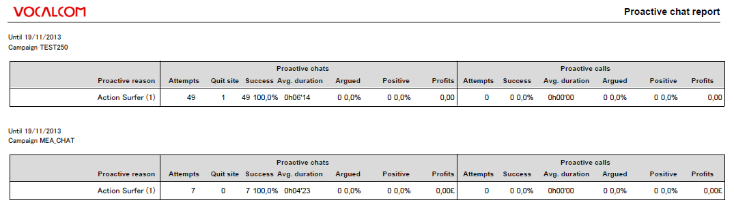
- Attempts: amount of proactive chat attempts
- Quit site: net surfer quits the page after the chat attempt
- Success: reachability ratio
- Avg. duration: avg. duration time of proactive chat session
- Argued: amount of argued chats (according to chat status category)
- Positive: amount of positive chats (according to chat status category)
- Profit: provisional profit (according to value set in chat status group)

Sequences of pages
This report is designed to show the different “sequences” that have happened on the site as well as the sequences happening on the pages.
The options tab allows setting the amount of sequences per page and per site.

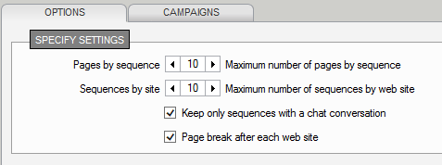

“print screen of report not available”

Fax status by agent distribution
This report gives the detail of chat sessions quantity received by hour, grouped by result type, for campaigns and agents selected, in a defined time period (detailed by agent).

A graphical view of these data is also generated that the proportions between Positive, Argued, No argued categories:

Agent activities
This set of reports is based on agent activities.

5 predefined reports are available and detailed in this chapter:

- Agents report
- Activities by agent report
- Activities by date report
- Agents state distribution report
- Agents state distribution report (with e-mails)
- Billing by agent
- Billing by date
- Production by agent
- Agent Pause report

Agents report
This report gives an overview of the distribution of selected agent activities during a defined time period.

Options
This tab allows defining the additional parameters to filter the report data.

Data: allows choosing if you want to see the details per campaign and/or the recapitulative summary.
Ignore Pause : indicates that pause states must not be taken into account for reporting.
Page break after each agent: allows having the data of each agent on a separate page.

Once created, the report is presented in a separate window.
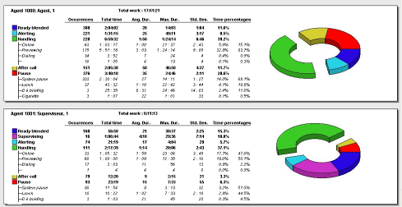

A frame represents the activities of an agent.
In this frame you will see:
The number of occurrences and the total duration per type of activity (supervising, alerting, handling, pause…)
The detailed handling time divided in sub-activities (on line, dialing…)
The detailed pause time divided in sub-categories of pauses (system pause, general pause ,…)
You can also see the average and maximum durations per activity, the standard deviation and the percentage in comparison to the total time.

The Handling category gives the total number of calls handled.
Online : number of treated calls (out, in and manual)
Previewing : number of previewed outbound calls
Dialing : number of manual calls
Callback : number of registered callbacks in an inbound campaign
Search mode : number of customer search before calling
E-mail : number of treated mails

Remark :
The Standard Deviation gives the dispersion of values around the average.
Example: Total duration in state “Ready” for an agent is 13:22 seconds. The average duration is 1:15 seconds by call. The standard deviation is 16 seconds: We can consider that the agent stays on average in “Ready” state 1:15 seconds ± 16 sec (results are dispersed between 59 and 1:31 sec.)

If you choose the detailed display, a frame shows the data of a single agent.
If you choose the summarized display, the data of all selected agents will be shown on a single page.
If you choose the detailed and summarized display, then the agent frames are followed by a summarized page.

In each frame, a graph shows the distribution of activities.
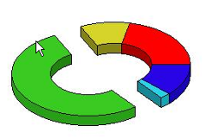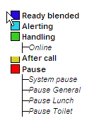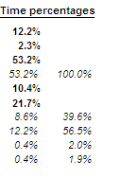

This pie chart shows the distribution of an agent’s activity time percentage (or a recapitulative on the last page).

Activities by agent
This first report gives a detailed view of activities carried out by selected agents, per day, during a defined time period.

Options
This tab allows defining the additional parameters to filter the report data.

Dates used: allows choosing if the dates used for the report are those when all selected agents were active or those when at least one selected agent was active.
Begin/End hour : allows specifying the common minimal hour interval to select.
Ignore Pause : indicates that pause states must not be taken into account for reporting.
Page break after each agent: allows having the data of each agent on a separate page.

Once created, the report is presented in a separate window.
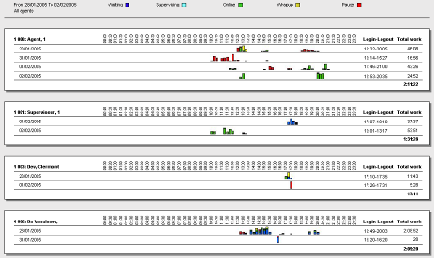
A frame shows the data for each agent.
Vertically, the dates of the agent’s activity are aligned (according to the dates used option).
Horizontally, the time scale of the day in 30 minute periods is displayed.
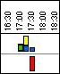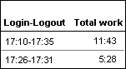
The activities are represented graphically by color bars whose legend is shown in the top part of the window.
Right of the graph, for each day, the Log-in Log-out times are displayed, as well as the total work time.

Activities by date
This report gives an overview of the activities carried out by selected agents, organized per day, during a defined time period.

Options
This tab allows defining the additional parameters to filter the report data.
Display agents: allows choosing if the data used for the report are those for all selected agents, or only for active agents.
Begin/End hour : allows specifying the common minimal hour interval to select.
Ignore Pause : indicates that pause states must not be taken into account for reporting.
Page break after each agent: allows having the data of each agent on a separate page.

Once created, the report is presented in a separate window.
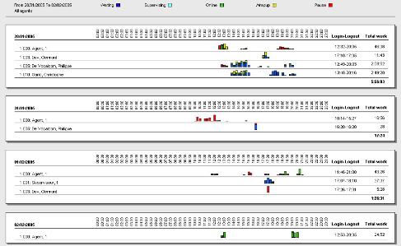

A frame presents the data for each date.
The agents are aligned vertically (according to the Display agents options).
The time scale for the day is shown horizontally in 30 minutes time periods.
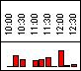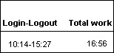
The activities are represented graphically by color bars whose legend is displayed at the top of the window.
.
Right of the graph, for each day, the log-in and log-out time is displayed, as well as the total work time.
On the illustrated example, the agent worked 16:56 sec between 10h14 and 15h27.

Agents state distribution
This report gives an overview of the distribution of inbound calls and their status in the frame of selected campaigns during a defined time period.

Options
This tab allows defining the additional parameters to filter the report data.
Data: allows choosing if you want to see the details per campaign and/or the recapitulative summary.
Ignore Pause: indicates that pause states must not be taken into account for reporting.
Distribution: allows selecting the type of distribution of activities (per month, week, days, hour, ½ hour, ¼ hour, (or no distribution at all).
Begin/End hour: allows specifying the common minimal hour interval to select (in case of distribution by hour, ½ hour or ¼ hour). If the system detects production data before of after the indicated begin/end hours, the report will take the totality of the production data into account, and not only the indicated interval.

Select on the right the supervision group or the supervisor you want to see the supervised data.

Once created, the report is presented in a separate window.
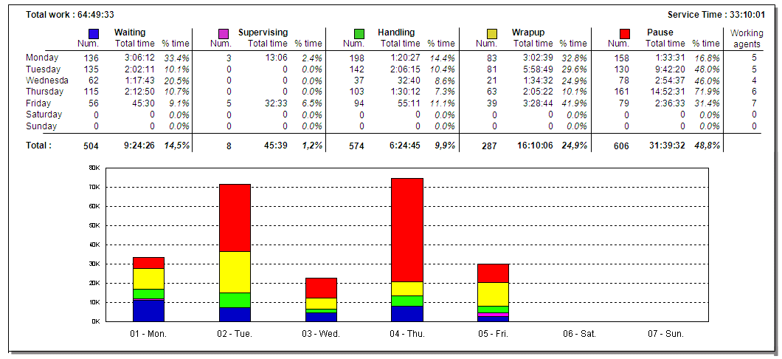

In this table, the distribution parameter is displayed vertically on the left:
The months of the year, the weeks, the days of the week, the hours, ½ hours or ¼ hours in a day. (In this example, the distribution per day has been selected)

The detail of the numbers is presented in a table per agent activity:
Num.: number of occurrences of activities.
Total time: total time of the activity.
% time: percentage of time of the activity in comparison to the total time.

The last column Working agents indicates how many agents were detected during this period.
Under the table, a graph of the data is shown.
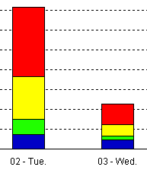

The colors used for the distribution of data are indicated next to each activity above the table.
The number of activities is displayed vertically; the unit of distribution is displayed horizontally.
This report doesn’t report any e-mails related activities.

Agents state distribution (with e-mails)
This report gives an overview of the distribution of inbound calls and e-mails, together with their status in the frame of selected campaigns during a defined time period.

Options
This tab allows defining the additional parameters to filter the report data.
Data: allows choosing if you want to see the details per campaign and/or the recapitulative summary.
Ignore Pause : indicates that pause states must not be taken into account for reporting.
Distribution: allows selecting the type of distribution of activities (per month, week, days, hour, ½ hour, ¼ hour, (or no distribution at all).
Begin/End hour : allows specifying the common minimal hour interval to select (in case of distribution by hour, ½ hour or ¼ hour). If the system detects production data before of after the indicated begin/end hours, the report will take the totality of the production data into account, and not only the indicated interval.

Once created, the report is presented in a separate window.
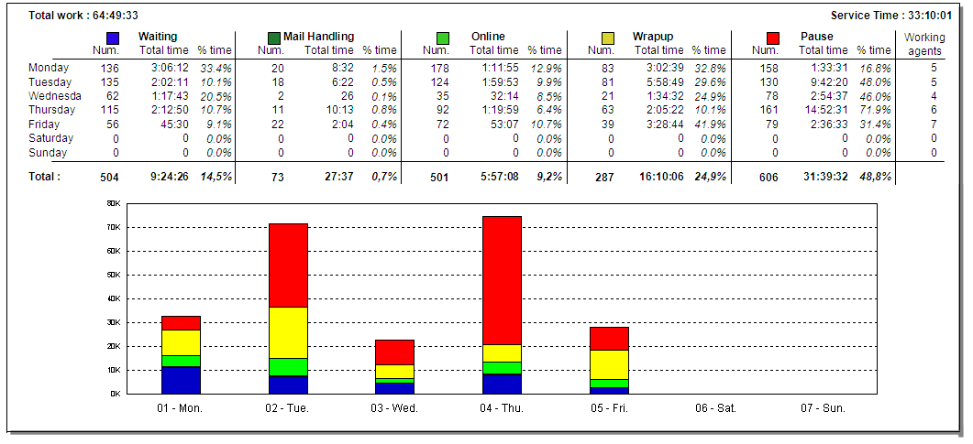

In this table, the distribution parameter is displayed vertically on the left:
The months of the year, the weeks, the days of the week, the hours, ½ hours or ¼ hours in a day. (In this example, the distribution per week day has been selected)

The detail of the numbers is presented in a table per agent activity:
Num.: number of occurrences of activities.
Total time: total time of the activity.
% time: percentage of time of the activity in comparison to the total time.

The last column Working agents indicates how many agents were detected during this period.
Under the table, a graph of the data is shown.

The colors used for the distribution of data are indicated next to each activity above the table.
The number of activities is displayed vertically; the unit of distribution is displayed horizontally.

Billing by agent report
This report was created to give an overview of the amount of worked hours of a particular agent during a specified period. In this report, a difference is made between “Active duration” (excluding Pause time) and “Login time” (including Pause time).

This report offers different options for opening:
- Always include actions with no campaign: actions with no campaign are the actions performed by the agents when no skill has been affected to them; in other words, when the agent doesn’t have any skill while being logged in.
- Page break after each agent: this option allows showing more than one agent per page.

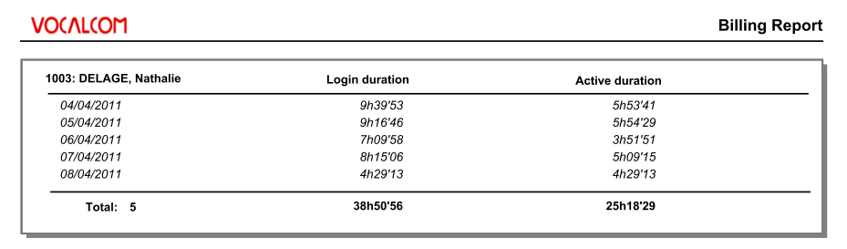
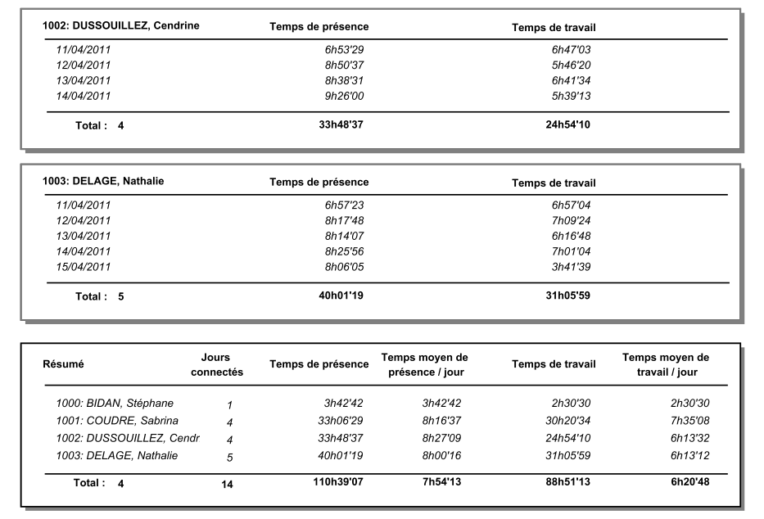

Login duration and Active duration are displayed per agent and per day.
The last page of the report is the summary where the Amount of days logged is displayed as well as the Total Active duration and Total Login time.

Billing by date report
This report was created to give an overview of the amount of worked hours of a particular day and for the specified agents. In this report, a difference is made between “Active duration” (excluding Pause time) and “Login time” (including Pause time).

This report offers different options for opening:
- Always include actions with no campaign: actions with no campaign are the actions performed by the agents when no skill has been affected to them; in other words, when the agent doesn’t have any skill while being logged in.
- Page break after each agent: this option allows showing more than one agent per page.
- Show graphics: allows showing the graphic of max logged agents during specified interval

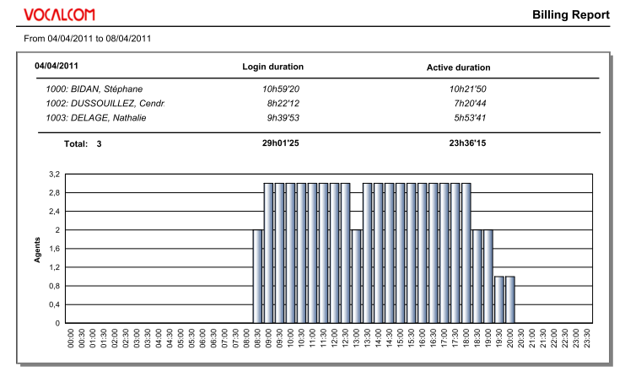

A graphical view is also presented to show the maximum amount of agents present during a specified interval of time.

Agent production report
This report was designed to show the quality and the quantity produced by agents.
For each agent the quantity of “calls” and “emails” are displayed.
To measure the quality, we refer to call status categories used in Hermes .NET, which are Argued calls and Positive calls.

This report offers different options for opening:
- Always include actions with no campaign: actions with no campaign are the actions performed by the agents when no skill has been affected to them; in other words, when the agent doesn’t have any skill while being logged in.
- Ignore pause: this option allows showing or hiding the pause time.
- Show campaign details: allows showing per agent the different campaigns on which the agent has worked. The campaigns are displayed under the agent name
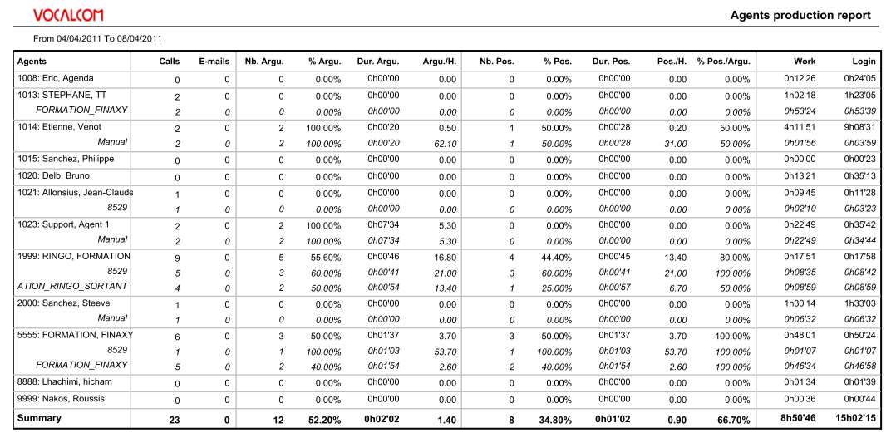

For each of these 2 categories the statistics are provided
Argued category:
- Nb argued: amount of qualified argued calls
- % argued: amount of argued compared to total of calls
- Avg duration: average duration of a argued call
- Arg/H: amount of qualified argued calls per hour
Positive category:
- Nb positive: amount of qualified positive calls
- % positive: amount of positive compared to total of calls
- Pos duration: average duration of a positive call
- Pos/H: amount of qualified positive calls per hour
- Pos/Argu: Positive calls compared to argued calls

At the right of the report page, the work time (with pause time excluded) as well as Login time are displayed (with pause time included).
At the bottom of the report page a “Summary” is provided.

Agent pause report
This report has been designed to give a complete overview of the pauses used by agents per interval and during a specified period.

This report offers different options for opening:
- Always include actions with no campaign: actions with no campaign are the actions performed by the agents when no skill has been affected to them; in other words, when the agent doesn’t have any skill while being logged in.
- Page break after each agent: this option allows showing more than one agent per page.
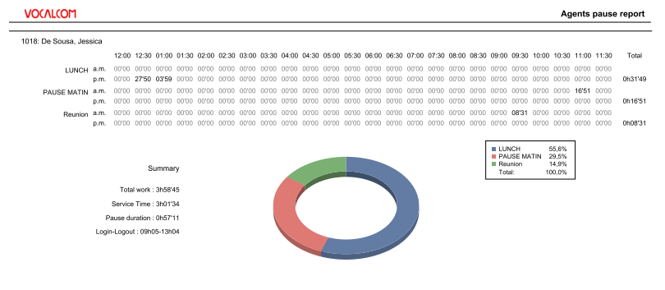

Following data are shown in the report:
- Each pause reason used by agent is divided in 2 horizontal lines: am (morning) & pm (afternoon).
- The different day intervals (12:00 11:30) are presented vertically and allow checking exactly when a certain pause has been used and also for how long.
- At the end right of the report the total time of the pause is displayed.
- A graphical view is also displayed showing the proportion of each pause.

IVR REPORTS

IVR Distribution report
This report gives an overview of the distribution of the IVR visits per hour.
The following information is displayed per column:
- Visits: amount of visits in the IVR
- Max duration: indicates the length of the longest visit duration
- Avg duration: indicates the average duration of a visit
- Min duration: Indicates the length of the shortest visit duration
- Hand by agent: indicates the call that has been forwarded to an agent
- Hang-up in IVR: calls which ended in IVR following a system disconnection
- Abandons: calls which ended in IVR following a user disconnection (hang up)

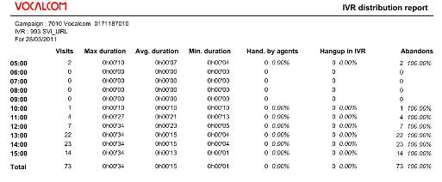

A graph is also generated indicating the amount of simultaneous visits (vertical scale) for each time slot (horizontal scale).
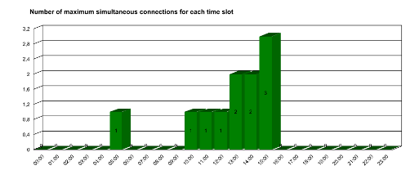

IVR Message report
This report gives an overview of the distribution of the IVR messages (markers). Those markers are placed at some points in the IVR branches and every time a call passes through one of the markers, a new occurrence is registered (see IVR editor documentation for the configuration of the markers).
An average duration is also displayed under the message.
The total amount of visits per message is displayed at the end of each message.

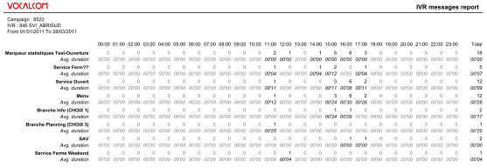

IVR durations report
This report shows the different markers of the IVR script and how long the calls spend in each one of them. Those markers are placed at some points in the IVR branches and every time a call passes through one of the markers, a new occurrence is registered (see IVR editor documentation for the configuration of the markers) Graduation is divided in 5 segments: Less than 5sec, between 5 sec and 20 sec, between 1 min up to 5 min, more than 5 min.
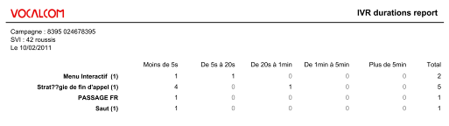

Scheduling reports

Setup &Save report
The first step of scheduling a report is to choose the report you want to schedule from the top menu. In the example here below, we’ve chosen the “Call Status by agent report”.
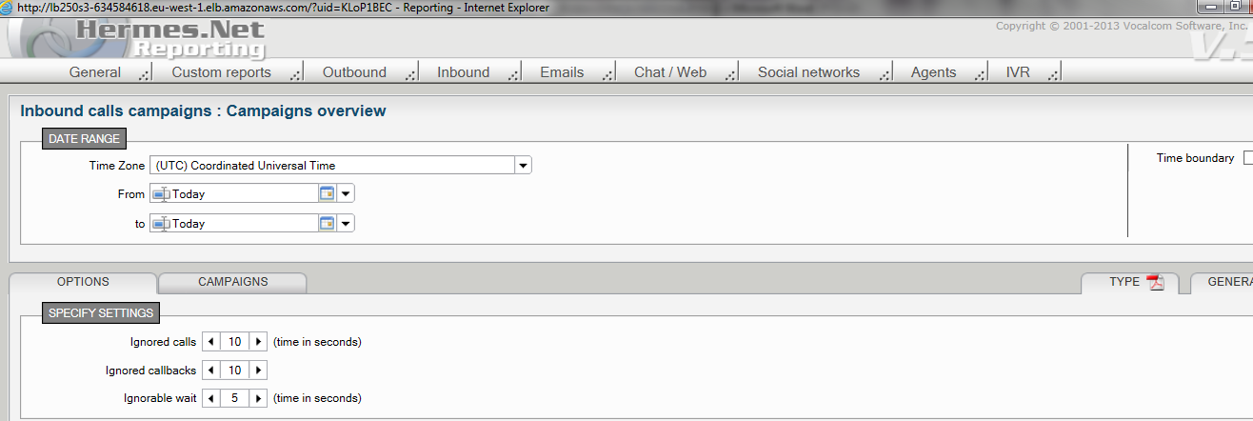
Next choose the periodicity of your scheduling and select the appropriated “Date range” for your report. You can either select a static date range (ex: 01/01/2011 to 31/02/2011) or a dynamic range by selecting a predefined dynamic date range from the “From” field and from the “To” field:
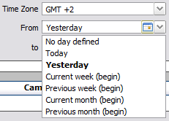

Open the dropdown list to choose from the following options:
- Today: will select data related to the day of the report generation
- Yesterday: will select data related to the day of the report generation -1 day
- Current week: will select data of the current week until the day of generation
- Previous week: will select data from previous week (Monday to Sunday)
- Current month: will select current calendar month
- Previous month: will select previous calendar month
For a daily report make sure to select “Yesterday” on order to get the data -1 day.

Once you’ve selected the date range you can save this report configuration by opening the menu: General \ Save this report.

Schedule report
Go to the General menu and open the “Saved reports list”. You will see the list of all the saved report configurations.
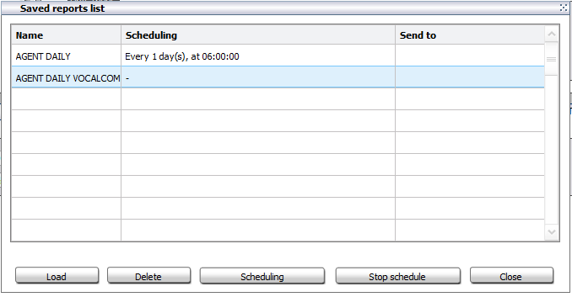

Select the one you wish to schedule and press the “Scheduling” button at the bottom part of the screen.
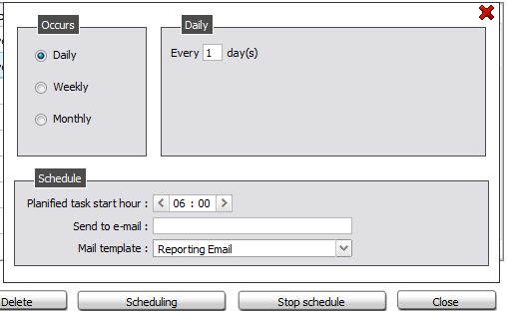
Now select the frequency (“Occurs”) of the report generation by selecting Daily, Weekly, Monthly according to the date range you’ve selected on the report setup.
You can as well select the time of generation from the “Schedule” area: Planified task start hour.

Send report via Email
To send the report by email as an attachment:
- Specify in the “Send to e-mail” field one or more email addresses separated by “;”.
- Also select the mail template you want to use to attach the document to. The mail templates are created in the administration module (menu “outgoing media\Outbound email\Templates for reporting)
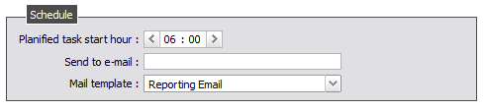

There’s no button so save this operation, you can simply close the screen using the red cross. Your report will from now on be generated automatically and sent by email.

Open generated reports
You can always open reports that have been scheduled and sent by email.
Go to menu “General \ Generated reports list:
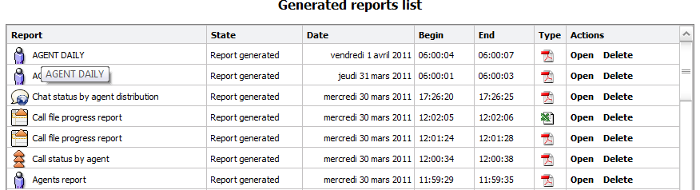

You new freshly generated reports will be presented in the list of the generated report together with all the other reports you’ve created manually or automatically scheduled.

Custom reports
For this section, please consult the “Custom Reports” documentation.

