Creating a Campaign


Hermes.net V5

Created by: Jon Dawson
Modified by: Jon Dawson
Date de creation: 21/02/2014
Last modified date: 21/02/2014
Version: 1.0 Vocalcom Campaign Social V1 Copyright © 2001- 2011

Summary

Document description............................................................................................................. 2
Adding Facebook application "Developer" ………..................................................................... 2
Creating a Facebook application .……...................................................................................... 4

Document description

This technical note describes how to create a Facebook application for social networks to the campaign web admin Hermes net.

Adding Facebook Application "Developer"

Only the developer of Facebook accounts have the rights to create Facebook applications, this part of documentation explains how registered a developer account on Facebook.

Login to your Facebook accounts URL: http://www.facebook.com/ or via the registration steps to access your Facebook account.

Having logged in as the Facebook user, use the search feature and type Developer
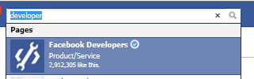

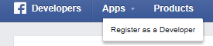

Creating a Facebook application

After adding the "Developer" Facebook application, it can be accessed via the following URL: https://developers.facebook.com/apps. Then, to create a Facebook application, just click on create an application right at the top of the page.

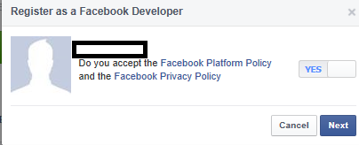

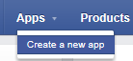

Enter the application name and then click continue when the popup is displayed:

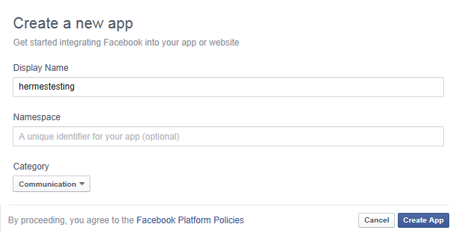

Skip security step

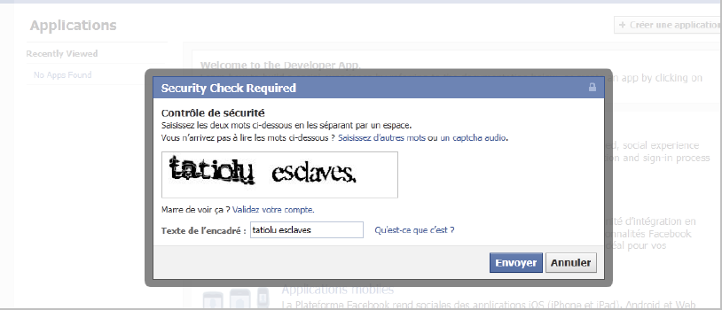

Finally, we have a new Facebook application and necessary information to enter in web admin for the social media campaign. This page is the general configuration of the application; the red rectangles are the parameters to remember: You will need to keep these settings for the Hermes Campaign

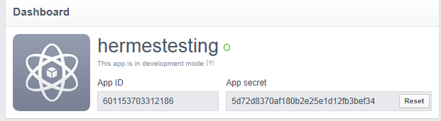

Select Add Platform

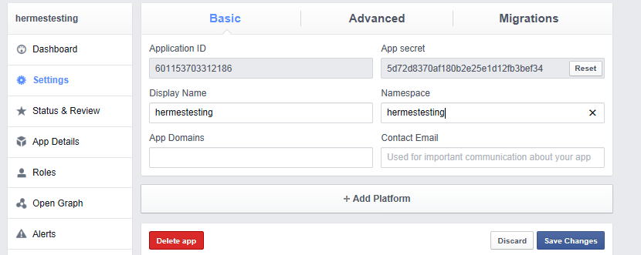

Select App on FaceBook
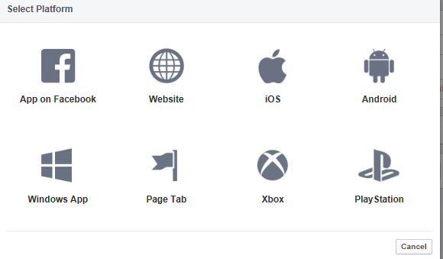

You will need a Canvas page for vocalcom in this example like the below

https://apps.facebook.com/hermestesting

You will need the following secure URL

https://octopus.vocalcom-software.com/hermes_net_v4/thelink/b4d62466352455b4/

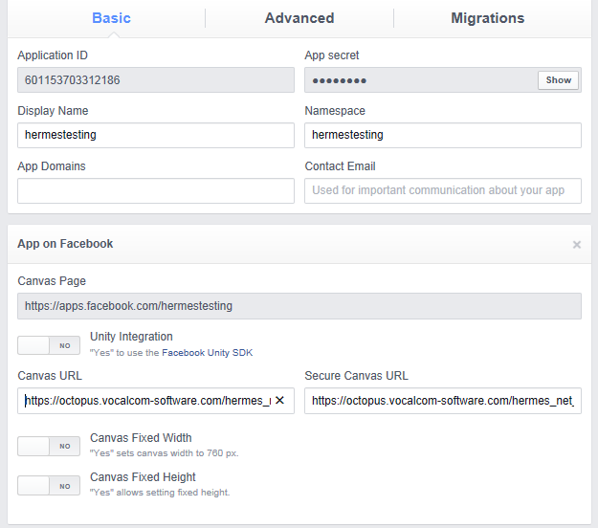

In the advance TAB you will require the client token for Hermes

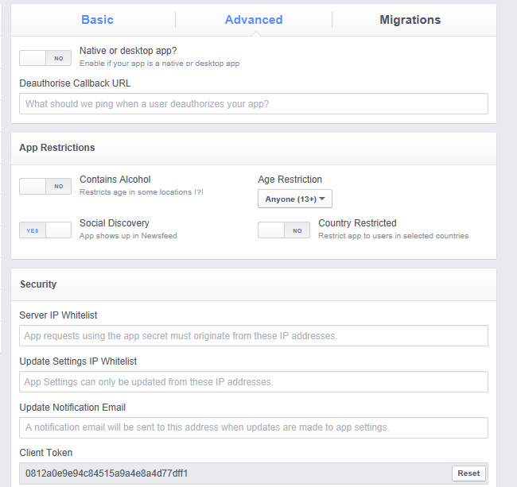

Make the application public
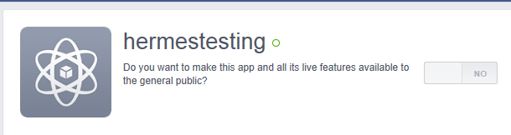

Now create social media campaign in web admin Hermes Net, using the details you have captured during this setup process you can now complete the Hermes setup.

- Application ID
- App secret
- Client Token
- Canvas Page
- Canvas URL
- Secure Canvas URL

1 – Go to the tab "Social Networks" in web admin
You will require the following:
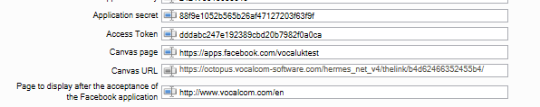
Campaign configuration
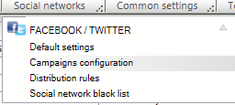

2 – Create a "FaceBook" campaign
- ID = leave or create your own
- Database = select your connection

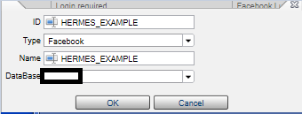

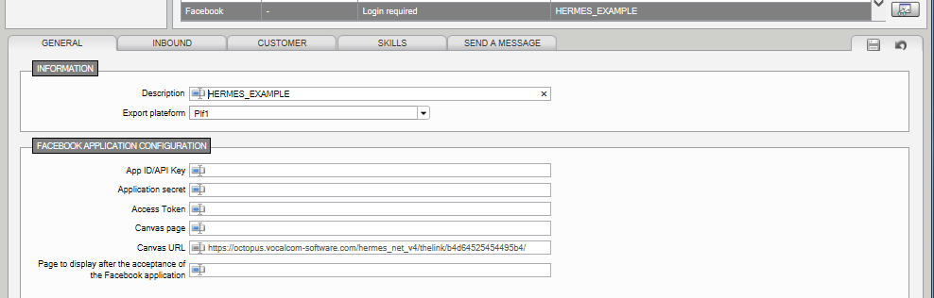

3 – Complete configurations of the campaign with the parameters of the Facebook app:
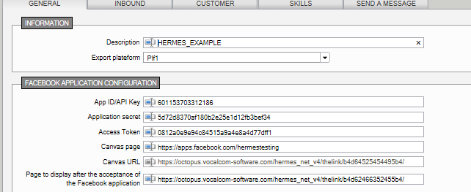

Now select the “Log on to Reading of Campaigns” to active the account

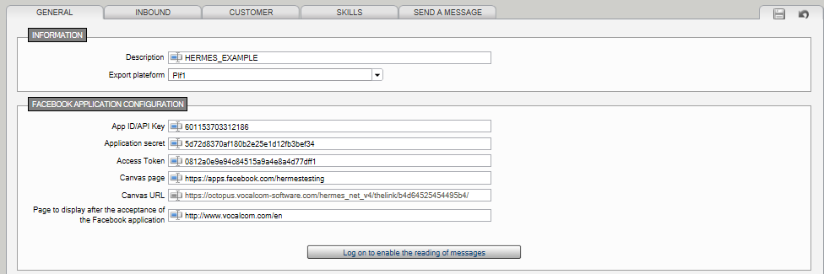

You may have to login to Facebook the first time but once this has been setup you will see the following message when you click the
