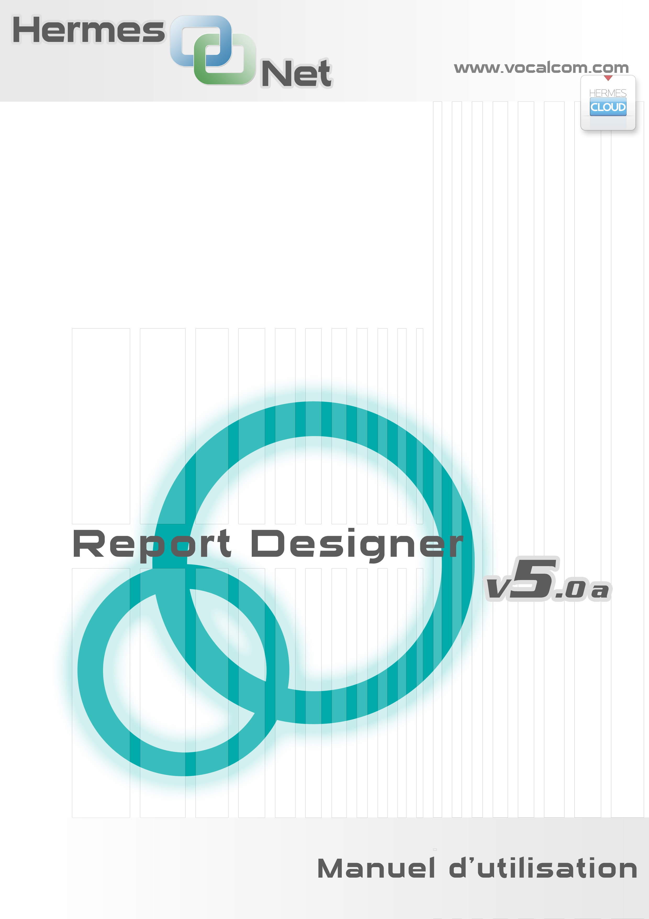

Author : Ed. Reill
Date : 06/08/2013
Version : 1.0
Applis To : Hermes.Net 5.0

Table of Contents
Introduction 4
1 Report definition 4
2 Report Designer Selection 4
2.1 List of Reports 5
2.1.1 Filters and commands on the list of reports 5
2.1.2 Report Groups 6
2.1.3 List of Reports 7
2.2 Creating new reports 7
2.3 Importing reports 8
3 Creation interface 8
3.1 Overview of the general interface 8
3.1.1 Menus 9
3.1.2 The Menu Bar 9
3.1.3 Object Properties Tab 10
3.1.4 Area properties 10
3.1.5 Report Page 10
3.1.6 List and chapter selection, Statutes, and other information 10
3.2 Menus 10
3.2.1 Menu Rapport 12
3.2.2 Menu Pages 15
3.2.3 Edit Menu 19
3.2.4 Model Menu 21
3.2.5 Preferences Menu 21
3.3 Interface edition cover 21
3.3.1 Table of Contents 21
3.3.2 Headers and footers 22
3.4 Edition Chapter Interface 22
3.4.1 Configuring the Repeater 23
3.5 Editing Interface page 24
3.5.1 Objects 24
3.5.1.1 Texte (Statique) 25
3.5.1.2 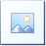 Image (Static) 25
3.5.1.3  Panel (Static) 25
3.5.1.4 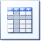PivotTable (Connected) 25
3.5.1.5 Table (Connected) 27
3.5.1.6 Vertical bar graph (Connected) 29
3.5.1.7 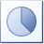Pie chart (Connected) 33
3.5.1.8 Curve (Connected) 36
3.5.1.9 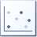Scatter (Connected) 37
3.5.2 Property Management 39
Annexes 43
1. Select columns in wizards 43
2. Configure filters in wizards 44

Introduction
The Report Designer application is to allow to create fully customizable reports in terms of graphics, data and functional architecture for rendering.

These reports will be based on the "standard" telephony data, chat, or email, but also customer data files.

Once configured a report can be generated and exported from the Reporting application.

Report definition
A report can be seen as a file containing a cover sheet and a set of chapters. Each chapter can in turn contain a cover page, a set of pages and page end.

All pages of a chapter can be repeated for one or more variables (query result) specified.

The pages of a report are made of a set of objects each of which is configurable via a menu (style properties) or via an agent (for configuration data relating to)

Default report contains a set of global variables, and we can extend this set of variables in the configuration report.

A report will be saved as a "report template" in order to reuse its full configuration or just the styles of its objects.

We can also create groups of objects preconfigured as "components" and reuse it in several reports.

Report Designer Selection
The home screen of the interface selection allows you to manage existing reports and models to import or create new. It consists of three main parts: a header and a status line.
Each of the main parts is available by clicking on the corresponding tab.

Entête
The only information available about this band is the screen resolution which will be launched in the editor. Possible resolutions are:

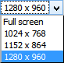 | The resolution is selected automatically saved for each of the different users of Report Designer.

Part 1: List of reports.
Part 2 : Creating new reports.
Part 3 : Importing reports.

Status bar.
Allows :
Exit the application ('Exit').
To know information about your login ID and Company.
To know the version of the application. This version You may be required when requesting support..

List of Reports
The "Report List" consists of three areas:

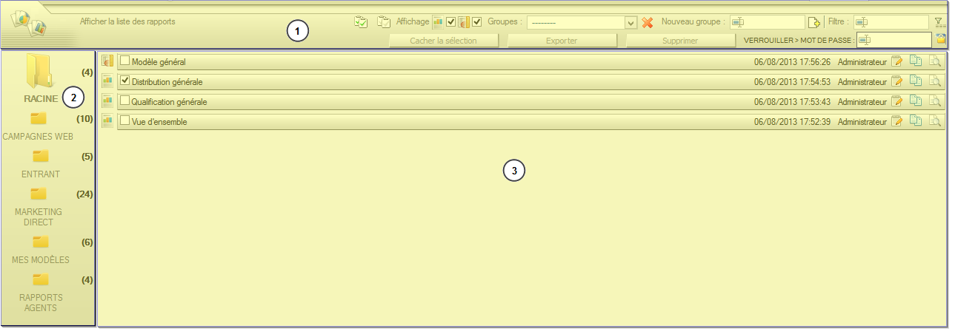

Filters and commands on the list of reports
This area is composed of an always-visible upper part and a lower part visible only when at least one ratio is selected.

Description of various features of the tab "List Reports":

Allows you to select / deselect the group reports displayed.
Allows you to filter the list of reports by type (Report Template)

Report
Model

Displays a list of existing groups. Deletes a group. Reports belonging to the deleted group are automatically moved to the root.
Creating a new report group.
Allows you to filter the list of reports on their names. A wildcard (*) may be used.
This command allows you to hide the selected reports. Hidden reports are deleted from the list and can be redrawn at any time by selecting one of the following commands.

Lets you display reports marked as hidden. The value in parentheses indicates the number of hidden script. The first icon allows you to restore all reports, the second to display the hidden list of reports and retrieve individually.
Can export selected and recover files RDR (Report Designer Report) reports. Once the export started, the following window appears.
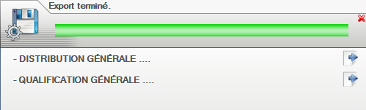
RDR to download files, click on the icons

Deletes the reports selected. Confirmation is requested.

Lock the selected reports. When a report is locked, you cannot edit it, to generate, export, or delete it. All these operations will be available again when the report is released.

Report Groups

Groups reports allow the user to classify reports.
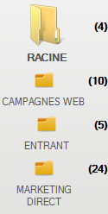 | The indicator to the right of the group icon displays the number of reports in the latter. The "Root" group indicates the default group (actually: no group).  Add a report to a group  The reports add or remove groups via "drag & drop" mouse. Click the icon to move the script and drop it on the desired group.

List of Reports

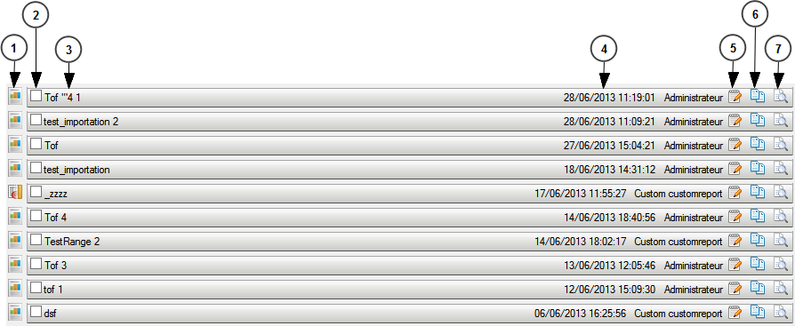
1a - Double-click the icon to open the report with the publisher.
1b - Drag and drop the icon on a group to move to the current destination group.
2 - Check this box to select the report and access the various functions described above (2.1.1).
3 – Report name
4 - Date, time of last modification. Name of the user who made ​​the change.
5 - Same functionality as the double-click the icon of the image.
6 – Click this icon to duplicate the report.
7 – Click this icon to access the interface report generation.

Creating new reports
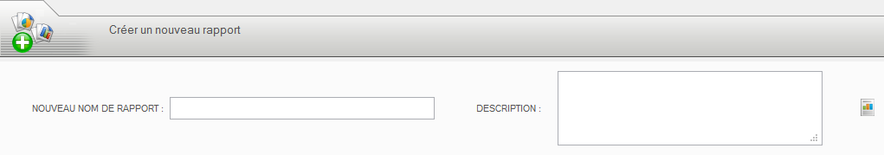
This tab allows you to create a new report..
Enter the name of the new report and a description (optional). Click the icon to the right to create the script.

Importing reports

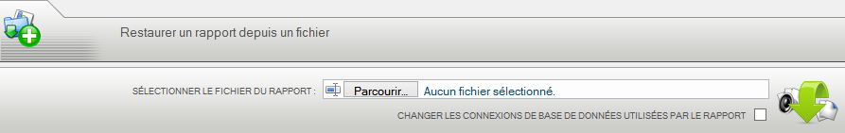

This tab allows you to import a saved report. The extension of the file to be imported must be “RDR”.

Choose the file on your disk ". RDR", then click the icon to the right.

The box "Changing database connections used by the report" check box allows you to replace the connections used by the report by other connections configured by your administrator. Beware, if the tables and columns do not exist, they will not be recreated.

Creation interface

Overview of the general interface

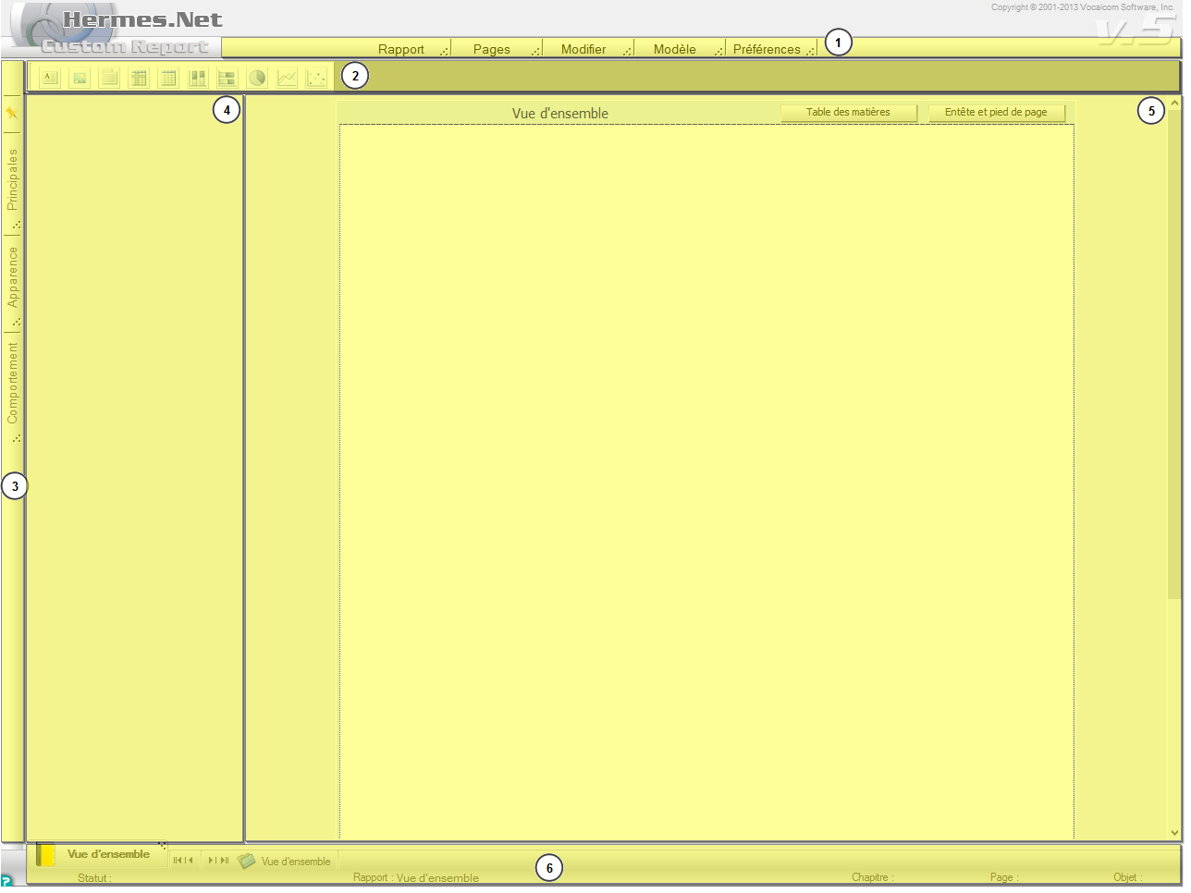

Menus
Provides access to the various actions of the interface. Each menu can be displayed in the Menu Bar (2) by clicking the icon to the right of the menu.

The Menu Bar
Reserved for user menus location.
Click on the Menu bar allows you to choose menus in it.
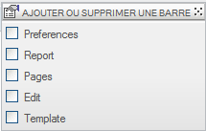
Right click on a menu bar menu to select the items displayed in it.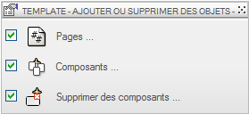

By dragging a menu bar menu icon , in the main area (5) You can remove the menu from the menu bar to make a popup:
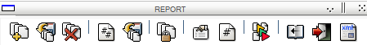

Object Properties Tab
Lists tabs to access different groups of object properties.
The icon / allows to display or not the area properties (4). If the zone is hidden popups properties will open over the content of the page (5) and will close automatically when they are no longer used.

Area properties
Reserved for groups of objects opening area properties.

Report Page
Display area of ​​the page being

List and chapter selection, Statutes, and other information
Icons used to move the chapter list if it cannot be displayed in its entirety because of too many chapters.

The first tab of the list to return to the editing of the report cover interface. Others provide access to the editing interface of the corresponding chapter.

Menus
The following screens are represented all active items. Activation of items depends on the current state of the interface.
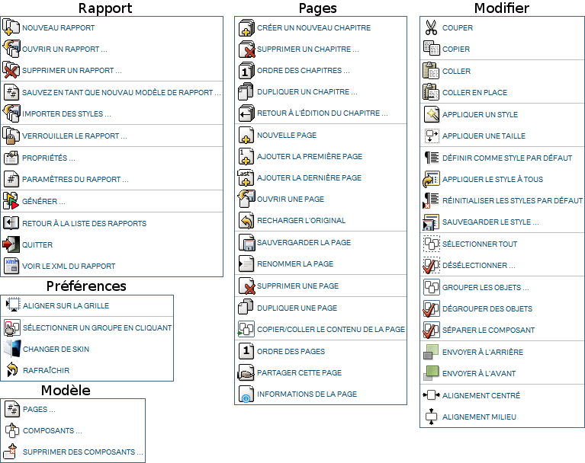

Menu Rapport  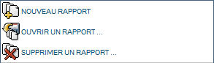  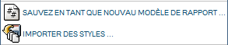  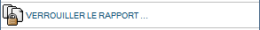  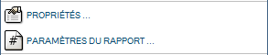  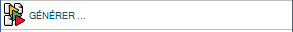  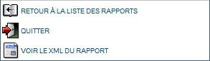 | Nouveau rapport  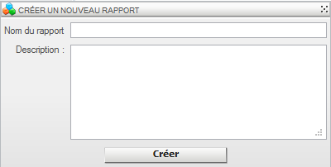 Allows you to create a new report. Enter a name and description (optional).  Ouvrir un rapport  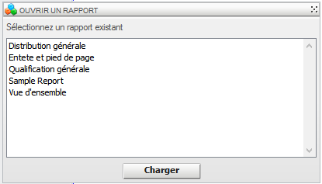 Select the report to open, and then click Load  Deleting a report  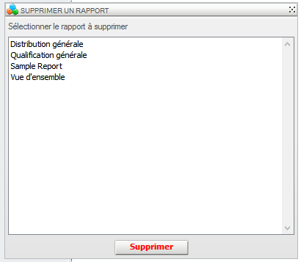  Select the report you want to delete and click "Delete." A confirmation is requested. It is possible to select multiple scripts to delete a single command. For this, use the CTRL key while clicking on the names of scripts to remove.  Save as a new report template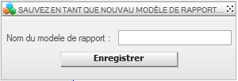  Enter the name of the new template, and then click Save.  Importing style  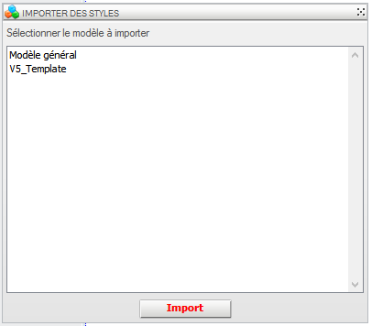  Select the style you want to import and click Import  Lock report  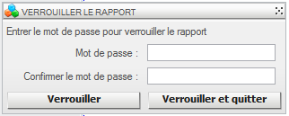  To lock a report with a password. You can simply lock the report or lock and exit the report.  Properties  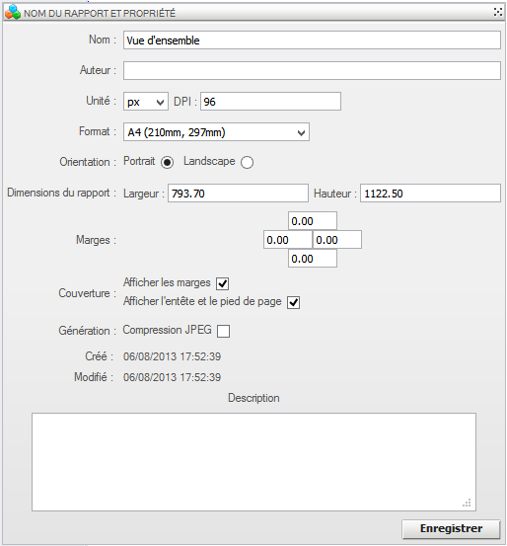Allows :  - • Rename the report  - • Add the name of the author  - • Change the unit of measurement of the  - • Change the format of the report. Either using the list of predefined size (A4, A3, B5 ...) or manually by setting the height and width  - • Change the orientation of the report (landscape, portrait)  - • Set margins report  - • Choose whether to display the margins and header and footer on the report cover  - • To enable compression of images  - • Add / modify the report description  Report Parameters  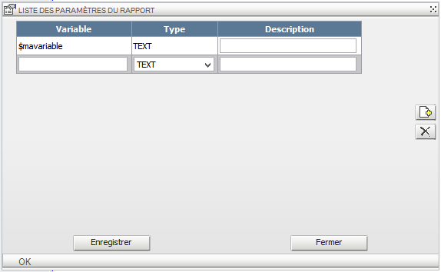  Sets global variables that can be reused in the report objects.  The name of each variable must begin with the character "$", a type must be selected in the "Type" list. A description can be added.  The value of the variable will be required when generating / planning report.  Generate  Link interface generation Reporting module.  Back to list of reports  Return to the list of reports  Quit  Quit the application and close the browser  View XML report  Displays the source of the report in XML format in a new window.
Menu Pages  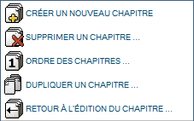  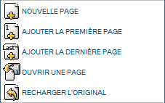  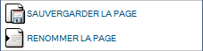  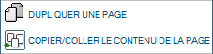  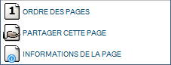 | Create a new chapter  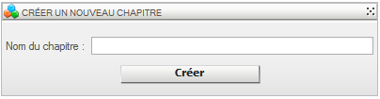  Enter the name of the chapter and then click Create  Delete Chapter  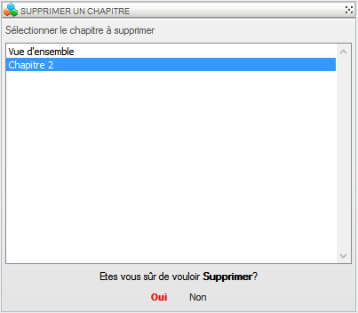  Select the chapter you want to delete and click Yes. You cannot delete a chapter if it is the only chapter of the report.  Chapter order  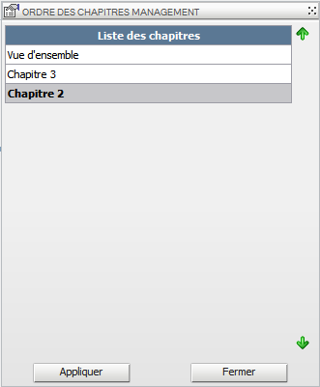  Allows you to change the order of chapters using the arrows (right). Once the order is changed, click Apply.  Duplicate chapter  To duplicate the section being edited.  Back to editing the chapter  When editing a page, to return to the home page of the chapter.  New page  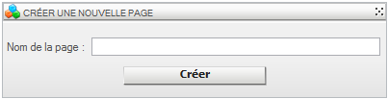  Enter the name of the new page to be created in the current chapter, then click "Create"  Add first page  Add the cover page of the current if it does not exist chapter.  Add the last page  Adds the end of the current page if it does not exist chapter.  Open a page  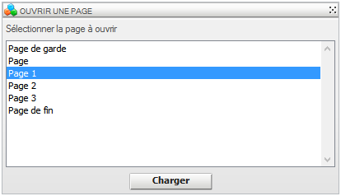  Select the page to open from the list of pages in the current section, then click "Load"  Reload original  Reload the page in the status of the last backup.  Save the page  Rename the page  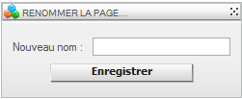  Enter the new name of the current page, then click "Save"  Delete a page  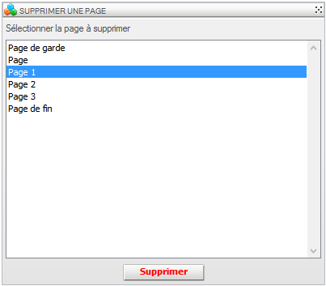  Select / pages to delete and click "Delete." A confirmation will be requested.  To select multiple pages, use the mouse and click the CTRL key on the keyboard.  Duplicate a page  Duplicates the page being edited  Copy / Paste the contents of the page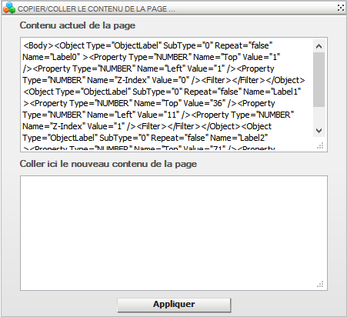  Is intended for advanced users.  To change the source code of the script page.  Page order  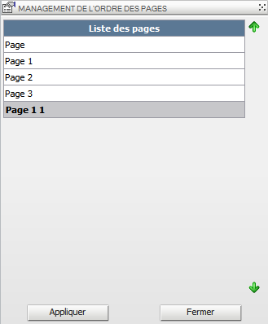  Allows you to change the order of pages of current chapter (with the exception of the cover page and end page) using the arrows (right). Once the order is changed, click Apply.  Share this page  Allows you to share the page being edited to use it in another report.  Information Page  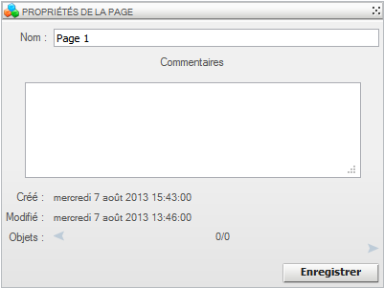  Allows you to change the name of the page and add comments.  Gives the date created, date last modified, and the list of objects on the page.
Edit Menu  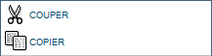  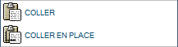  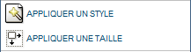  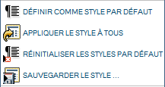  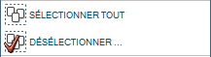  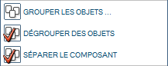  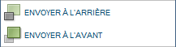  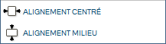 | Cut  Removes the object and places it in the clipboard.  Copy  Copies the selected object to the clipboard.  Paste  Inserts the contents of the clipboard into the current page. Place the glued above the copied object.  Paste in Place  Inserts the contents of the clipboard into the current page. Place the object stuck in the same place as the copied object.  • The objects of the clipboard can be copied from one page to another.  Applying a style  Can apply only copied the style of the selected object.  Sizing  Can apply only the size of the copied object to the selected object.  Set as default style  After selecting an object, click on this item. All subsequently created objects have the same style as the original.  Apply style to all  Allows affected the default style to all objects of the same type on the page.  Reset Default Styles  Cancels the default style  Save the style  Saves the style selected for reuse later object.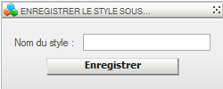  Enter the name of the style to save, then click "Save"  Select all  Selects all objects on the page  deselect  Deselect selected objects.  Grouping objects  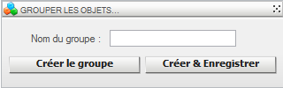  Allows you to create a group of objects. This group can only be created in the page: click "Create Group" or "Create & Save" for future use in another page or another report, then we'll talk component.  Ungroup objects  Ungroup the objects in the selected group.  Separate component  Ungroup the selected component.  Send to Back  Away from the foreground object. Is equivalent to the z-index property of the object (z-index-1)  Send to front  Returns the object in the foreground. Is equivalent to the z-index property of the object (z-index 1)  Centered alignment  Vertically aligns the selected objects (changes ownership "Left" objects).  Alignment medium  Horizontally aligns the selected objects (change "Up" object property).
Model Menu  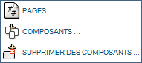 | Pages  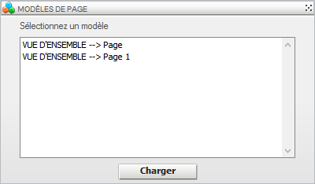  Allows you to import a page from another report. Pages available in this screen are the pages that have been saved with the "Share", see Menu page.  Components  To import a component that was saved, see Edit menu.  Remove Components  Deletes one or more components. See Edit Menu.
Preferences Menu  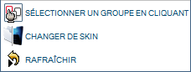 | Snap to Grid  Allows you to place objects on a virtual grid  Select a group by clicking  To select a group of objects predefined by clicking on one of the objects in this group.  Change skin  Refill the interface with the other skin (Light / Dark).  Unsaved changes will be lost.  Refresh  Charging interface, any unsaved changes will be lost.

Interface edition cover
The editing interface of the cover of the report is the same as the page editing interface (3.5).
Nevertheless, it allows you to configure the table of contents and the header and footer of the report

Table of Contents

By clicking on the "Table of Contents" button you can configure the table of contents to be displayed on a page just after the report cover.
When the configuration interface of Contents is started, just click on "Activate Contents"
Then the configuration is done using the properties (left area) of the object table of contents in the way of any object.

Once setup is complete, click "Back to Report"

Headers and footers
By clicking on the "Header and Footer" you can configure the header and footer that will be displayed on all pages of the report.
When the configuration interface of Contents is started, just click on "Activate the header" and "footer Enable" to enable the desired section.
Once activated, each section can be resized with the delimitation of the bar section.
Once setup is complete, click "Back to Report"

Edition Chapter Interface
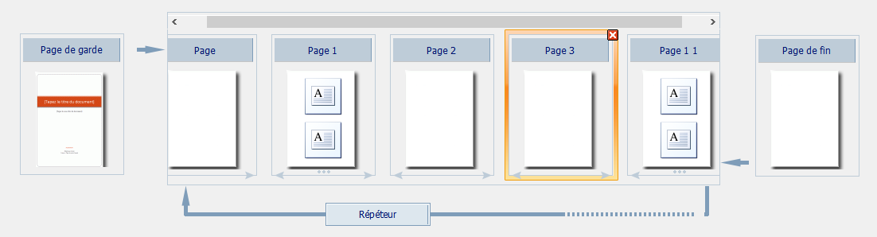
All pages of the chapter is shown to have a simplified overview of the content of the chapter.
Each page is selectable. When clicking on a page, the popup opens containing its properties. We can then change the name of the page, and add comments. Information creation date, modification date, and list items are displayed.
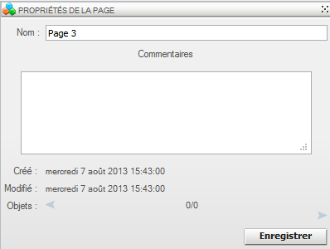

When a page is selected, it may, with the icon, delete it. A confirmation will be requested.
You can change the order of pages (excluding title page and end page) using icons.
When double-clicking on a page, the user is redirected to the edit page interface.

Configuring the Repeater
By clicking on the "repeater" button, the user will have access to popup configuration repeater.
In this popup you can configure the columns on which the pages of the chapter will be repeated, and filters for values.

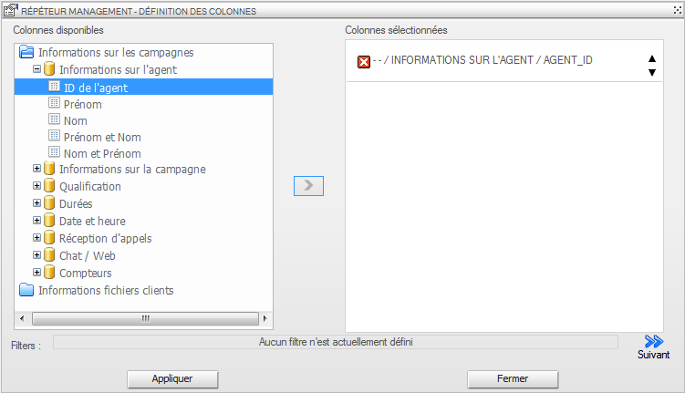
Refer to Appendix 1 for the selection of columns.
To go to step filter configuration, use the button
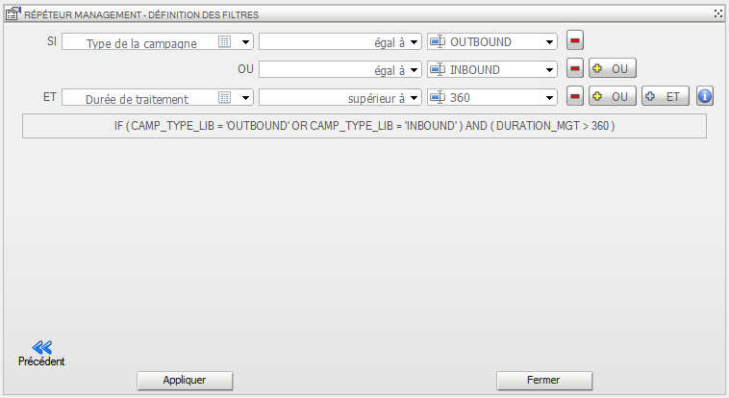
Refer to Appendix 2 for the filter configuration

Editing Interface page
The main difference with the editing interface of the cover page of the report is the presence of the navigation bar in the chapter on the right of the interface.
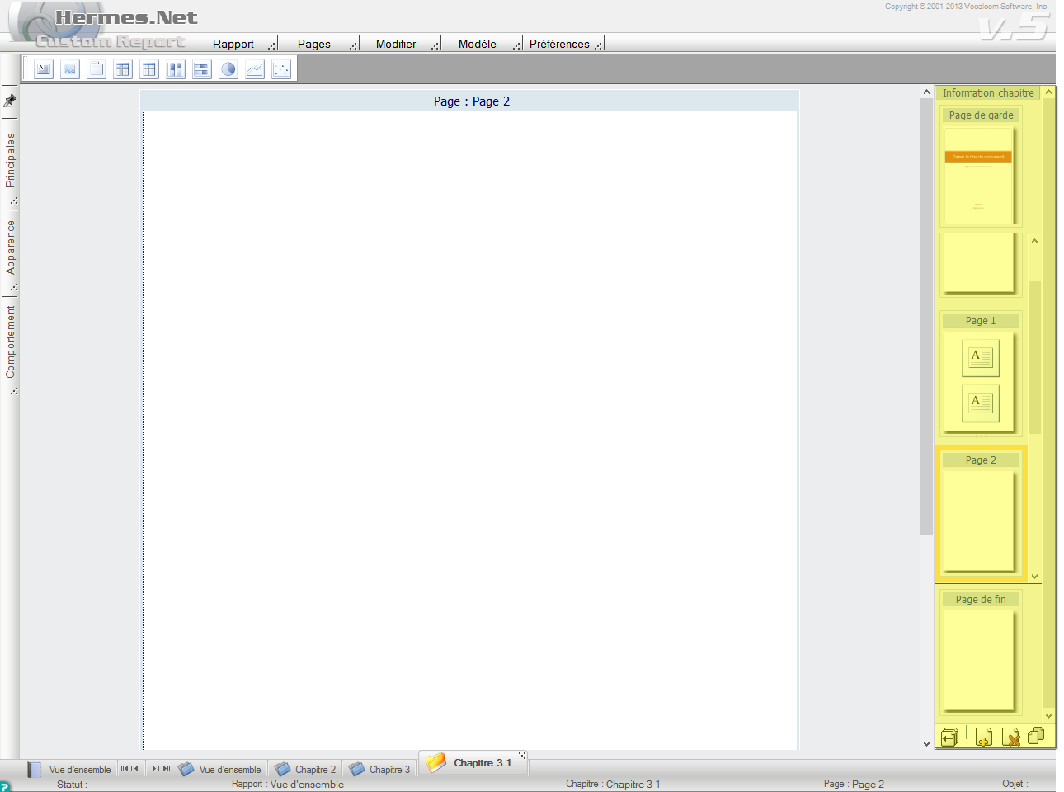
To change the page click on the thumbnail of the page.
You can return to the editing interface by clicking chapter or
The toolbar at the bottom of the navigation bar contains menu items of Pages:
• Back to editing the chapter
• New page
• Delete a page
• Duplicate page Voir 3.2.2 Menu Pages

Objects

You through the menu bar
add objects to the pages of your report.
Two families of objects are available: The "static" and "connected" objects.
The connected objects are configurable via wizards accessed either by double-clicking the object or by clicking on the icon .

Texte (Statique)

Allows you to display text in a page.
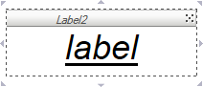

Image (Static)

Allows you to display an image on a page.

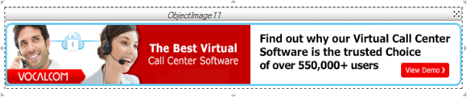

Panel (Static)

Displays a "zone" in a page.
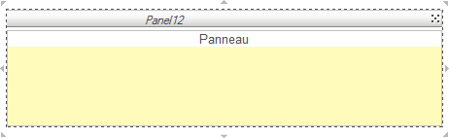

PivotTable (Connected)

Used to generate a summary of the selected columns crossing, and add a row and a column calculation.

The operation result of crossing will always sum.
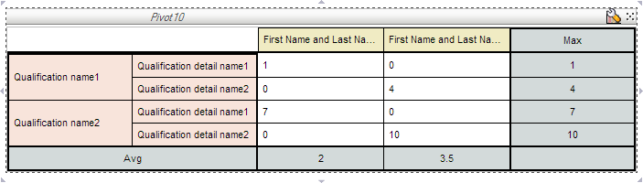

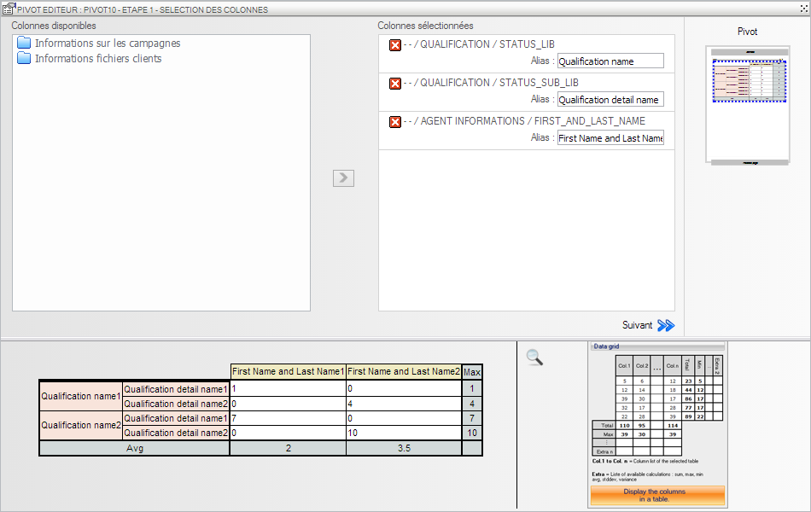
Refer to Appendix 1 for the selection of columns.
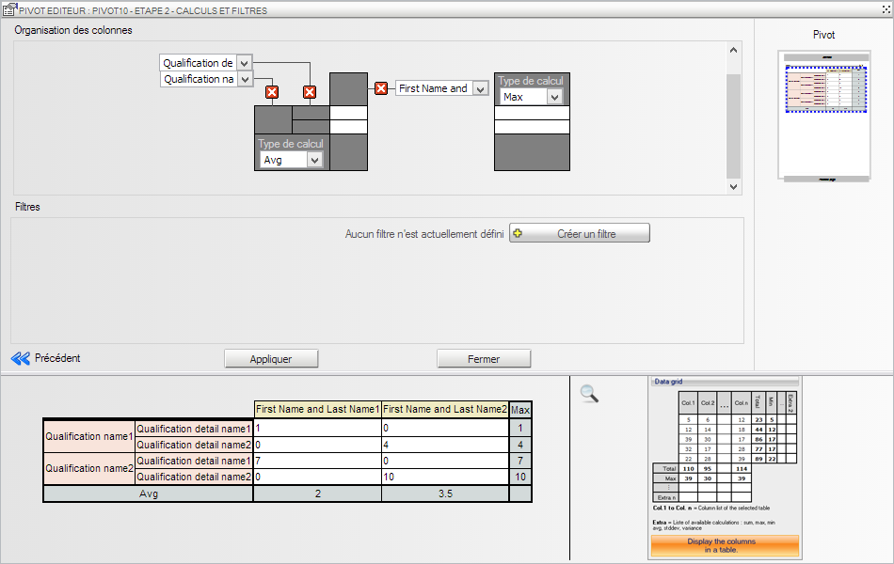
Refer to Appendix 2 for the filter configuration.

Vous pouvez changer l'emplacement des colonnes à l'aide de :
- To move line to column and column line.
- The drop-down lists to sort columns in each section.

You can change the type of calculation rows and columns using the drop-down list.

Table (Connected)

Can display tabular form the values ​​of one or more columns and add calculation functions grouped by rows or columns.
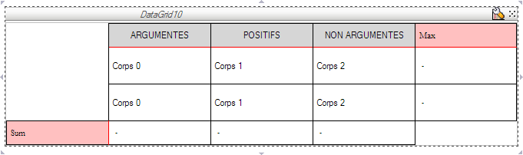

Step 1: Select the columns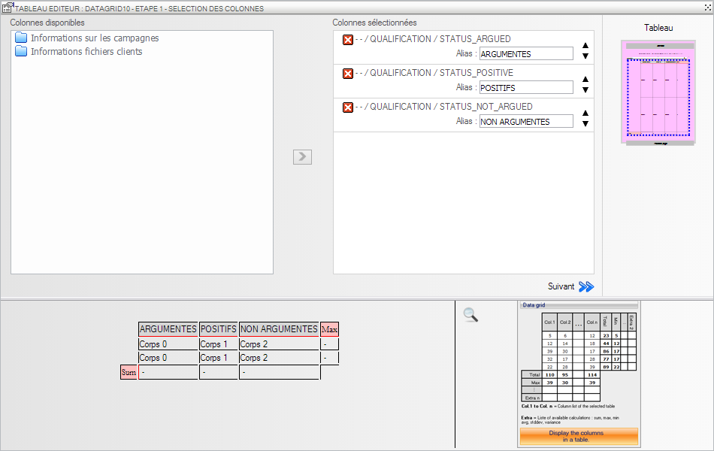
Refer to Appendix 1 for the selection of columns.

Once all of your selected columns, click on "Next" to access the configuration of the types of calculations and filters.

Step 2 configuration calculations and filters: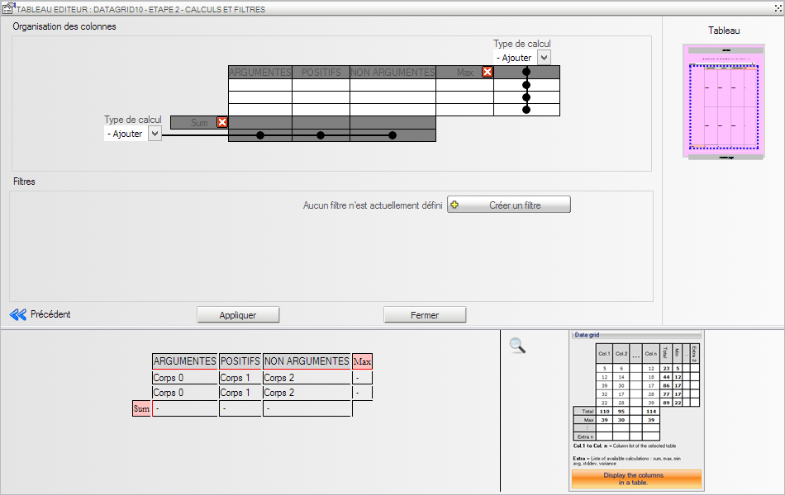
Refer to Appendix 2 for the filter configuration.

You can add rows and columns of calculations using drop-down lists.
To delete a row or column calculation, click

Vertical bar graph (Connected)

Can display as vertical bars the values ​​of one or more columns.

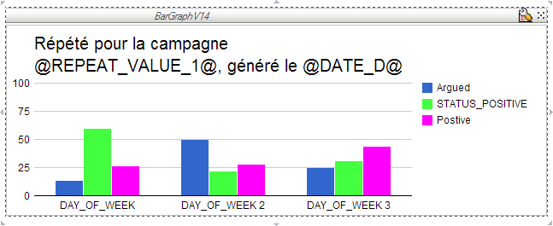

Step 1 Select the columns.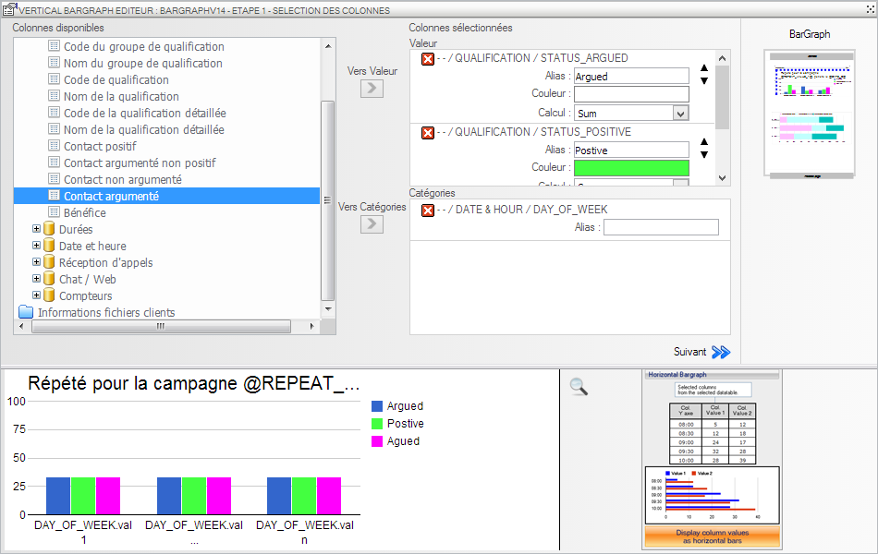
Refer to Appendix 1 for the selection of columns.

You can select multiple values ​​and a single category.
The category used by grouping column. This means that there will be as many groups of values ​​of values ​​for the input column as category
Step 2 Configuring filters.
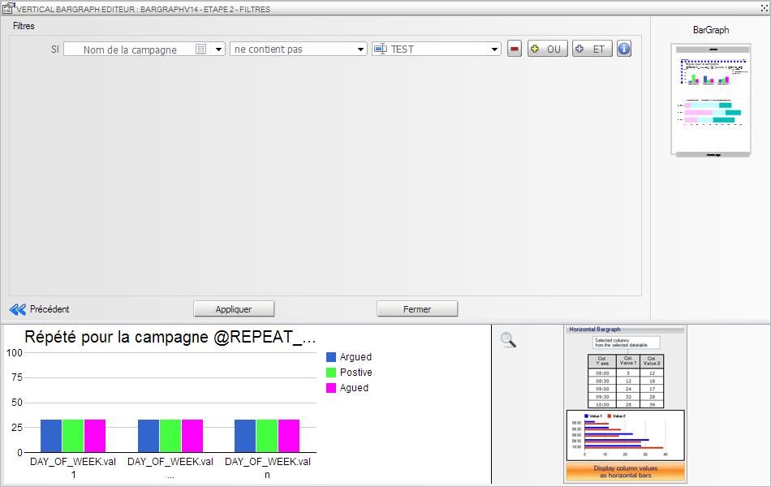
Refer to Appendix 2 for the filter configuration.

-  Horizontal bar graph (Connected)

Can display as horizontal bars the values ​​of one or more columns.

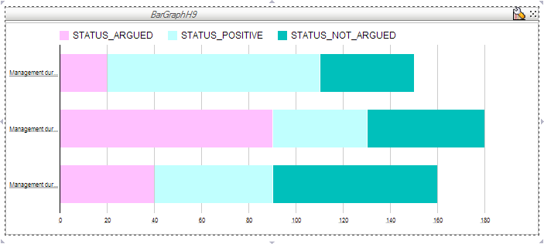

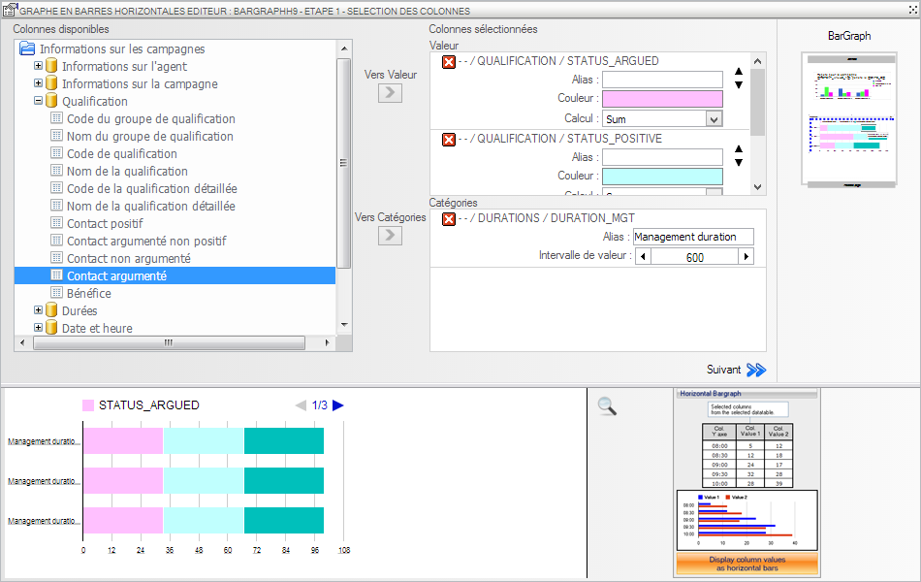
Refer to Appendix 1 for the selection of columns.

You can select multiple values ​​and a single category.
The category used by grouping column. This means that there will be as many groups of values ​​of values ​​for the input column as category
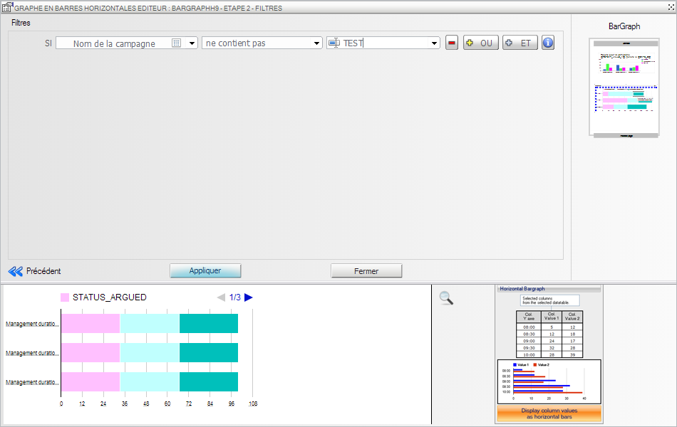
Refer to Appendix 2 for the filter configuration.

Pie chart (Connected)

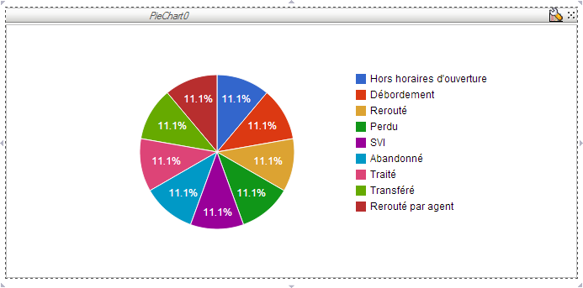

Two types of pie charts are available.

• Type 1 displays as pie segments, the contribution of a value to a sum. To do this, the user selects X columns from one or more tables. He chose to make the contribution which model (sum, max, min, etc..).
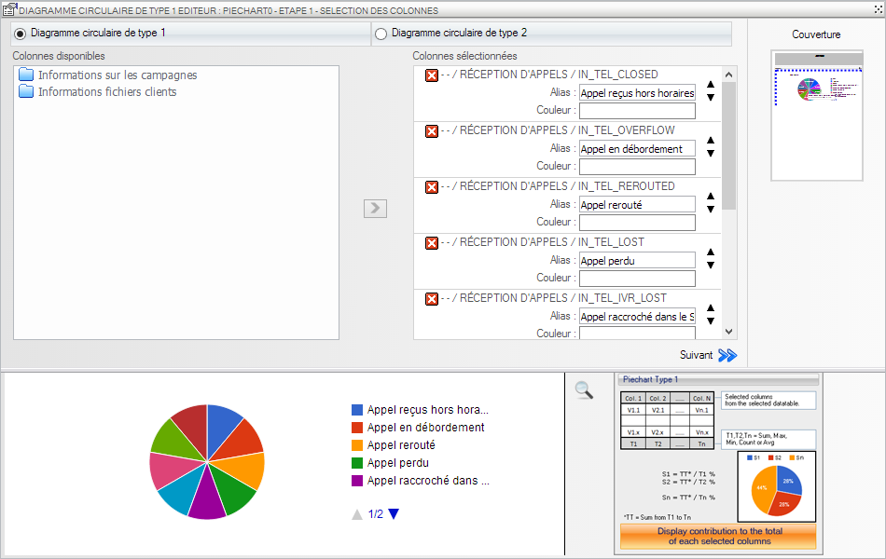
Refer to Appendix 1 for the selection of columns.
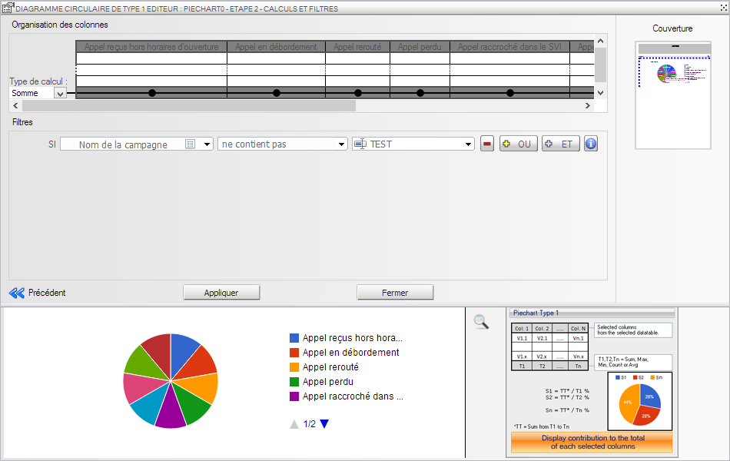
Référez-vous à l'annexe 2 pour la configuration des filtres.

• Type 2 displays as pie segments, the contribution of distinct values ​​selected, the sum of the series series. To do this, the user can select at most two columns in one or more tables.
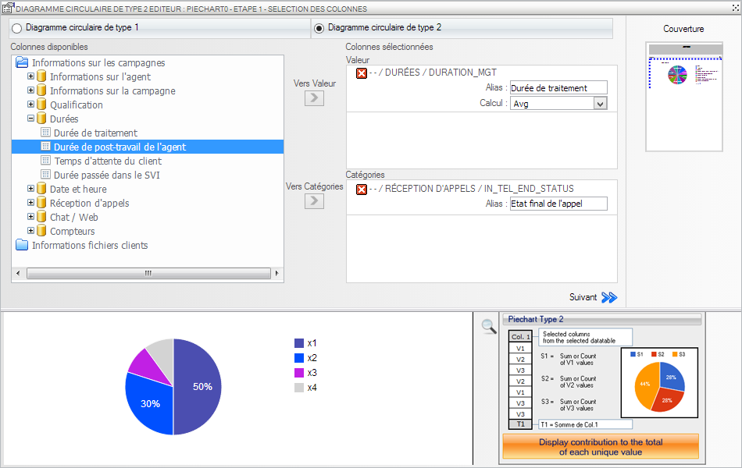
Refer to Appendix 1 for the selection of columns.

You can choose only one value and only one category.
The category used by grouping column.

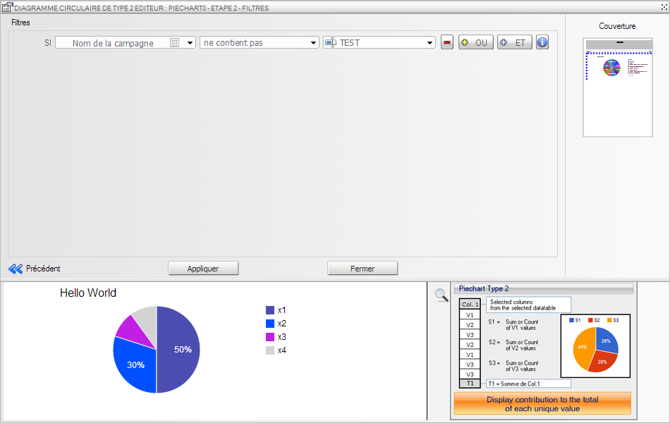
Refer to Appendix 2 for the filter configuration.

Curve (Connected)

Can display as curves the values ​​of one or more columns.
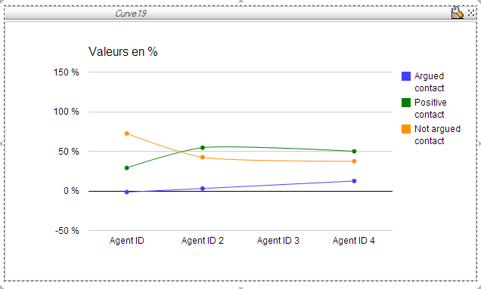

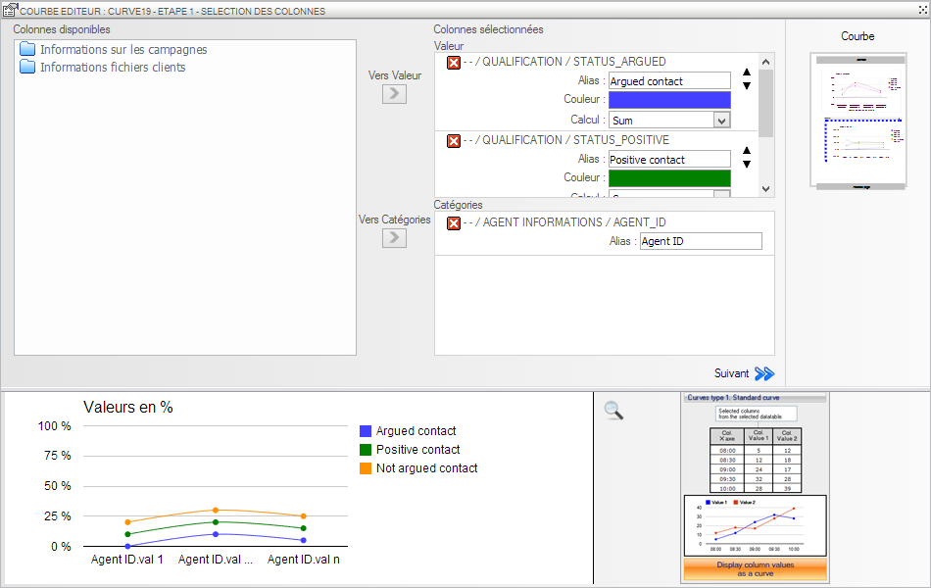
Refer to Appendix 1 for the selection of columns.

You can select multiple values ​​and a single category.
The category used by grouping column. This means that there will be as many values ​​for each curve values ​​for the input column as category
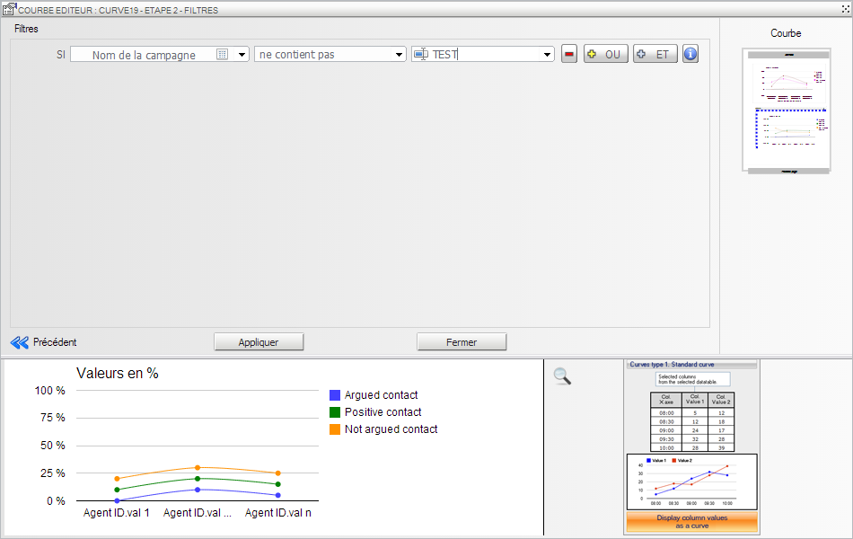
Refer to Appendix 2 for the filter configuration.

Scatter (Connected)

Allows displayed as scatter values ​​of one or more columns based on another column values.
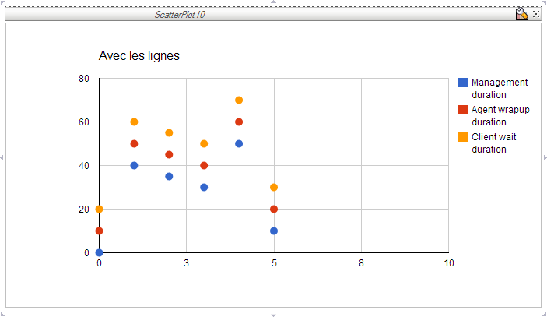

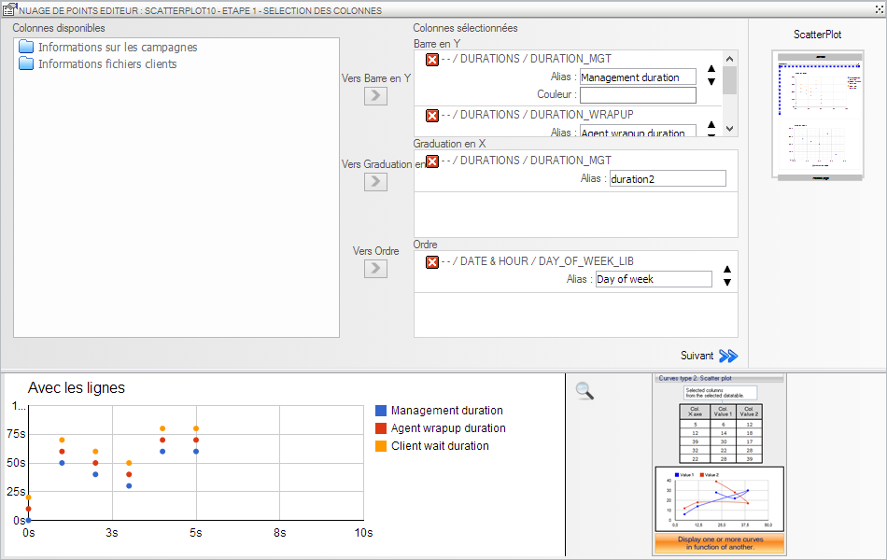
Refer to Appendix 1 for the selection of columns.

You can select multiple values ​​and a single category.
The category used by grouping column. This means that there will be as many values ​for each scatter plot of values ​​for the input as a category column.

You can input columns to specify the order of points.
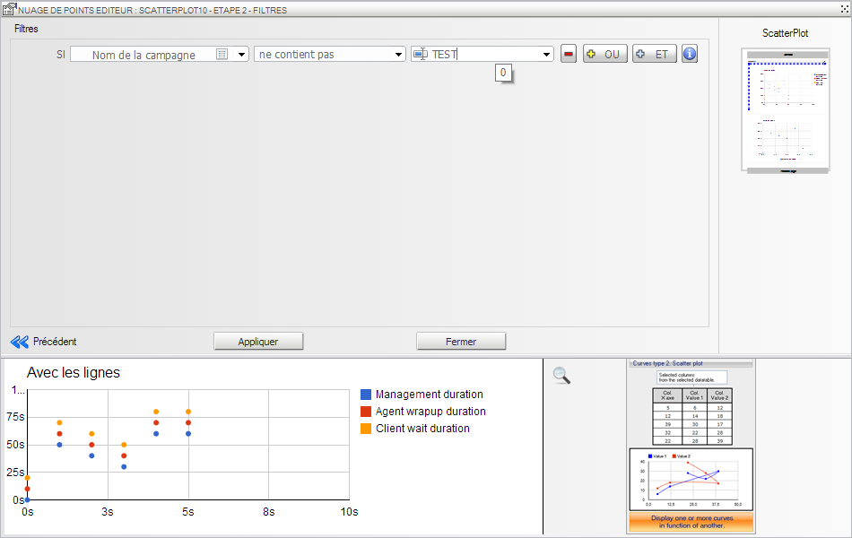

Property Management
When an object is selected, the properties tabs are dynamically loaded to configure the properties of the object.

Click on a tab to display the popup configuration properties in this tab.

Properties can be of different types:
- Free field

Manually enter the value of the property.

Button opens a popup with a larger area of ​​seizure.
In this popup you can insert global variables report using the predefined list.
Enter the variable to insert and then click the button to add the variable in the input box at the cursor location.

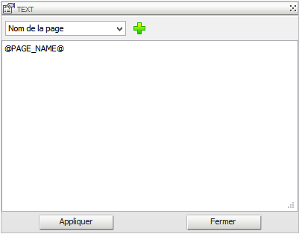

- Selection list

Allows you to choose the value of the property from a list of predefined values

- Selection list + Free Field
Allows you to choose the value of the property from a list of predefined values ​​or enter the property value manually
- Numerical

Captures the value of a numeric property
By clicking on the buttons you can decrease / increase the value of 1.

Pressing and holding the CTRL key and clicking on the button you can decrease / increase the value of 10 key.

The property value must be numeric greater than 0.
- Colour picker

Captures the value of a property of type color.

The value must be of the hex code (black: # 000000)

Button opens a popup visual color selection.
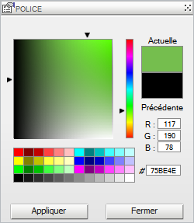

- Checkbox

Active ownership when the box is checked.

- Image

Allows you to choose the value of a property of type Image using the popup selection / import image.

Click to open the popup.

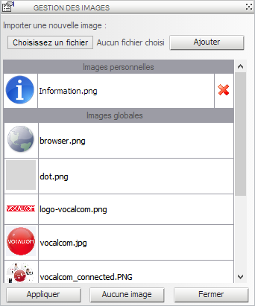

In this popup you can choose to import an image from your hard drive, or use an already imported image.

The image list contains two sections:

• Personal Images
Corresponds to imported by a user of your company image.
You can delete an image of these images by clicking on the button .

Caution! If you delete an image used in another report, then the image will no longer exist in the other report.

• Global Images
Match the pictures provided by Vocalcom. You cannot delete these pictures.

Click on an image to the selected, and then click Apply to assign the image to the property.
By clicking on the "No Image" button you can delete the value of the property.

Annexes

1. Select columns in wizards

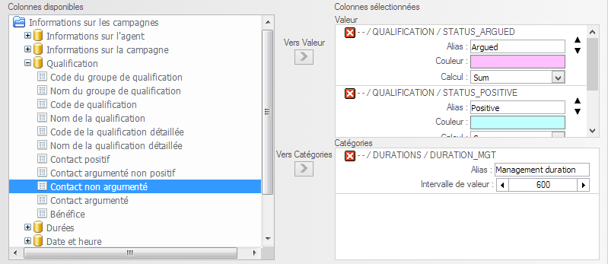
Available columns are divided into two groups:
- The Information campaigns
- Files Customer Information

The selected columns will be divided into one section to n according to the wizard.

Once selected in the left pane, use the button to assign this column repeater / the value / the class / etc.

You can enter an alias for the selected column. If no alias is entered, the technical name of the column will be displayed during the generation.

Depending wizards you can:
• Sort columns through icons.
• Choose a color for the column.

Click the field to open the popup color selector.
• Select the calculation to be performed on the column from the list.
• Select the date format (for columns of type date) from the list.
• Select the aggregation interval values ​​(for numeric columns).

The values ​​found in the database will be rounded to the beginning of the interval in which they are located. Example: 17 with an interval of 5 will be rounded to 15.

To delete a column in a section, use the button

2. Configure filters in wizards

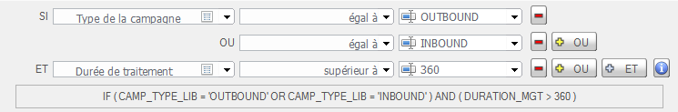
Enter the column on which you want to apply a filter, then choose the filter operator from the list, then enter the values.

To remove a filter click

To add a filter on the same column you can either click on the button and enter a new operator and a new value, or click and regroup column operator and value.

If you click on the button , one of the conditions is required for the filter group.
If you click on the button , conditions must all be met.

To view a summary of all the filters click

