Table des matières
1. Hardware Architecture diagram 3
2. Network Architecture diagram 4
a) Current Architecture 5
b) Next architecture 6
3. Data Architecture diagram 7
4. Application/Database diagram 8
5. A complete inventory of all applications, including business owner()s), versions, user counts 9
6. Shared drives (if available) 12
7. Mailing groups(internal/external) 13
a) Internat Distribution List 13
b) External distribution list 13

Hardware Architecture diagram
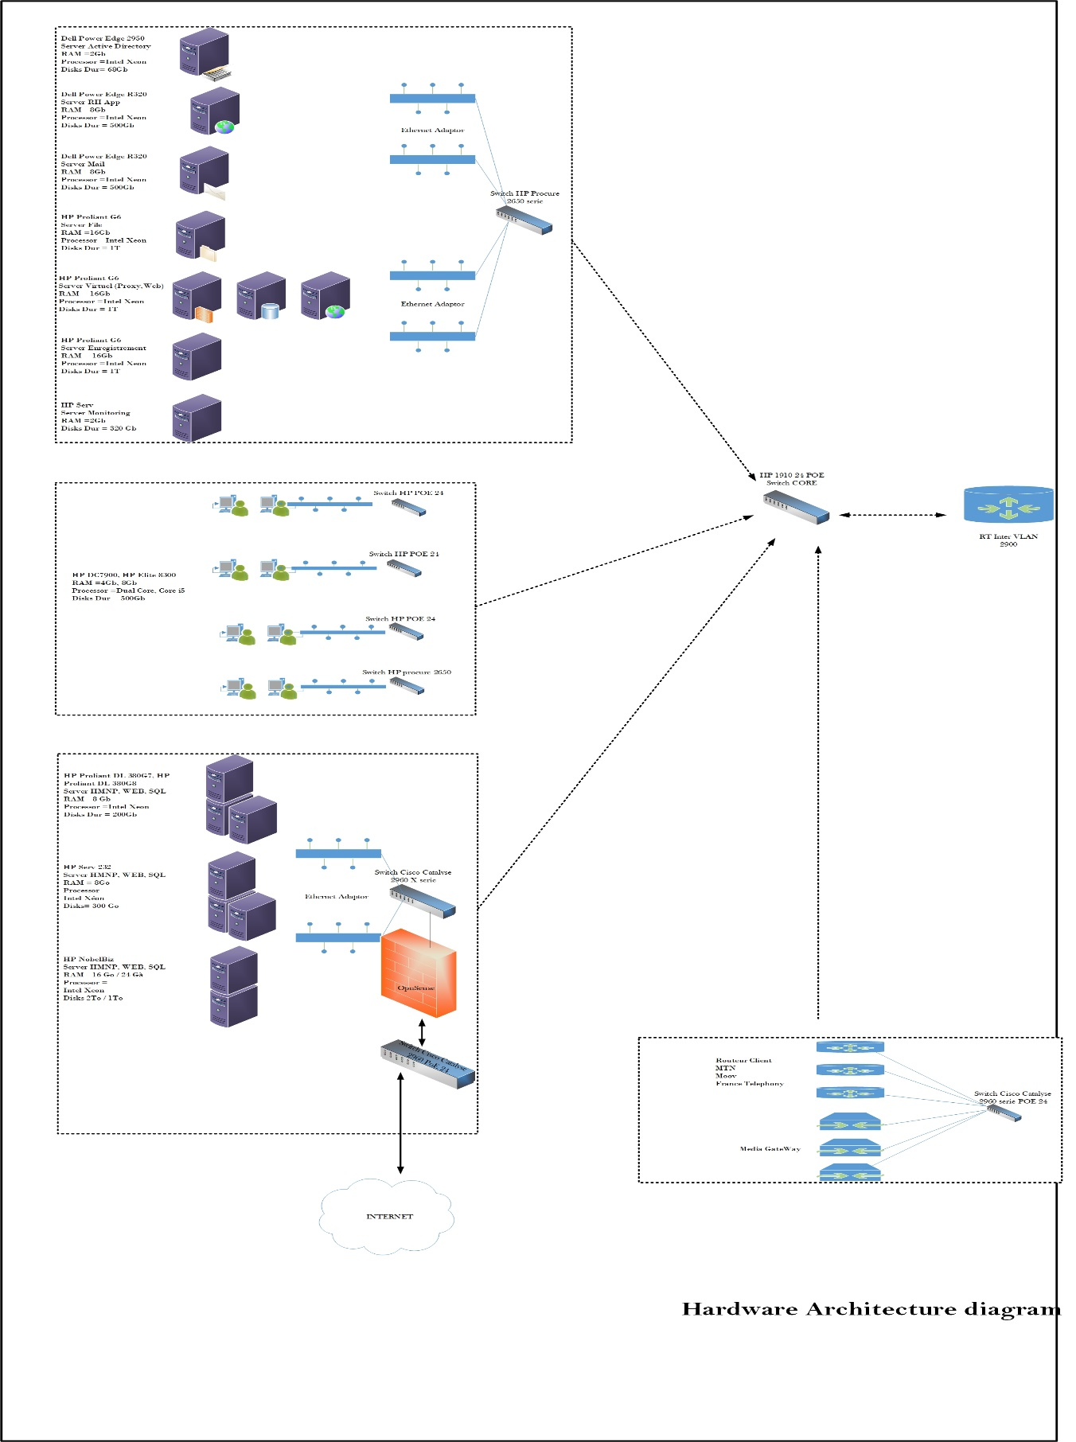

Network Architecture diagram

Current Architecture

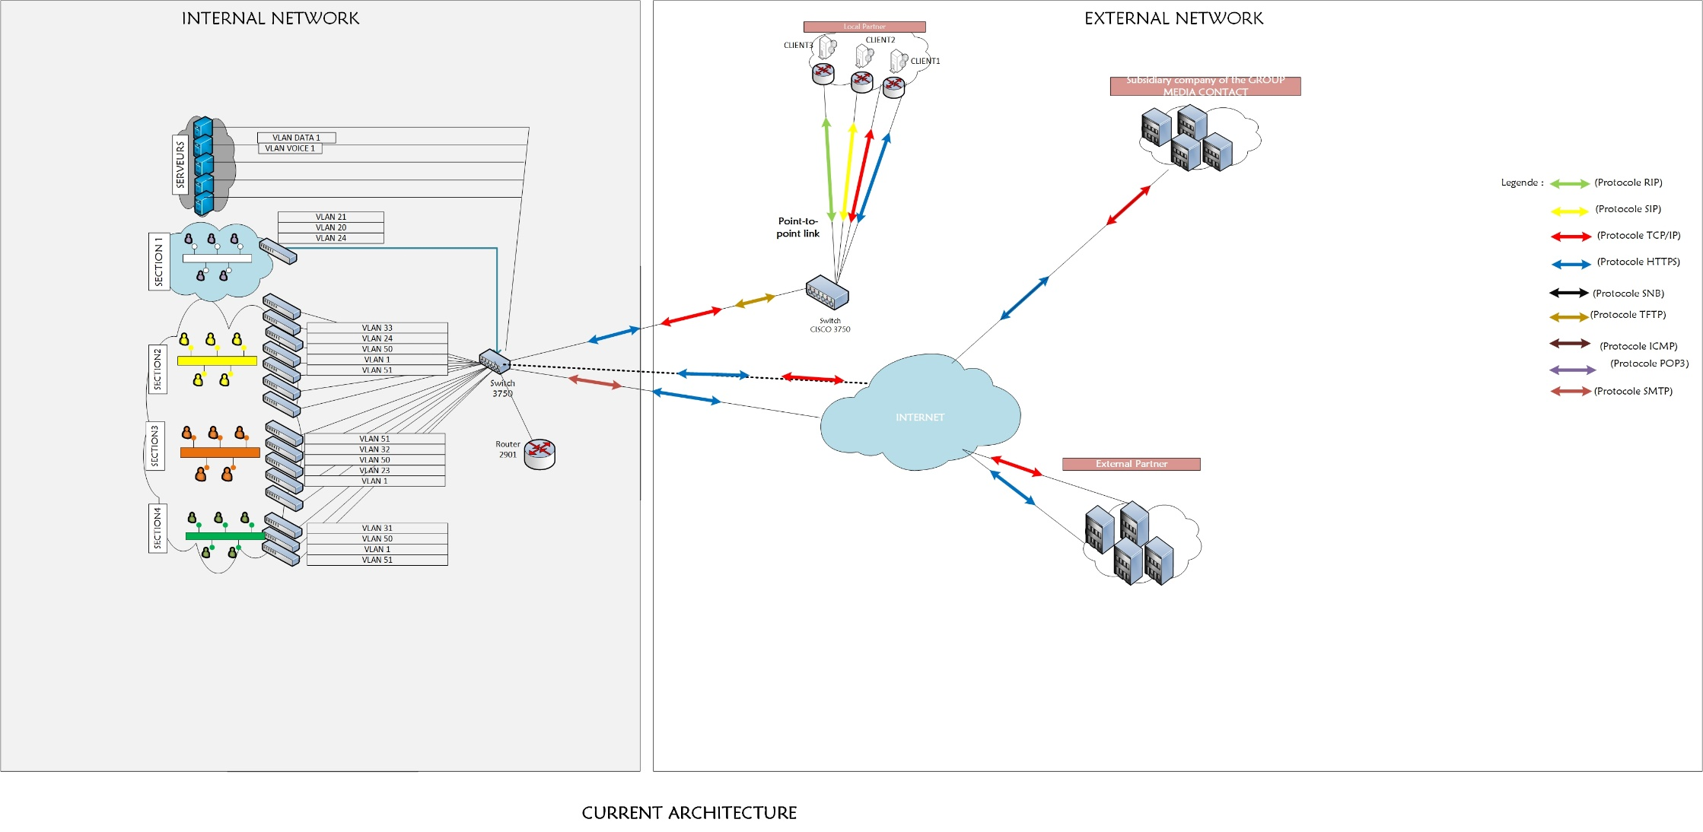

Next architecture
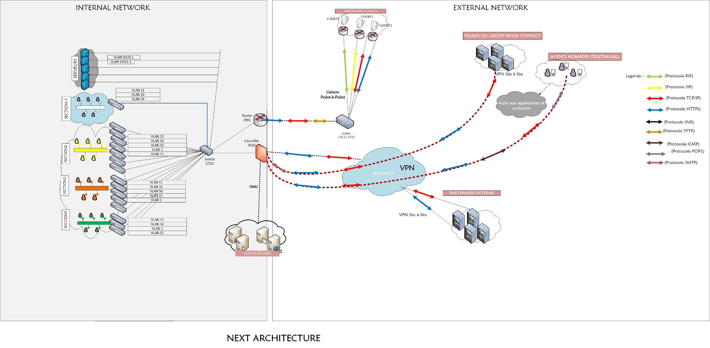

Data Architecture diagram

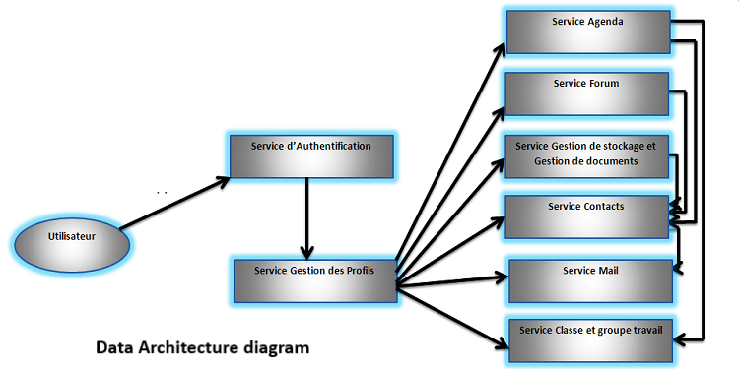

Application/Database diagram

The databases of the different applications are housed on two servers
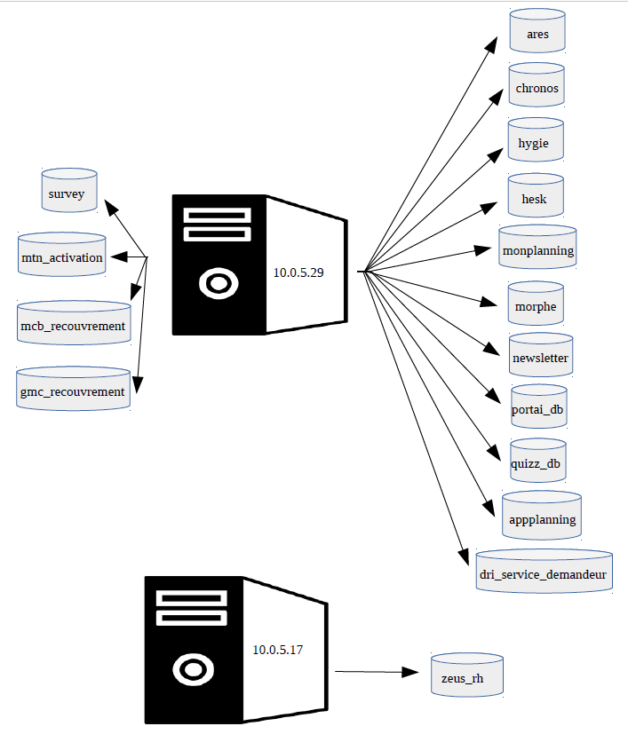

A complete inventory of all applications, including business owner()s), versions, user counts

Business Applications Name | Business Owner | Number of users | Version
Quizz | ALL departments | 449 | 1.0
Performances Employés | Human Resources Department | 7 | 1.0
SURVEY | ALL departments | 449 | 1.0
ARES | QUALITY Department | 14 | 1.0
PLAYSMS | Management information systems | 5 | 1.0
INTRANETGMC (SELF SERVICES) | ALL departments | 449 | 1.0
BACKOFFICE GMC | Operations Department | 294 | 1.0
HYGIE | INFIRMARY | 2 | 1.0
DRI SUPPORT | Research and Development Department | 449 | 1.0
DSI SUPPORT | Management information systems | 449 | 1.0
INSTANCES DE RECOUVREMENT | Financial and Accounting Department | 4 | 1.0
DRI SERVICE DEMANDEUR | Research and Development Department | 449 | 1.0
ZEUS RH | Human Resources Department, Financial and Accounting Department | 7 | 1.0
GESLOGI GMC | SERVICES GENERAUX | 449 | 1.0
MORPHE | Programs Department, Operations Department | 294 | 1.0
NEWSLETTER | Marketing and Communication Department | 449 | 1.0
GesAbsence | Operations Department | 294 | 1.0
GesChargesEX | Financial and Accounting Department | 4 | 1.0
Microsoft SQL serveur 2008 | For CRM | 3 | Standard
Microsoft SQL serveur (Standard) | For CRM | 2 | Standard
Microsoft Windows 7 | Application | 1 | SP 3
Microsoft Windows 7 | Users | 150 | SP 3
Microsoft Windows 8 | users | 1 | Home
Microsoft windows 10 | Users | 150
Microsoft Exchange 2010 | ALL | 68 | Standard
HERMES.NET (CRM) | Operation departement  Qualite department | 160 | 5.5
SAGE | Finance Departement | 5 | -
PERFECTO | Finance departement | 5 | -
CACTI | IT | 5 | 1.2.2
ZABBIX | IT | 5 | 5.0
LibreNMS | IT | 5 | -

Shared drives (if available)

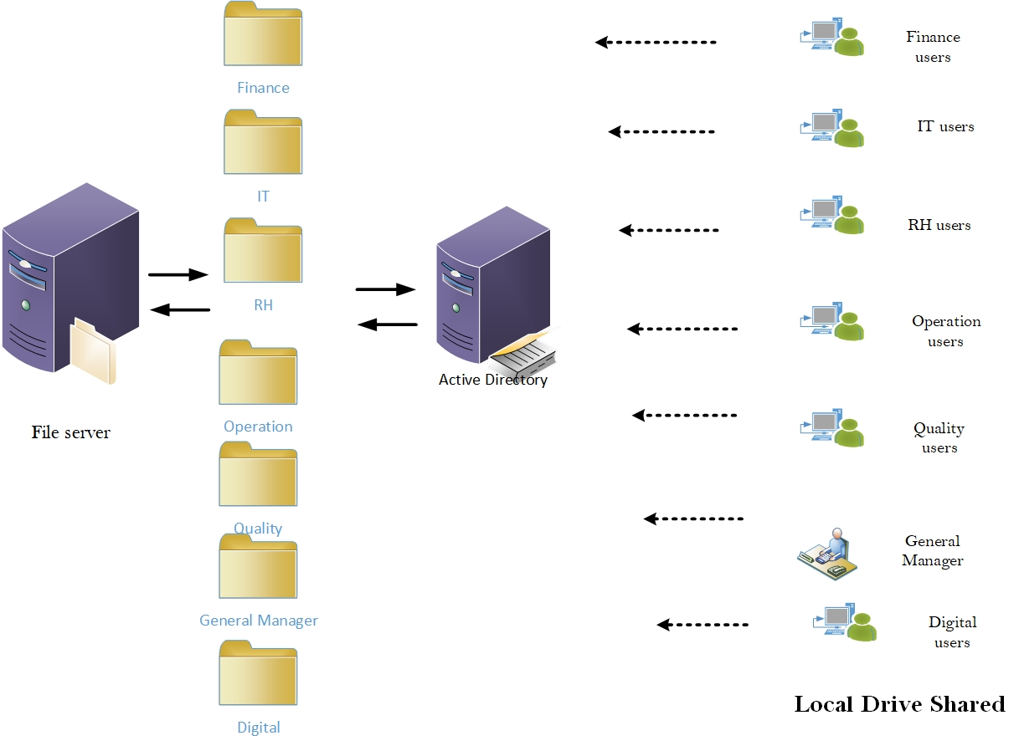

Mailing groups(internal/external)

Internat Distribution List
INTERNAT DISTRIBUTION LIST
Name distribution list | MAIL ADRESS
GMC CODIR BENIN | codirmcb@benin.groupmediacontact.com
GMC RESSOURCES HUMAINES BENIN | ressourceshumaines@benin.groupmediacontact.com
GMC OPERATIONS BENIN | operation-benin@benin.groupmediacontact.com
GMC QUALITE BENIN | qualite@benin.groupmediacontact.com
GMC SUPPORT-IT BENIN | support@benin.groupmediacontact.com
GMC RECRUTEMENT | recrutement@benin.groupmediacontact.com
GMC_DIRECTION_PROGRAMMES BENIN | direction-programme@benin.groupmediacontact.com
GMC_DIRECTION_PROGRAMMES | direction-programme-gmc@benin.groupmediacontact.com

External distribution list

EXTERNAL DISTRIBUTION LIST
NAME OF DISTRIBUTION LIST | MAIL ADRESS
GMC CODIR GROUPE | codir-gmc@groupmediacontact.com
GMC RESSOURCES HUMAINES GROUPE | rh-gmc@groupmediacontact.com
GMC OPERATIONS GROUPE | operation-gmc@groupmediacontact.com
GMC QUALITE BENIN | qualite@benin.groupmediacontact.com
GMC QUALITE GROUP | qualite-gmc@groupmediacontact.com
GMC SUPPORT-IT BENIN | support@benin.groupmediacontact.com
GMC SUPPORT-IT GROUP | support-it-gmc@groupmediacontact.com
GMC_RECHERCHES_INNOVATIONS GROUP | support-dri-gmc@groupmediacontact.com
GMC DAF BENIN | daf@groupmediacontact.com
GMC DAF GROUPE | daf-gmc@groupmediacontact.com
GMC DIGITAL NATIVE | communication-gmc@groupmediacontact.com
GMC ALL STAFF CAMEROUN | allmccam@groupmediacontact.com
GMC ALL STAFF BRAZZAVILLE | allmcbrazza@groupmediacontact.com
GMC ALL STAFF COTE D'IVOIRE | allmcci@groupmediacontact.com
GMC ALL STAFF CONAKRY | allmcgn@groupmediacontact.com
GMC ALL STAFF GROUP | all-staff-gmc@groupmediacontact.com

