



MTN RFP Response
BPO SERVICES FOR CONTACT CENTER MANAGEMENT FOR MTN GROUP

© Copyright 2020 NobelBiz, Inc. | All Rights Reserved

Table of Contents
Company Presentation and Profile 5
About US 5
Company History 5
Competitive Advantages 5
Present & Future 5
Numbers and Profile 6
Why NobelBiz 6
Global Presence & Subsidiaries 6
About NobelBiz Omni+ Cloud Contact Center Solution 6
Architecture and Integrations Highlights 7
Medias & Communication Highlights 7
Our Global Presence 8
Proposed Architectures 8
Omni+ Cloud AWS or Private Cloud 8
Omni+ Cloud AWS or Private Cloud with Redundancy 9
Omni+ Premise 9
Omni+ Premise with Redundancy 10
Omni+ Cloud with Centralized Synchronized Centralized CRM 10
Omni+ Cloud and Premise Hybrid Synchronized Centralized CRM 11
RFP Reference: 2.2.2.5 Outbound - Contact center 11
1. Outbound Calling Tools – Dialing Engine 11
Predictive Dialer 11
Preview Dialer 11
Automatic Preview 11
Progressive Dialer 11
Message Broadcast Blaster 12
RFP Reference: 2.2.2.8 Technology-Contact Center 12
Computer Integration - CTI 12
Automatic call Distributor (ACD) 12
Call Recording both voice and screen 13
Web chat, WhatsApp, Email management and social media 15
Integration of Call Center Platform with MTN Systems (CRM, etc) 15
Ability to prerecord welcome greetings in different languages. 16
2. Multi-Channel 16
3. Interactive Voice Response 17
Main Account Airtime Balance Checks Mobile Money balance and subscriber checks 17
Prioritised routing by segment based on agreed percentages 17
Language Storage / set preferred language feature support for all languages irrespective of the market 18
Proactive messaging to customers in instances where there are major service impacting failures 18
Blacklisting functionality 19
Should be able to allow all customer contacts across on different channels and should adequately handle any volume or spike in calls 19
Dynamic IVR; Provide customer their favorite selection as a first option to avoid customers listening to long menu’s 20
Support for surveys, and integration with current VoC solution 20
4. Service support with AI influence 21
IVR menu should be driven by AI analytics 21
Channel support must be driven by AI analytics 21
Proactive AI support through all channels 21
5. Storage and archiving 22
Support for 5 years offline storage of customer interactions history 22
Support of 1-year offline storage of call and video recording 22
Support of 1year online storage of all transactions 22
RFP Reference: 2.2.2.9 Change Management - Contact Center 22
1. RESPONDENT should be able to exhibit Agility of new deployments and upgrades in both IVR and ACD within timelines to be defined by MTN 22
2. RESPONDENT should present a transparent mechanism to check and control the achievement of the SLA for change 22
3. Support for required customizations (including integrations) 23
RFP Reference: 2.2.2.2 Innovative - Contact center 23
1. Innovative – MTN’s Digital transformation strategy 23
2. Innovative – continuous engagement with Opcos 24
RFP Reference: 2.2.2.2.2 Call Quality & Closed loop feedback 24
1. Call Quality Measurement 24
Real time quality monitoring tools and WFM 24
Remote Access to call monitoring platform, and have oversight of quality, and workforce 24
RFP Reference: 2.2.2.2.3 Training – Contact Center Staff 26
Training Requirement / System and Product 26
RFP Reference: 2.2.2.2.4 Monitoring-dashboards 27
Monitoring, Performance, SLA, ASA, AHT 27
Realtime Supervisor Dashboards 27
Customizable Supervisor Dashboards 28
Supervisor Realtime Alerts 29
Supervisor Agent Voice Whisper 29
Realtime Supervisor Screen Control 29
Realtime Supervisor Screen Monitoring 30
RFP Reference: 2.2.2.2.5 Reporting, SLA, KPI’s, Metrics, and Data 30
Reporting Engine, Business metrics, historical, and Data management 30
Omni+ Reporting Overview 30
Out of the box Transaction Reports 31
1. Reporting Refresh Rate 31
2. Reporting Refresh Rate – Report Filters 32
3. Advanced Analytics Reporting 34
4. Interactive Realtime Dashboards 34
23. Minimum Report Requirements. 36
24. Day to Day Operation Reports 37
25. Omnichannel Reports 38
26. Remote Dashboard Access 38
27. Different Database Formats 38
28. Reporting: KPI Reporting 39
29. CC DATA Management 40
RFP Reference: 2.3.1 Business Continuity and Disaster recovery 40
RFP Reference: 3.1 Security 40
NobelBiz Network Security Policy 40
Overall Network Security Guidance 40
Network security management 41
External entities 41
Network security organization 42
Network, systems and application security development 43
Firewall Controls 44
Identification, Authentication, and Access Control 44
Change Control 45
Physical and Environmental Security 45
RFP Reference: 3.1 Security 45
NobelBiz Incident Response Plan 45
RFP Reference: 3.1 Security 47
Information Security Policy 47
Top 15 Clients with contact details 51
SERVICE LEVEL AGREEMENT (SLA) Sample 52

Proposed Architectures

Omni+ Cloud AWS or Private Cloud

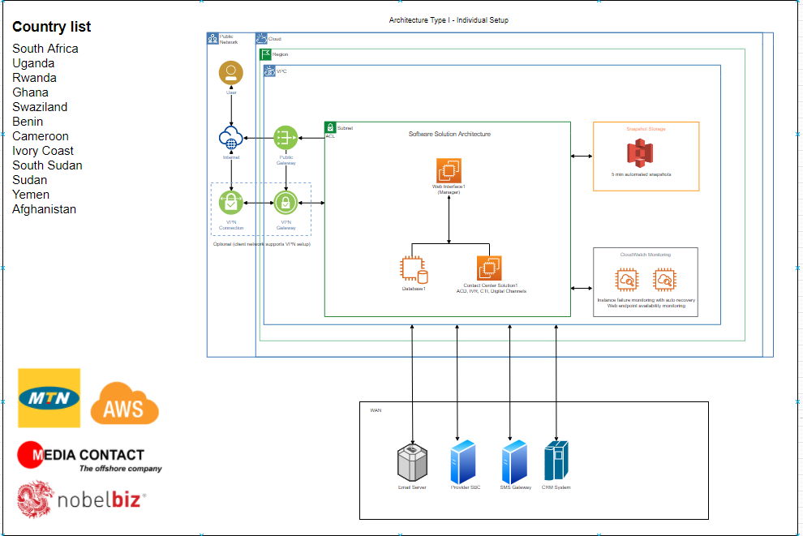

Omni+ Cloud AWS or Private Cloud with Redundancy

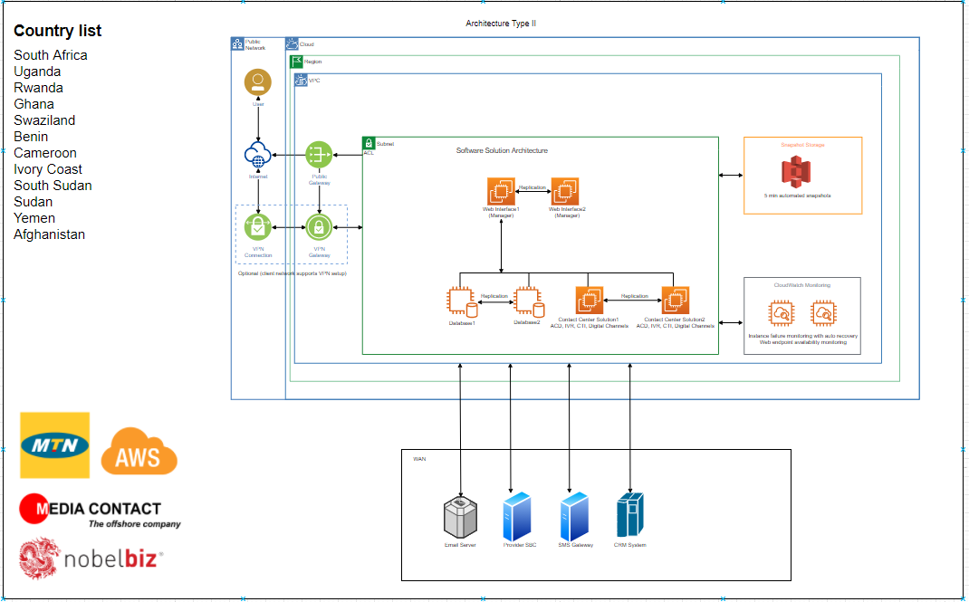

Omni+ Premise

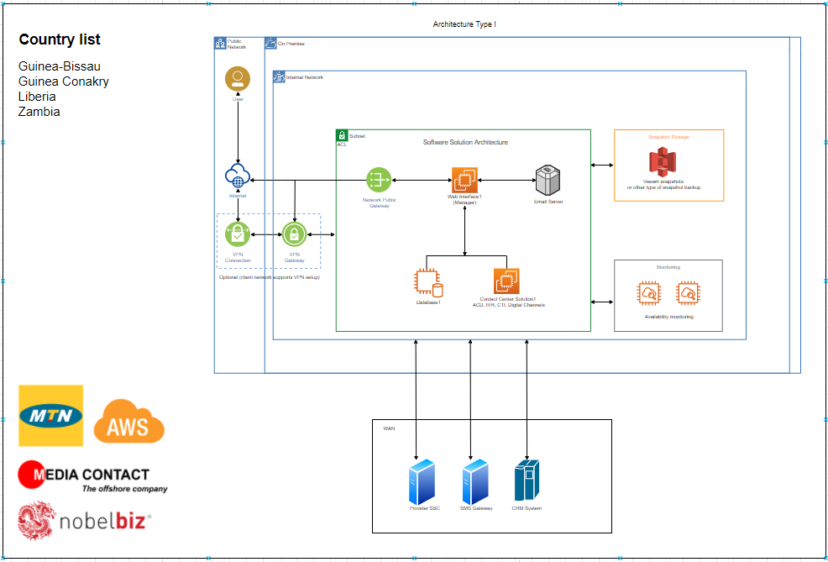

Omni+ Premise with Redundancy

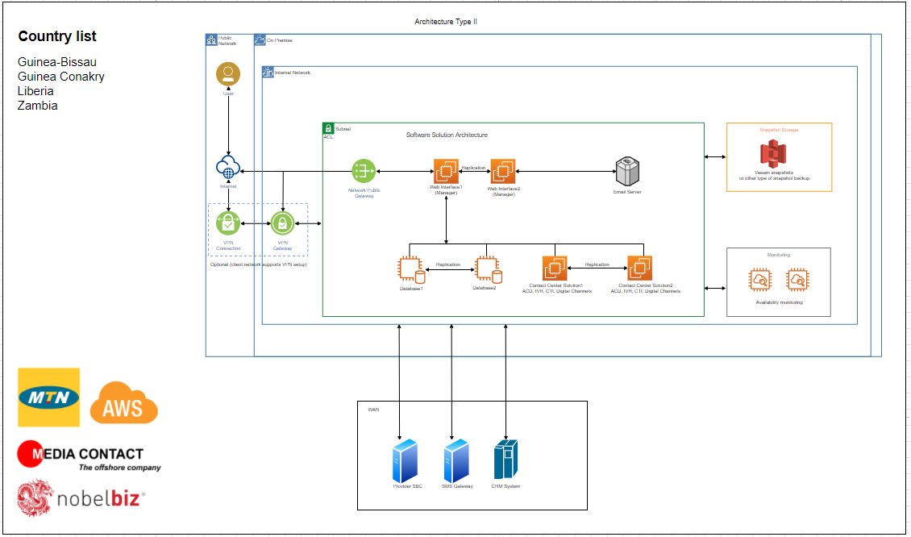

Omni+ Cloud with Centralized Synchronized Centralized CRM

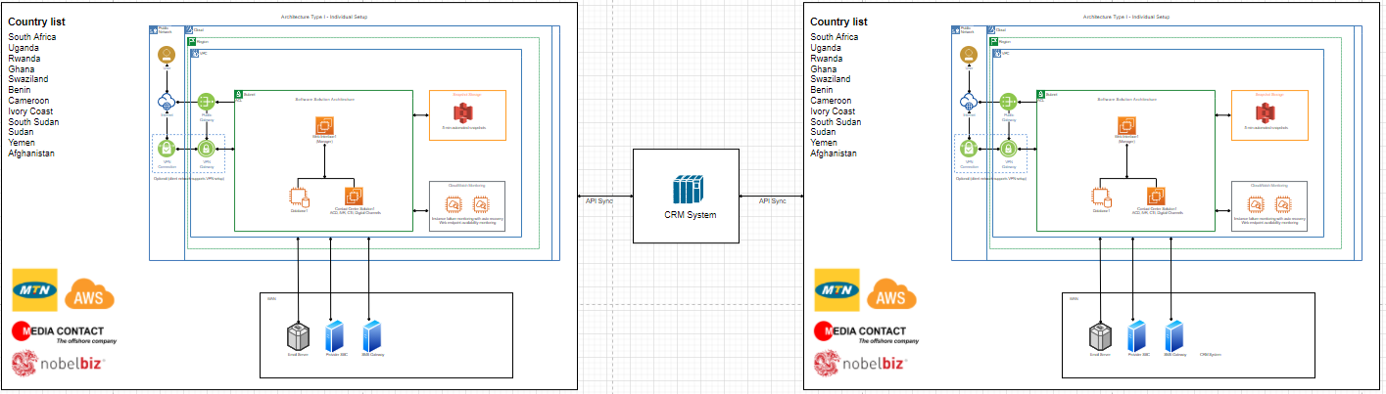

Omni+ Cloud and Premise Hybrid Synchronized Centralized CRM

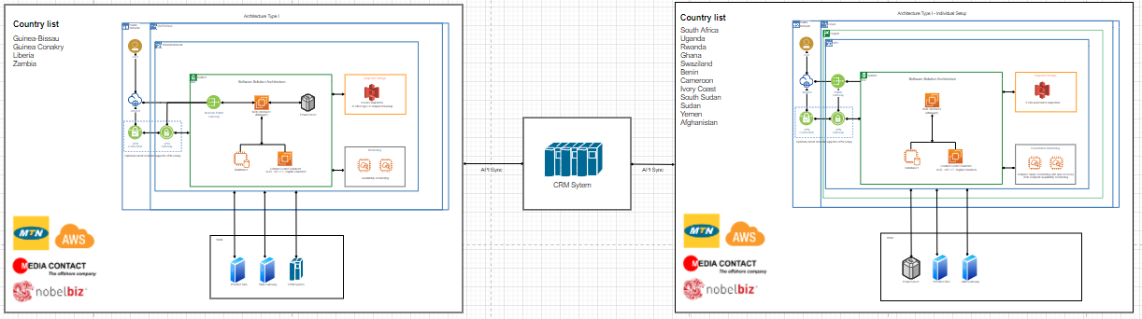

RFP Reference: 2.2.2.5 Outbound - Contact center

1. Outbound Calling Tools – Dialing Engine

System provides the following dialing modes; these dialing modes can be used for various calling methods depending on the vertical. Telemarketing, Mystery Shopping, Episodic/Transactional, Education, market research, collections, and sales.

Predictive Dialer
A predictive dialer is technology that automates the dialing of outbound phone calls
and uses an algorithm to predict outbound agent availability, thus ensuring maximum
efficiency, increase talk time and successful calls per hour.

Preview Dialer
Preview dialing presents the agent with the information about the prospect or customer to
be called and requires a response either to make the call or not to make the call. It differs
from a predictive dialer, which turns all calls over to the next available agent.

Automatic Preview
Automatic Preview dialing presents the agent with the information about the prospect or
customer to be called and system will automatically dial the number after a predetermined
amount of time. It differs from a predictive dialer, which turns all calls over to the next
available agent

Progressive Dialer
Progressive Dialer is an automated telephone dialing system that only connects agents
to calls answered by a live person. This mode is typically used in a busines to business
environment and will dial at a one-to-one ratio.

Message Broadcast Blaster
Broadcast dialing is the ability to send out pre-recorded voice broadcasting for promotions,
payment reminders, alerts, and targeted messages to voters, employees, and contacts.
This is an agentless dialing mode that can also be customized with TTS and there is no
agent involvement, this is a self-service messaging feature.

RFP Reference: 2.2.2.8 Technology-Contact Center

Computer Integration - CTI
Omni+ native CTI, allows computer system to interact with telephony functions and other forms of communications (i.e., live chat, text messaging, social channels, and email.) Omni+ can use the caller’s phone number or values entered in an IVR to identify caller and display contact account information and historical interactions automatically. Our native CTI can interact with companies proprietary, third party CRM and built in Omni+ agent workflow scripting tool. Image below describe how the platform can use a telephone number or values from an IVR to present relevant information to agents automatically.

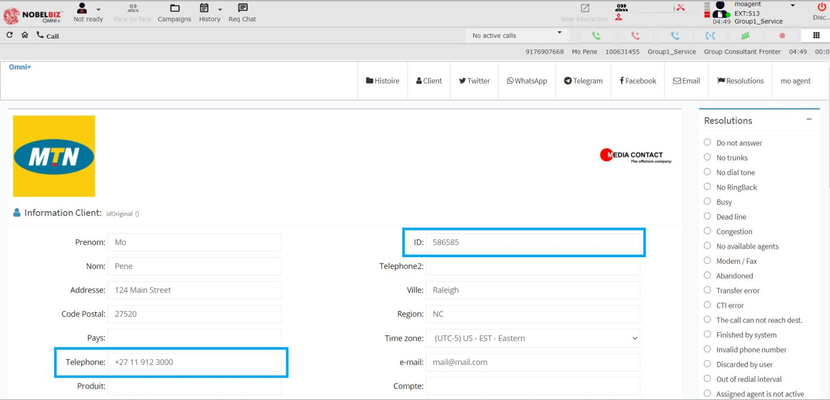

Automatic call Distributor (ACD)
An Automatic Call Distributor (ACD) is a telephony system that answers incoming calls and routes them to a specific agent or department. Our ACD can distribute calls to agents based on skill sets, profiles and historically interaction to a specific agents or department. Different queue strategies can be implemented based on customers’ requirements. In the two images below, we show that Omni+ can be configured to route calls based on a number of different criteria’s; queue strategies, skill sets, service targets (SLA’s), business hours, services, etc.
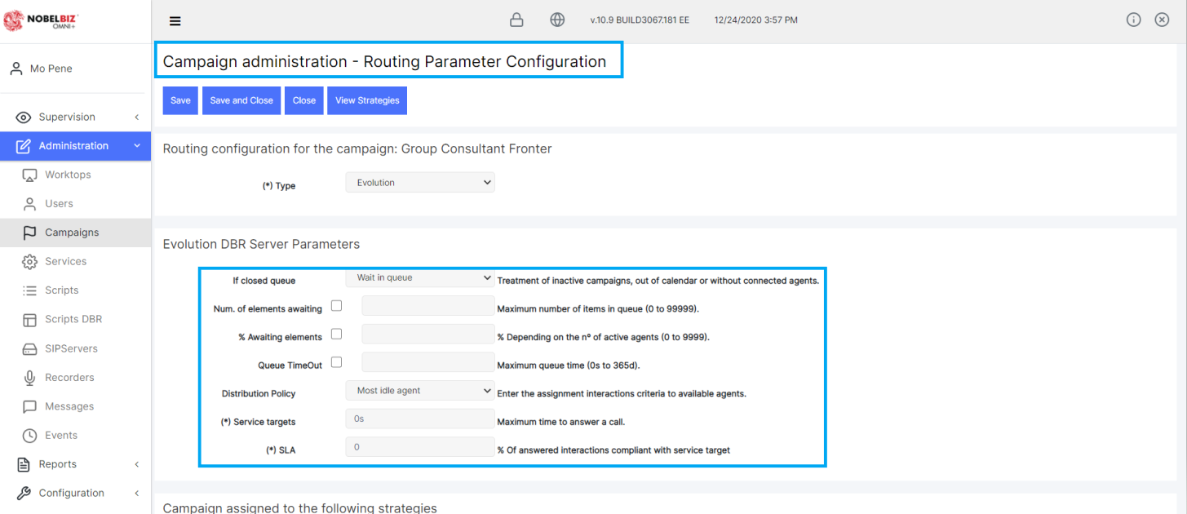
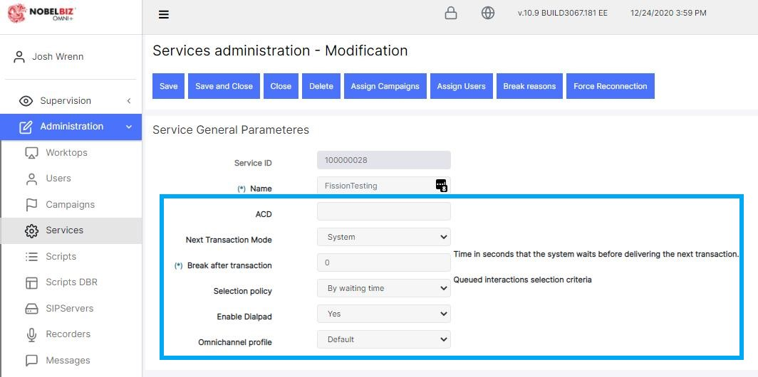

Call Recording both voice and screen
Call recording is the process of capturing audio associated with phone calls. With call recording, the conversation between a customer and an agent is recorded so that it can be stored, retrieved and evaluated, according to business needs. With Omni+ call can be recorded; manually, automatically or integration method, where the recordings are driven via script actions; recordings can be started or stopped based on the agents work flow automatically. Images below demonstrate the different configuration options, and call recordings playback options.
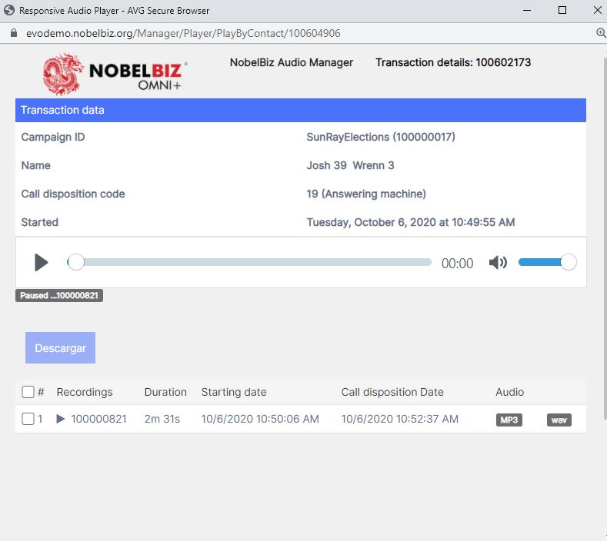
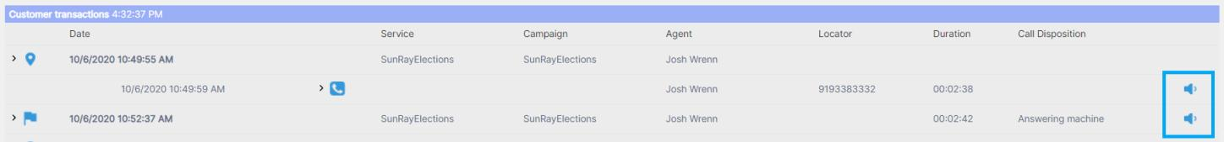
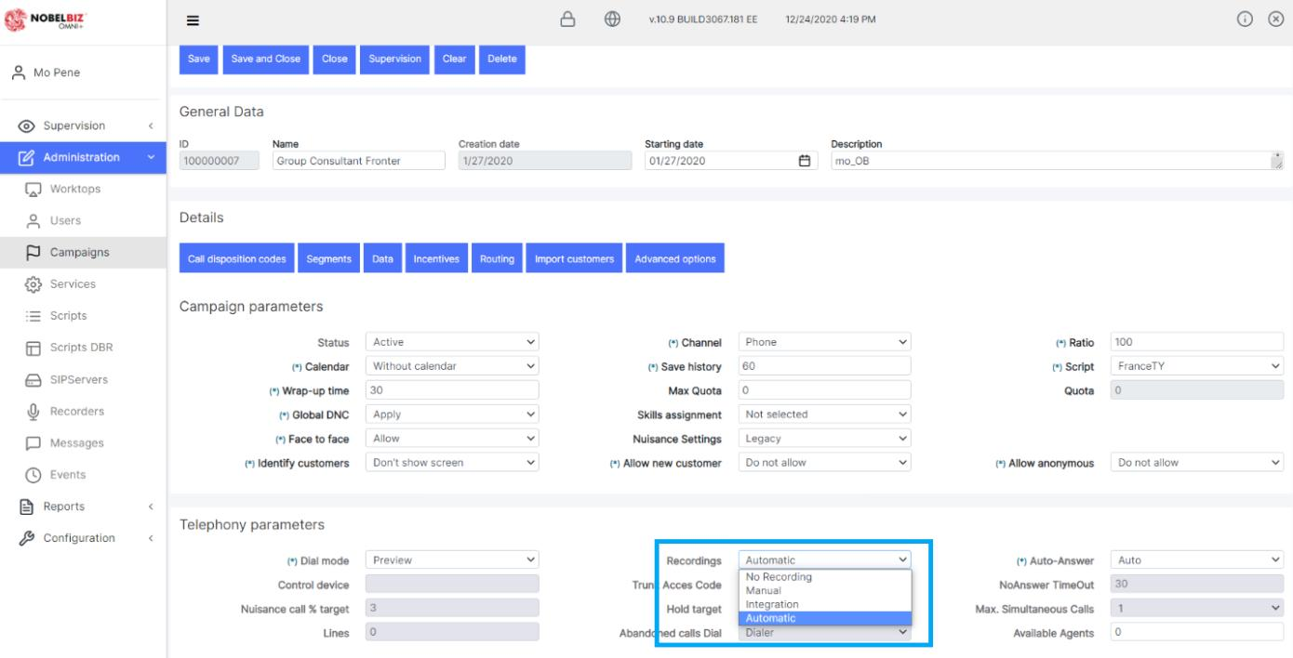

Supervisors can quickly assess the situation on agent’s desktop and see their workflow firsthand without walking the aisles, with a click of a button. For virtual call centers, when agents work remotely most of the time, screen monitoring is indispensable. Screen recordings is in our short-term roadmap and when complete they will be associated to the voice recording for supervisors and QA/QC teams will have the ability to simultaneously listen and view the voice and screen at the same time. Image below shows our supervisors tool bar that allows real-time monitoring and ability to take control of the agent’s screen.
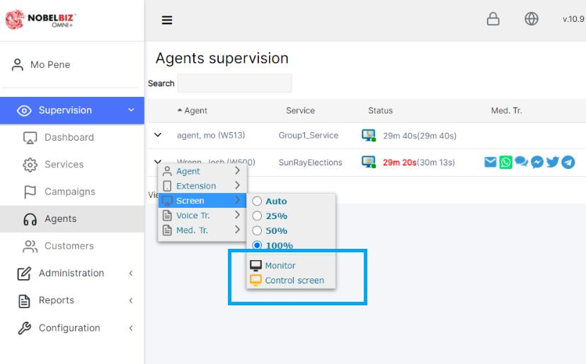

Web chat, WhatsApp, Email management and social media
An omnichannel contact center is a customer service strategy focused on allowing customers to contact companies using their preferred method of communication. These contact centers are designed to allow a seamless experience for the customer, no matter what their communication method of choice is. The image below demonstrates the agent can interact in real-time with a number of different medias; voice, WhatsApp, Telegram, Email, SMS, Twitter, Facebook messenger, webchat, web callback, and voice mail. Ayoba can be seamlessly integrated, with our API libraires that use open standard integration methods.

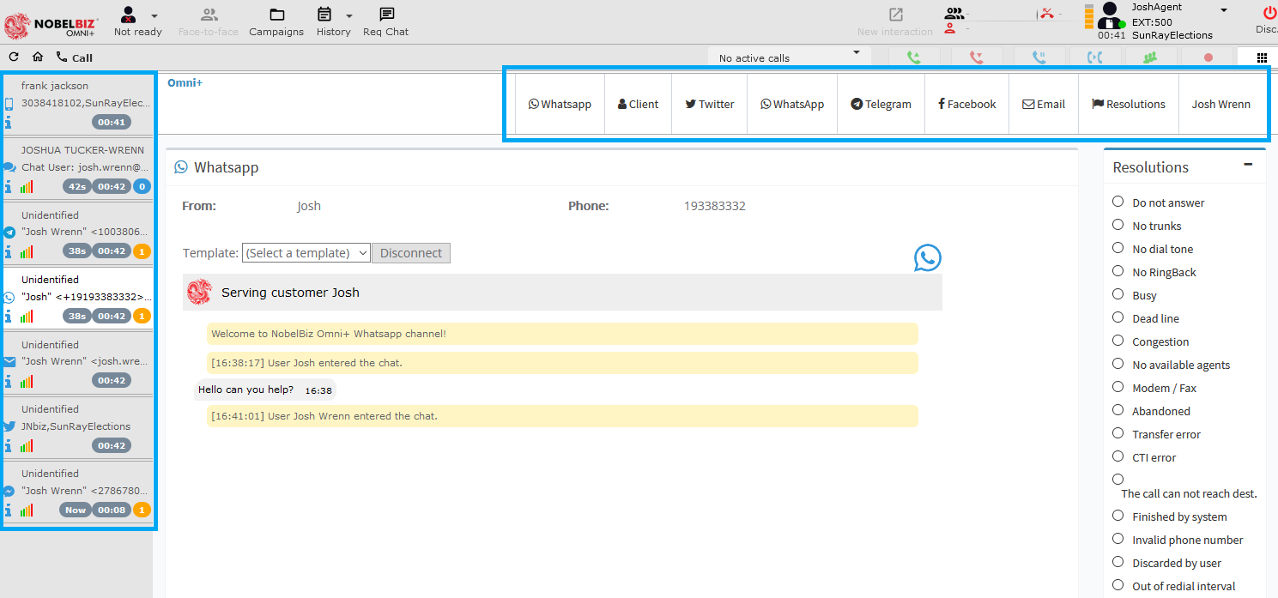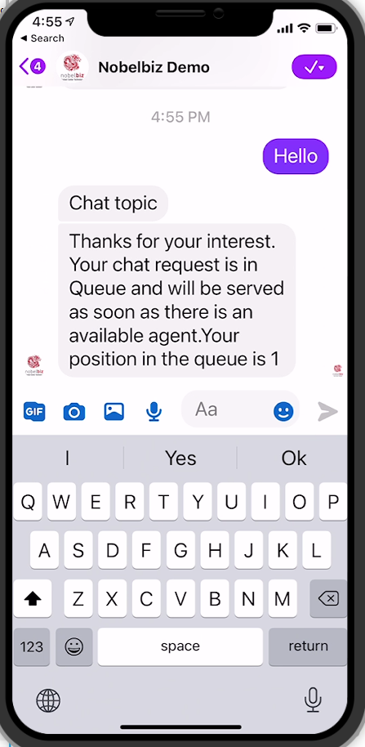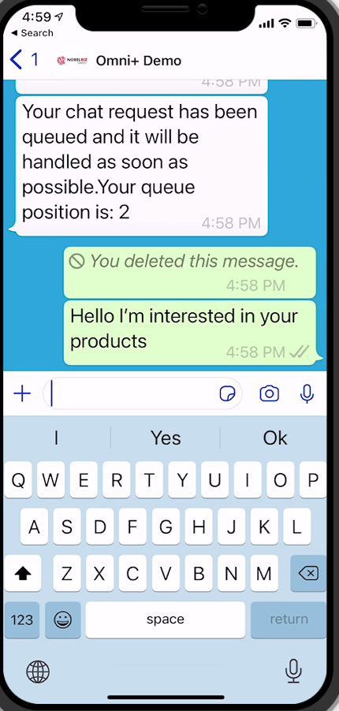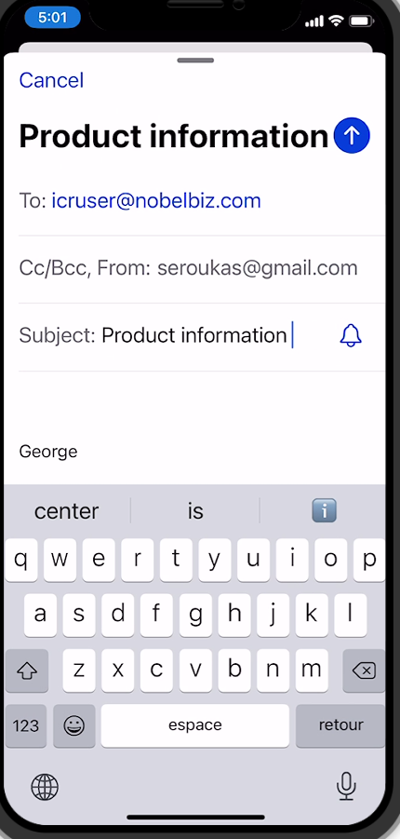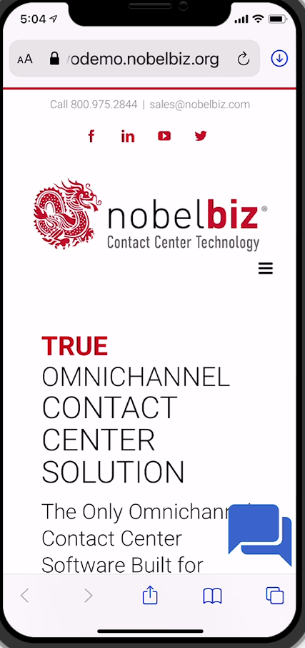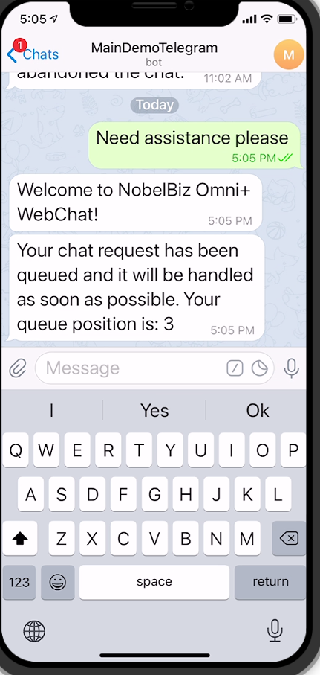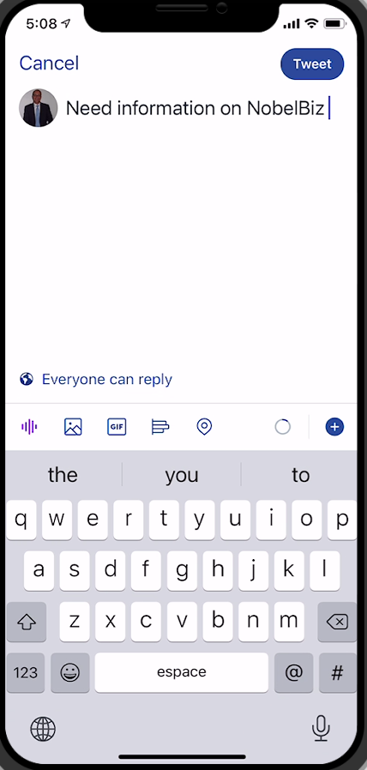

Integration of Call Center Platform with MTN Systems (CRM, etc)
A CRM integration is the seamless connectivity between your customer relationship management (CRM) software and third-party applications. Your CRM is not only essential for communicating with customers, it should also create alignment and streamline communication within your company.

The image below demonstrated how Omni+ can integrate your CRM applications and give your agents immediate access to customer data imbedded within the agent’s interactive desktop. Our API’s can share real-time information from the contact center platform to the CRM and access the database vis secure web services and other integration methods.
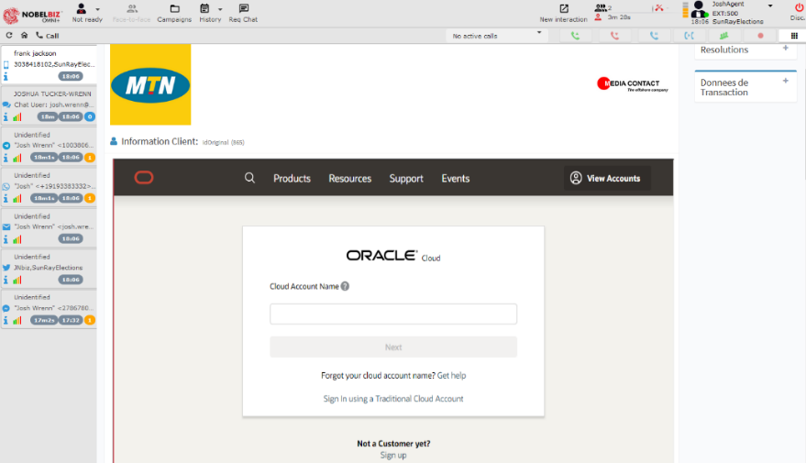

Ability to prerecord welcome greetings in different languages.
Omni+ offers the ability to prerecorded queue and IVR messages based on demographic regions, campaigns, ASR, IVR’s, DBR’s, queue’s, customer historical preference, and callers phone number. The out of the box library holds of a number of different languages and more can be integrated from different speech engines by means of API’s.
Image below demonstrated the GUI IVR/DBR script generator and the different libraries that are available for configuration. Callers can be directed to the proper ressources from the language of their choice dynamically and efficiently.
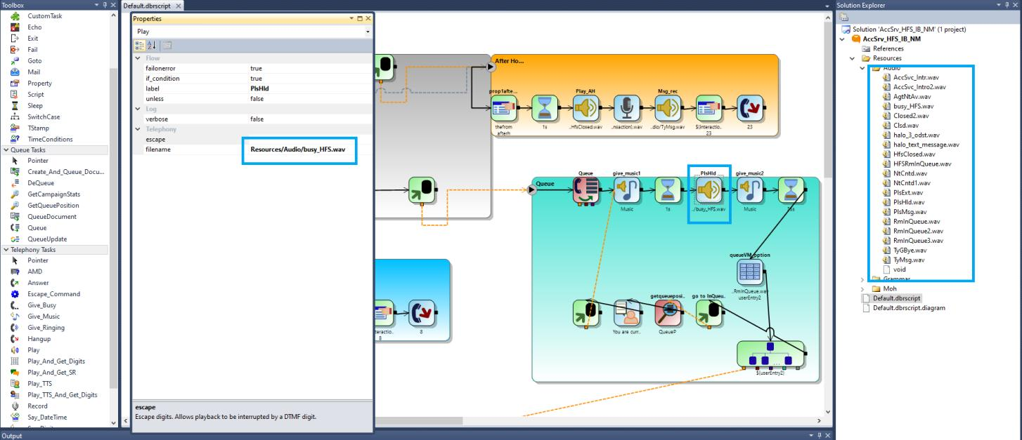
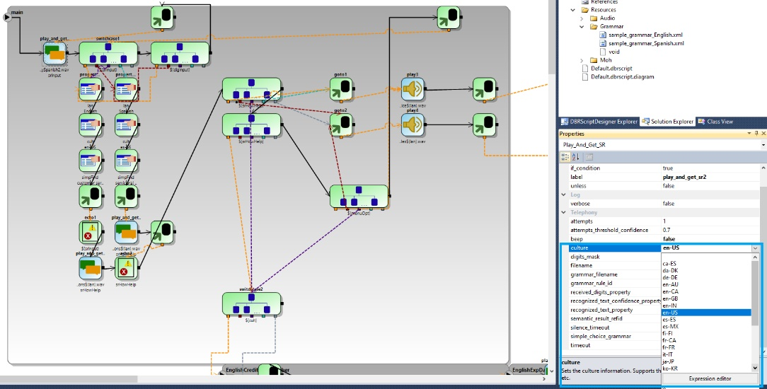

2. Multi-Channel
Multichannel refers to many channels. Companies that connect with customers in their contact center via multiple channels, such as email, social media, web chat, and telephone, can be said to have a multichannel contact center.
The image below demonstrates the agent can interact in real-time with a number of different medias; voice, WhatsApp, Telegram, Email, SMS, Twitter, Facebook messenger, webchat, web callback, and voice mail. Ayoba can be seamlessly integrated, with our API libraires that use open standard integration methods.

3. Interactive Voice Response

Main Account Airtime Balance Checks Mobile Money balance and subscriber checks
The Omni+ IVR can interact in real-time with the local or external database and provide self-service options. The integrated tools determine can determine the callers account profile prior to sending it to an agent and use methods to connect to the database and play back; balances, accounts status, and all relevant information by TTS, ASR and speech engines.
The image below demonstrates the ability to query databases in real-time and prompt callers with account balances with our out of the box speech TTS engine.
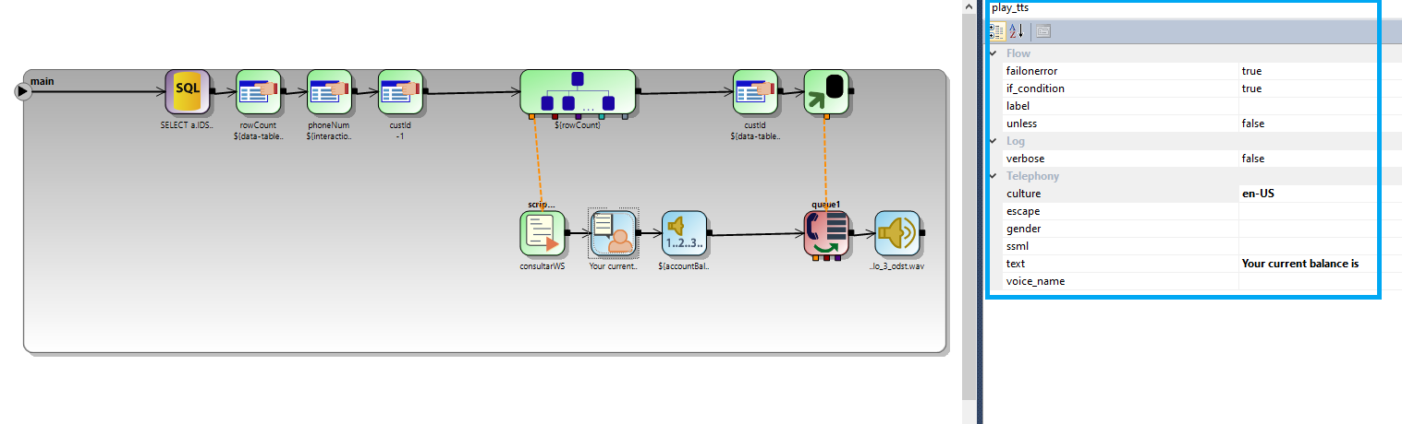
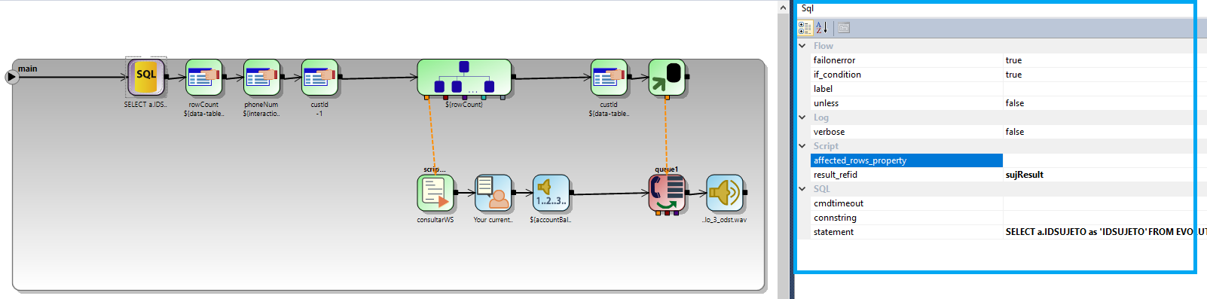

Prioritised routing by segment based on agreed percentages
Call routing allows businesses to connect their customers to the right agent faster. Attribute-based routing assesses the needs and context of each caller and connects them to the most qualified agent available with the skills to address those needs.
The image below demonstrates the IVR’s ability to query the database and determine how it will intelligently process the call based on historical values or real-time database query that are set for each client’s attributes. Callers with a VIP status, monthly spending volumes, business versus consumer, etc. can be prioritized and routed and handled differently.

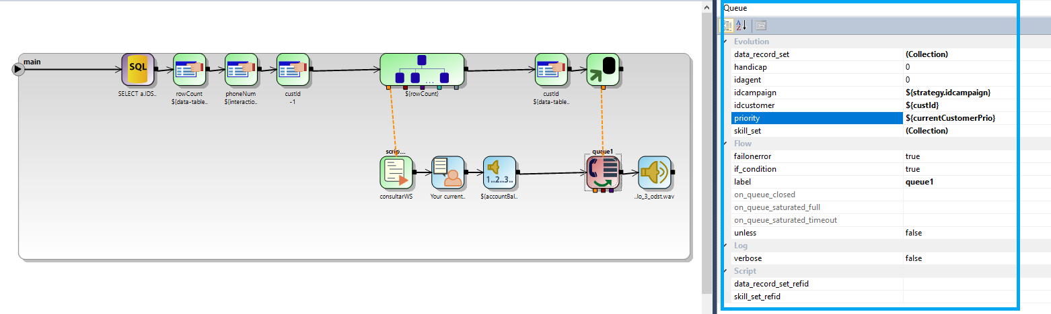

Language Storage / set preferred language feature support for all languages irrespective of the market
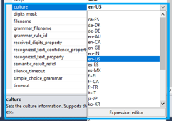
The Omni+ IVR can support diverse languages for different regions, the image below demonstrates various regions and demographic cultures. The IVR platform can also integrate other required languages and dialects from numerous speech engines or predefined prerecorded messages. 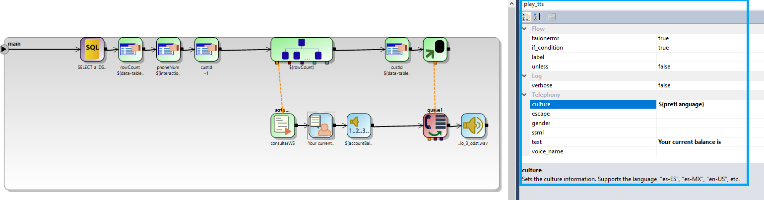

Proactive messaging to customers in instances where there are major service impacting failures
Broadcast dialing is the ability to send out pre-recorded voice broadcasting for promotions, payment reminders, alerts, and targeted messages to subscribers, employees, and contacts. This is an agentless dialing mode that can also be customized with TTS and there is no agent involvement, this is a self-service messaging feature.
The images below show the ability to create the messaging strategies and an example of a proactive outbound IVR to automatically notify target audience by means of a prerecorded customized message.
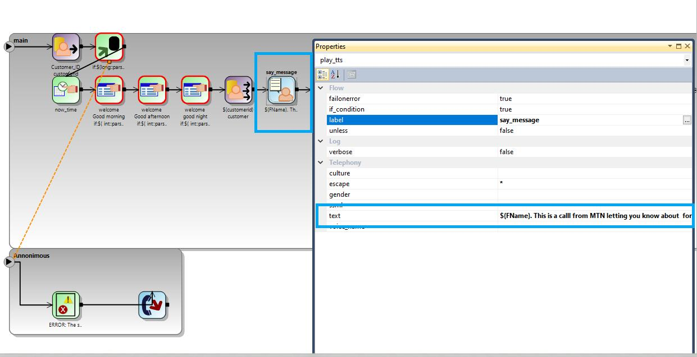

Blacklisting functionality
Blacklisting in Omni+ can be performed and configured in multiple ways. We can create rule and policies to block callers when detecting their phone number, in a Omnichannel situation we can block medias as is; emails, fakebook twitter, WhatsApp, telegram, etc. These contacts regardless of the media or interaction can be blocked and or prompted with different messaging that they have been blocked. The image below demonstrates an IVR/DBR strategy that will do a lookup on all medias to block the interaction. The system can prompt caller or other medias with an auto response or simply just reject the interaction.

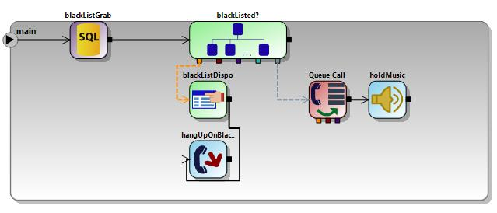

Should be able to allow all customer contacts across on different channels and should adequately handle any volume or spike in calls
Omni+ offers a wide variety of overflow solutions within the same medias or the ability to redirect contacts to other channels in order to eliminate spike in call volume. Example: a caller can be prompted with their estimated queue time or a position in queue on a messaging application that can redirect them to another channel. A call can be redirected to a webchat, email, self-service IVR, or social channels.
The image below demonstrates the ability to flag and lookup the caller’s previous preferences and bypass long IVR scenarios.

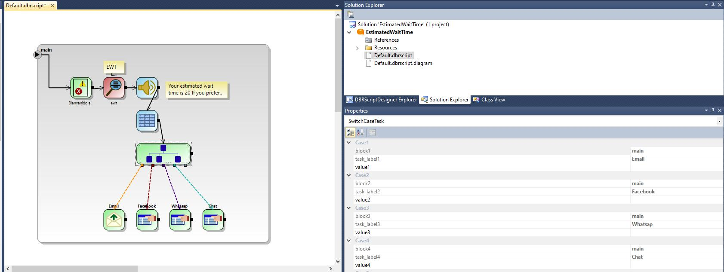

Dynamic IVR; Provide customer their favorite selection as a first option to avoid customers listening to long menu’s
Omni+ can lookup historical data when caller enters the IVR and based on their past selections they can be prompted (transferred) to a specific agent, language, skill, queue, department or preferred channel of their preference seamlessly and automatically.
The image below demonstrates the ability to prompt callers with their position in queue or estimated queue time, they can opt out and the IVR/BDR can redirect to other medias.
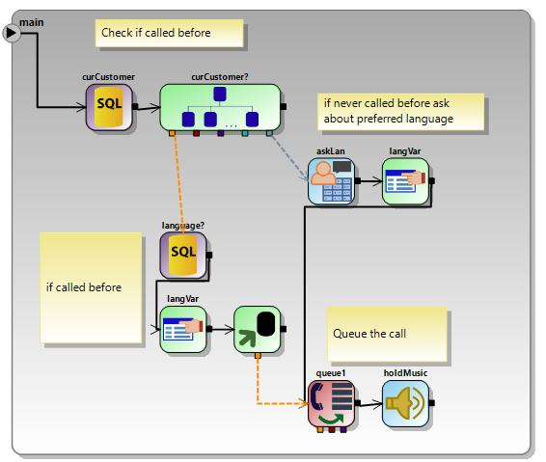

Support for surveys, and integration with current VoC solution
Voice of the customer (VoC) surveys can we created on any channel; voice, email, and messaging. These surveys can be driven by a voice ASR engine or a link can be sent to them to fill out a questionnaire/satisfactory survey developed within our application generator scripting tool. Integration to current VoC solution will need to be reviewed and determined by a scope of work.
The screen below demonstrates an example of a post call survey, the caller can be transferred to the survey via voice, or the platform can send a URL to an email, webchat, or social channel. Script can also be created and generated in our scripting tool.
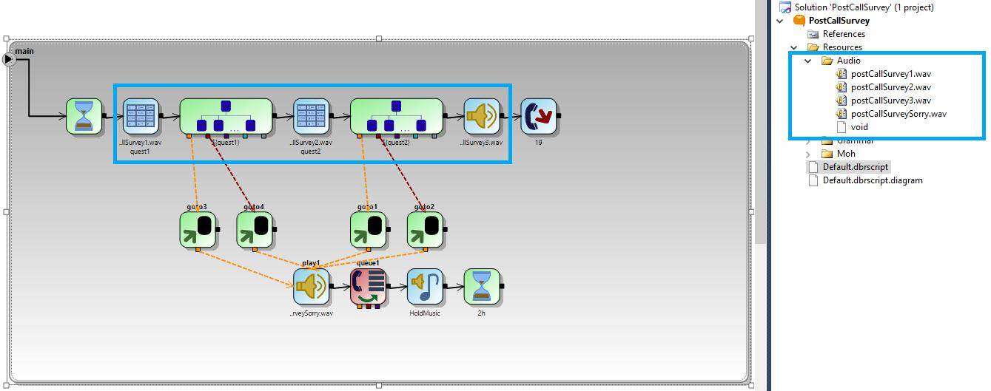

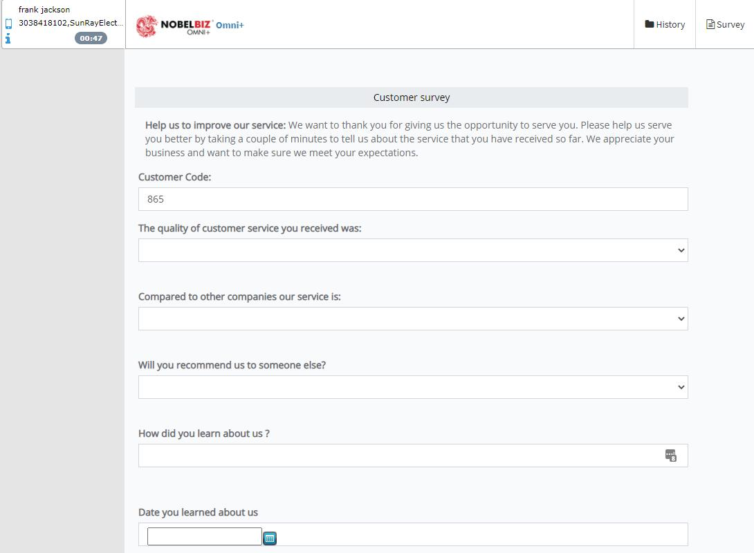

4. Service support with AI influence

IVR menu should be driven by AI analytics
Using an AI engines, with an IVR system creates smarter self-service applications and delivers better customer experiences. solutions combine customer data with AI to determine intent and select the right next step to deliver the relevant customer support. For example, the technology can identify patterns that indicate a customer's intent based on web activity or text and route the call or chat to the appropriate agent.
With Omni+ open API’s developers can integrate AI engine application that can be used in a proactive IVR scenario and across other media channels. MTN’s preferred AI vendor and strategy can be integrated to the OMNI+ solutions. A scope of work will be provided after NobelBiz determines MTN’s requirements.

Channel support must be driven by AI analytics
Using an AI engines, with an IVR system creates smarter self-service applications and delivers better customer experiences. solutions combine customer data with AI to determine intent and select the right next step to deliver the relevant customer support. For example, the technology can identify patterns that indicate a customer's intent based on web activity or text and route the call or chat to the appropriate agent.
With Omni+ open API’s developers can integrate AI engine application that can be used in a proactive IVR scenario and across other media channels. MTN’s preferred AI vendor and strategy can be integrated to the OMNI+ solutions. A scope of work will be provided after NobelBiz determines MTN’s requirements

Proactive AI support through all channels
Using an AI engines, with an IVR system creates smarter self-service applications and delivers better customer experiences. solutions combine customer data with AI to determine intent and select the right next step to deliver the relevant customer support. For example, the technology can identify patterns that indicate a customer's intent based on web activity or text and route the call or chat to the appropriate agent.
With Omni+ open API’s developers can integrate AI engine application that can be used in a proactive IVR scenario and across other media channels. MTN’s preferred AI vendor and strategy can be integrated to the OMNI+ solutions. A scope of work will be provided after NobelBiz determines MTN’s requirements

5. Storage and archiving

Support for 5 years offline storage of customer interactions history
Scalable and Elastic, Omni+ can store data in the cloud or on premise for an undetermined period. The purpose of elasticity is to match the resources allocated with actual number of resources needed at any given point in time. Scalability handles the changing needs of an application within the confines of the infrastructure via statically adding or removing resources to meet applications demands if needed.

Support of 1-year offline storage of call and video recording
Scalable and Elastic, Omni+ can store data in the cloud or on premise for an undetermined period. The purpose of elasticity is to match the resources allocated with actual number of resources needed at any given point in time. Scalability handles the changing needs of an application within the confines of the infrastructure via statically adding or removing resources to meet applications demands if needed

Support of 1year online storage of all transactions
Scalable and Elastic, Omni+ can store data in the cloud or on premise for an undetermined period. The purpose of elasticity is to match the resources allocated with actual number of resources needed at any given point in time. Scalability handles the changing needs of an application within the confines of the infrastructure via statically adding or removing resources to meet applications demands if needed

RFP Reference: 2.2.2.9 Change Management - Contact Center

1. RESPONDENT should be able to exhibit Agility of new deployments and upgrades in both IVR and ACD within timelines to be defined by MTN
Scheduled maintenance is performed with 24 to 48 hours notification to the customer and they will be performed during normal maintenance hours or during customer agreed intervals. This includes updates, enhancements, bug fixes, upgrades or releases of the NobelBiz platform and software

2. RESPONDENT should present a transparent mechanism to check and control the achievement of the SLA for change
NobelBiz manages work across teams with Jira Service Management so our employees and customers quickly get the help they need.

Service Desk
We make it easy for every team and our clients to access and use service desk. Through a simple, intuitive portal that makes it easy for your employees and customers to get help quickly, and for our teams to streamline their work.

Reports and metrics
We ask our customer for satisfaction reports to better understand their needs and improve our service with a simple, built-in tool for collecting feedback. We monitor and optimize our team’s work with reports and dashboards

Service Level Agreements (SLAs)
We set a number of SLA policies as needed to keep track of deadlines based on elapsed time or request categories and priorities. We resolve requests based on priorities, and use escalation rules to notify the right team members and prevent SLA breaches.

Alerting and on-call management
We centralize and filter alerts across all our monitoring, logging, and CI/CD tools to ensure our teams respond to issues quickly while avoiding alerts. We customize on-call schedules, routing rules, and escalation policies to handle alerts differently based on their source and urgency.

Awareness and communication
We link support tickets directly to major incidents empowering agents to see status changes in real-time. We keep stakeholders aware of updates using multiple notification channels, including SMS, email, and mobile pus alerts.

Major incident escalation
We escalate major incidents prompting the right Dev and Ops teams to immediately react and begin resolution. We use an internal chat channels (WowApp) and set up video conferencing (via a native video or Zoom) to accelerate collaboration and automatically record all actions with a rich incident timeline.

Reporting and analytics
We track and analyze all incident response activities. Identify areas of success and opportunities to improve. We use templates to easily create and export post-mortem reports, along with associated incident timelines, to Confluence we you continue to collaborate with Development, Operations, and other business stakeholders to track follow-on actions, and avoid similar incidents in the future.

Root cause investigation
We investigate if code deployments or third-party service outages relate to your major incidents and begin documenting the problem investigation in Confluence. Our teams monitor the status of underlying services and narrow potential causes.

Resolution
We initiate change procedures for problem resolution, securing all the necessary approvals. We run reports to reveal the number of incidents associated with a problem or the top problems per month to ensure recurring incidents don’t happen again.

3. Support for required customizations (including integrations)
Training, on-site support and application development are additional services and can be made available to Customer for an additional fee. The pricing and terms for all such additional services will be subject to mutual written agreement of the parties and defined in a statement of work (SOW).
This Project Statement of Work will provide a formal document that captures and defines the work activities, deliverables, dependencies, and timelines that MTN and NobelBiz will work toward to deliver Omni+.

RFP Reference: 2.2.2.2 Innovative - Contact center

1. Innovative – MTN’s Digital transformation strategy
Nobelbiz will dedicated a team of client advocates, project managers, and solutions engineers to MTN. These ressources will schedule monthly webinars to review and strategize on MTN’s digital transformation requirements. NobelBiz will also schedule quarterly onsite high-level management and development meetings in order to improve operations and service delivery.

2. Innovative – continuous engagement with Opcos
Nobelbiz will dedicated a team of client advocates, project managers, and solutions engineers to MTN. These ressources will schedule monthly webinars to continuously engage with Opcos to deep dive on issues and provide solutions.

RFP Reference: 2.2.2.2.2 Call Quality & Closed loop feedback

1. Call Quality Measurement

Real time quality monitoring tools and WFM
Omni+ provides real-time call monitoring that enables supervisors and managers to track all interactions across all agents and immediately alerts them to call events that may require some form of intervention. With real-time monitoring systems in place, customer service, performance, and compliance issues are no longer able to slip through the cracks. Call monitoring allows supervisors to listen and analyze your call center agent calls in
the moment. By monitoring calls, supervisors can help improve agent performance and customer satisfaction

A WFM solution can be implemented and integrated for historical reporting and Realtime adherence. This will help to manage staffing and scheduling based on real-time and historical data, this will increase overall efficiency and productivity among employees. Omni+ Software can deliver applications over the Internet as a service. Instead of installing and maintaining software, you simply access it via the Internet, freeing yourself from complex software and hardware management.

Image below demonstrates the supervisor telephony toolbar; Call, Monitor, Whisper and conference.

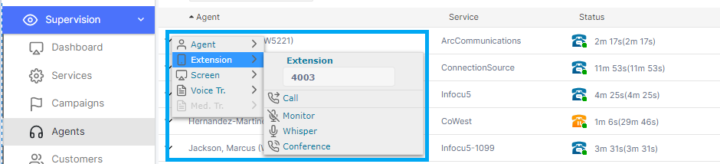

Remote Access to call monitoring platform, and have oversight of quality, and workforce
Call monitoring allows supervisors to listen and analyze your call center agent calls in the moment. By monitoring calls, supervisors can help improve agent performance and customer satisfaction. Supervisors can quickly assess the situation on agent’s desktop and take control remotely of the agent’s workflow without walking the aisles, with a click of a button. For virtual call centers, when agents work remotely most of the time, screen control is indispensable.

Image below demonstrates that the supervisor module is completely web based, all you need is a PC, browser and an internet connection.

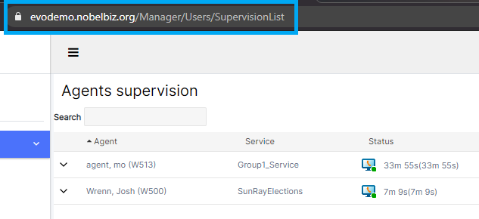

Voice Whisper is a coaching method that allows supervisors to discreetly speak to the call center agent without the customer knowing the supervisor is coaching the agent.

The screen below highlights the monitoring nod whisper/coaching features of Omni+

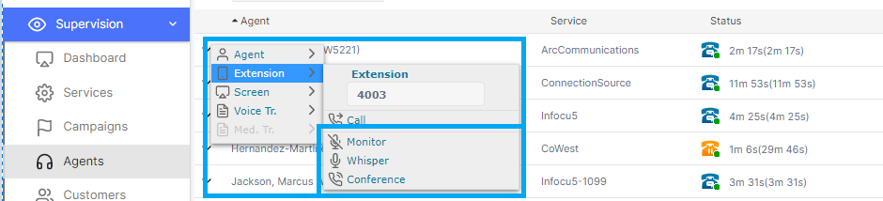

Real-time monitoring for call centers refers to the tools and software which enables managers to oversee and track agent interactions as they are carried out. Supervisors can quickly and easily identify customers at risk, they can take proactive steps to resolve the issues and retain those customers by using real time alerts.

The image below demonstrates the ability to monitor all channels in real-time, the supervisor can alert on different metrics, SLA’s and KPI’s.

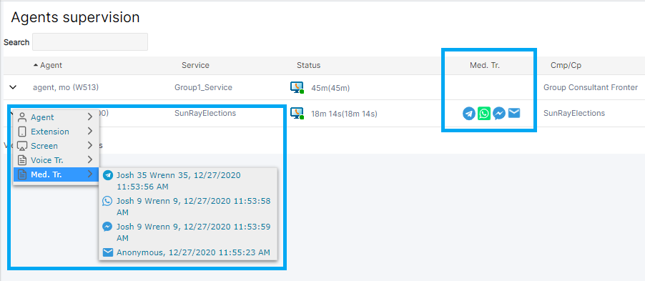

Real-time call monitoring enables supervisors to track all interactions across all agents and immediately alerts them to call events that may require some form of intervention. With real-time monitoring systems in place, customer service, performance, and compliance issues are no longer able to slip through the cracks.

The first screen below shows real-time alert, they an be set on a number of variables, KPI’s and SLA’s. the second screen shot displays the alerts that are set in the platform, these can be customized per campaign, service or agent.

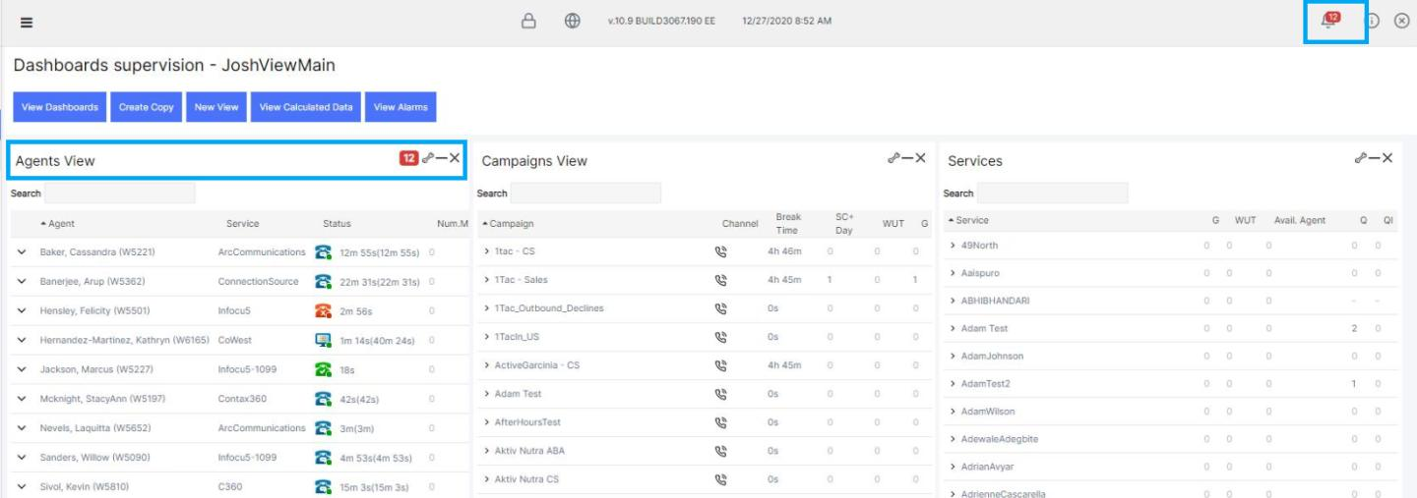

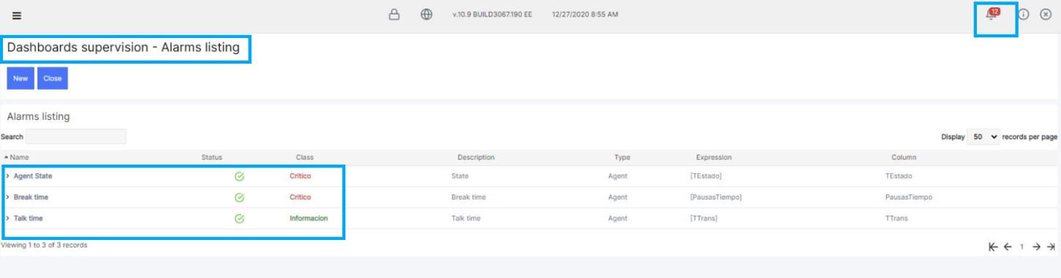

RFP Reference: 2.2.2.2.3 Training – Contact Center Staff

Training Requirement / System and Product
NobelBiz will provide End User Training and Certification to administrators, supervisors and call center managers. Training certifications will be customized and focused on team specific requirements, roles, campaigns and tasks.
End users will get training on train the trainer concept, this training will be focused to a limited number of users on the final user access to the system.
Scope: Provide train the trainer enablement, so they can take over the final users training. The training duration is full 32 hours training.
Deliverable End user training certification & End user training guide.
NobelBiz Responsibility Provide training instructor & Provide electronic copy of the end-user training guide.

Training Outline Example:
Module |  | Description | Responsible | Attendees
Agent |  | - Agent Login  - CTI Bar & Agent Workspace  - Call/Media Handling  - Agent Script  - Call/Media Processing  - Omnichannel | NobelBiz  Trainer#1
Administrator |  | - Campaign Management (Voice)  - Campaign Management (Omnichannel)  - Lead Import  - Skill sets and priority Routing  - HR  - Queues & Skills  - IVR Developer  - DBR Developer  - Agent Script Editor | NobelBiz  Trainer#1
Reporting & Supervisor |  | - Customized Dashboard  - Agent Supervision  - Service and Campaign view  - Monitoring Voice/Media & Data  - System Reports  - Dynamic links on System Report | NobelBiz  Trainer#1
Recap & Q/A |  | - Question Period  - UAT Testing  - Exercise book  - Self-Evaluation  - Online training sessions overview | NobelBiz  Trainer#1

RFP Reference: 2.2.2.2.4 Monitoring-dashboards

Monitoring, Performance, SLA, ASA, AHT

Realtime Supervisor Dashboards
Omni+ has Real-time call monitoring enables supervisors to track all interactions across all agents and immediately alerts them to call events that may require some form of intervention. With real-time monitoring systems in place, customer service, performance, and compliance issues can be monitored in real-time. Customizable dashboards allow to edit and modify views, supervisors may modify the display of information showed on the dynamic dashboards to monitor SLA’s, KPI’s and campaign or agent specific data.

The first image demonstrates an example of a real-time dashboard view and the second shows custom variables, KPI’s and service levels.

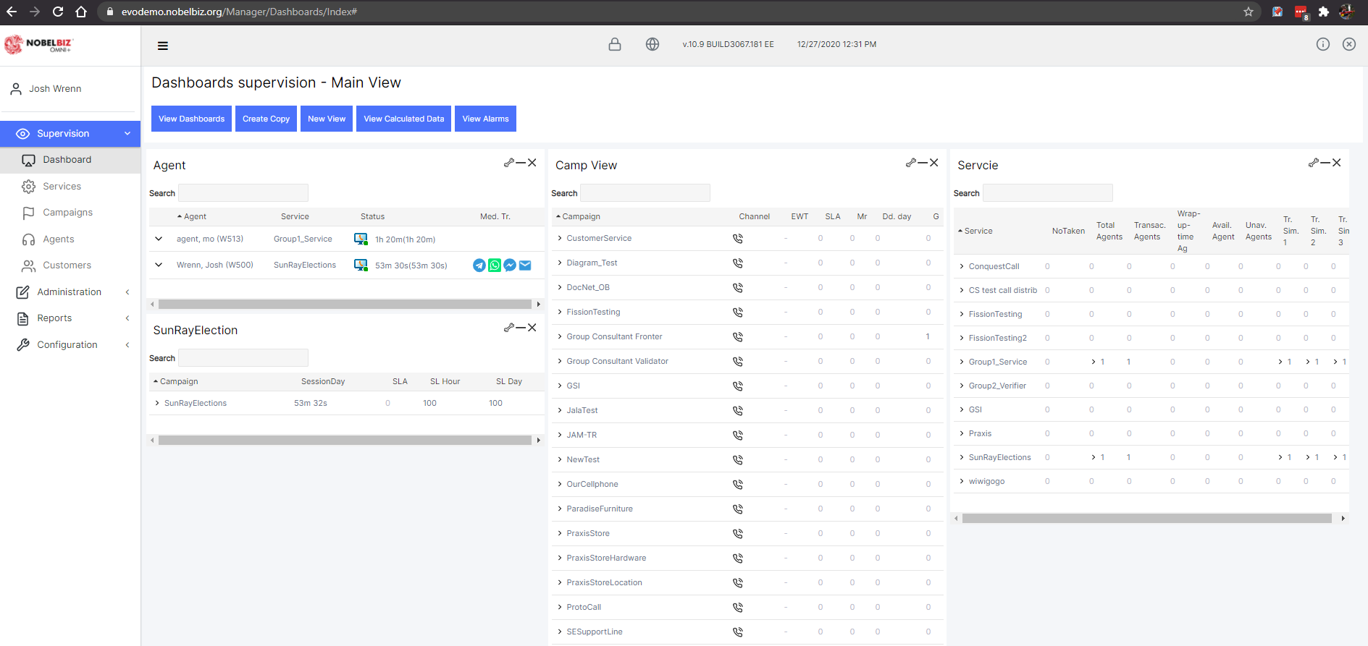

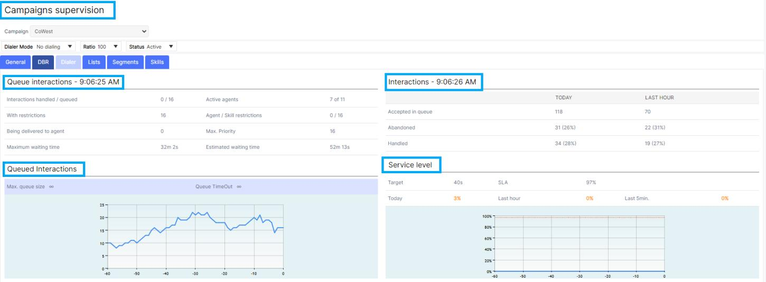

Customizable Supervisor Dashboards
Customize allows to edit and customize views, supervisors may customize the display of information displayed on the dynamic dashboards to monitor SLA’s, KPI’s and campaign or agent specific data.

The image below demonstrates the ability to customize the content of the real-time dashboard views, by drag and drop method.

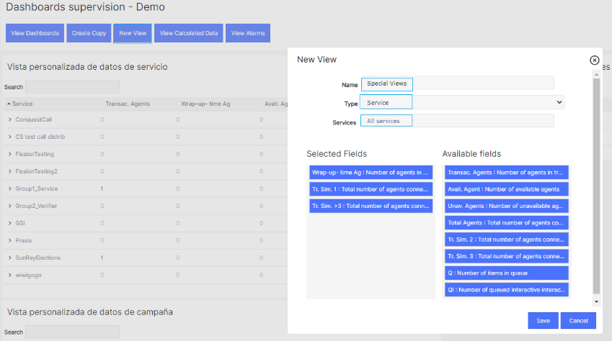

Supervisor Realtime Alerts
Real-time monitoring for call centers refers to the tools and software which enables managers to oversee and track agent interactions as they are carried out. Supervisors can quickly and easily identify customers at risk, they can take proactive steps to resolve the issues and retain those customers by using real time alerts. Call monitoring allows supervisors to listen and analyze your call center agent calls in the moment. By monitoring calls, supervisors can help improve agent performance and customer satisfaction.

The first screen below shows real-time alert, they can be set on a number of variables, KPI’s and SLA’s. the second screen shot displays the alerts that are set in the platform, these can be customized per campaign, service or agent.

Supervisor Agent Voice Whisper
Voice Whisper is a coaching method that allows supervisors to discreetly speak to the call center agent without the customer knowing the supervisor is coaching the agent.

The screen below displays the real-time whisper/coaching feature

Realtime Supervisor Screen Control
Supervisors can quickly assess the situation on agent’s desktop and see their workflow firsthand without walking the aisles, with a click of a button. For virtual call centers, when agents work remotely most of the time, screen monitoring is indispensable

The image below demonstrates the Omni+ supervisor screen controls.

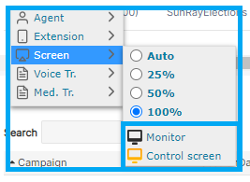

Realtime Supervisor Screen Monitoring
Supervisors can quickly assess the situation on agent’s desktop and see their workflow firsthand without walking the aisles, with a click of a button. For virtual call centers, when agents work remotely most of the time, screen monitoring is indispensable
The images below demonstrate both the voice and screen controls from the supervisor perspective.
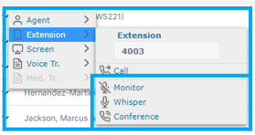

RFP Reference: 2.2.2.2.5 Reporting, SLA, KPI’s, Metrics, and Data

Reporting Engine, Business metrics, historical, and Data management
Omni+ includes tools to strengthen your call center performance. Our reporting Engine offers a wide range of analytics and reporting tools that provide historical and real-time data that you can customize and build comprehensive customized reports.

Our reporting engine allows for more informed decisions with fully integrated, real-time and historical insights on key business metrics and trends. Get immediate value from out of the box reports and ready access to the full range of data elements, to track call center reporting metrics such as agent status, service level and skill performance. Share actionable information throughout your business with ease and security, including external business intelligence systems, so you always know when action is needed. Choose from over 90 pre-built reports or create your own to maximize the value of your call center metrics.

Omni+ Reporting Overview

The Omni+ reporting module stores historical records of the call center activity allowing to obtain reports later. An automatic Task Daemon process populates the records daily into tables with historical data in order to ease their consultation.
The Manager application generates several reports and statistics by operating progress control. All calls, interactions, call dispositions, groups of call disposition, client’s data, and incentives data is available through the reports and statistics generated by Omni+ to make the center’s supervision easier.
The reports are provided with graphics that will help you obtain a much clearer vision of your call center productivity. It is possible to change the graphic types to dynamic during the report generation.
The architecture of the report module can also add new custom reports, customized reports can also be extracted to third party of proprietary reporting tools.
Reports are grouped under different categories:
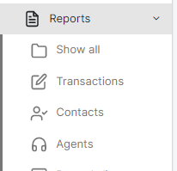

Out of the box Transaction Reports
To execute the report, select it from the list. To return to the reports lists only click on the selected report again.
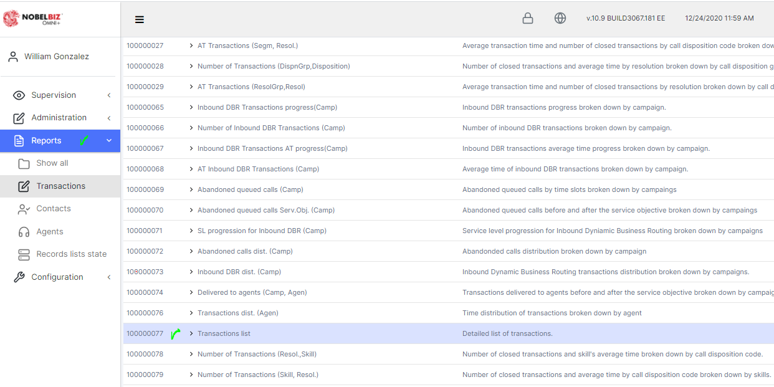

1. Reporting Refresh Rate

The refresh rate on the dashboards is 5 seconds and the reporting engine generator will query the system databases and provide the required report (out of the box or custom) on demand. The reporting engine will query the data in real-time and deliver real-time data.
Image below demonstrates the on-demand reporting engine.

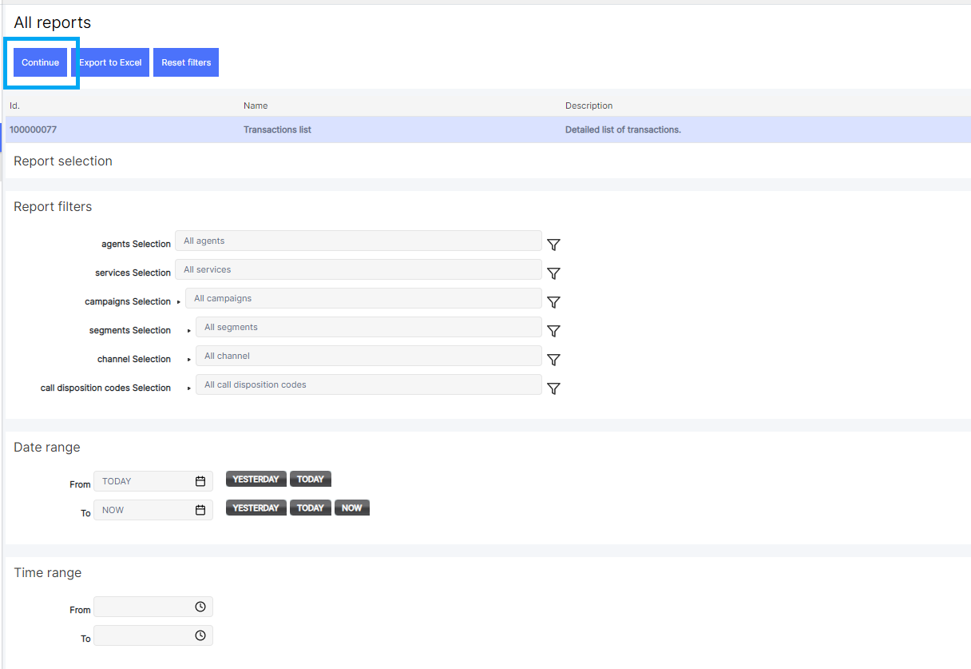

2. Reporting Refresh Rate – Report Filters

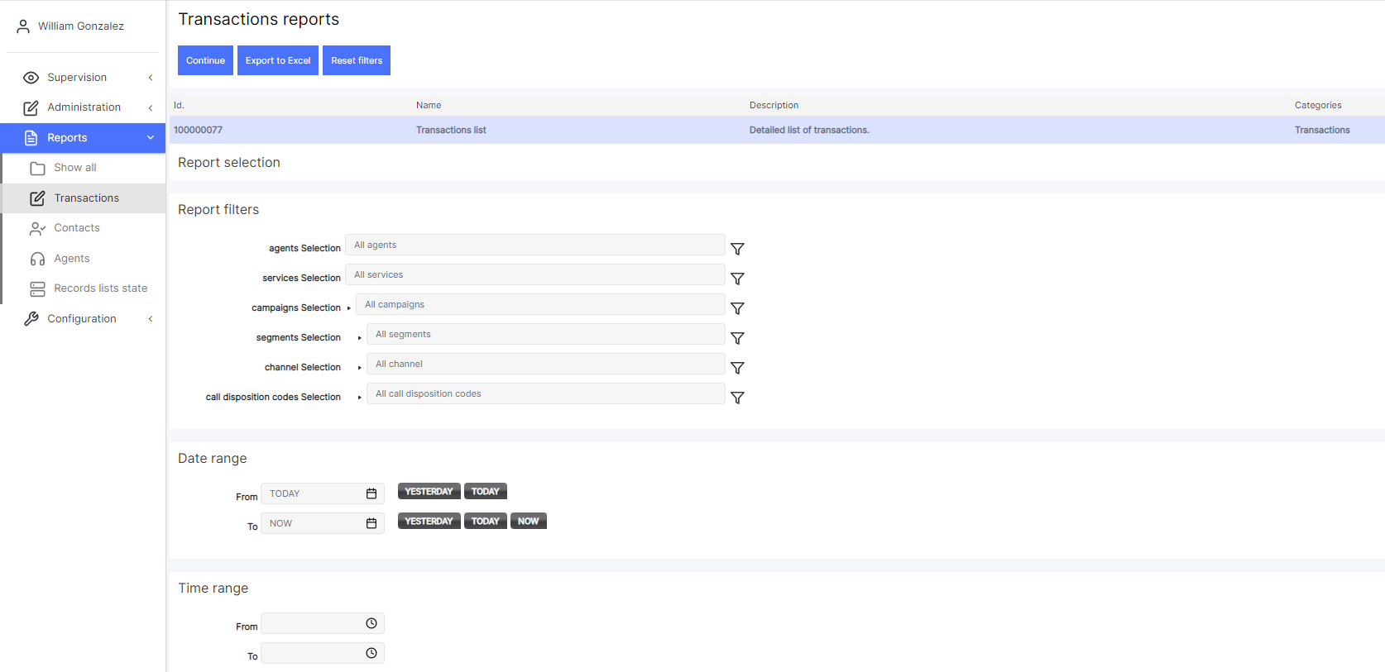

Available Omni+ Reporting Filters, you can also create, edit, and remove filters.
FILTER | DESCRIPTION
Agent | Allows selecting the agents from whom we want to obtain information. All  agents are selected by default.
Data clustering | Refers to clusters by date. Allows seeing the information by Days/Months.
Campaign | Allows selecting the campaigns from which we want to obtain information. All campaigns are selected by default.
Channel | Allows selecting the channel by which contact was established: telephone, e- mail, ...
Data itemization | Allows selecting the presentation of reports (by columns or rows) related to  additional client data.
Delivered to agent | Allows distinguishing the transactions between those that have been delivered to an agent and those that have not.
Pause status | Allows filtering by agent pauses in progress, finalized or both.
Session status | Allows filtering by agent sessions in progress, finalized or both.
call dispositions  codes | Allows selecting/filtering the call dispositions we want to list for this specific  report.
Groups of call dispositions codes | Allows selecting a group of call dispositions.
Date intervals | Select the interval for consultation, specifying both dates of the interval.
Hour interval | Allows selecting the time slot within which the requested records are found.
Pause reasons | Allows selecting/filtering the pause reasons of agents we want to list for this  specific report.
Service objective | Allows indicating the value of the service objective for the report. If left blank, the one assigned to each one of the campaigns shown in the result will be used. Time must be expressed in the following way: Ad Bh Cm Ds.  Where, Ad: A days, Bh: B hours, Cm C minutes and Ds: D seconds, with A, B, C, D positive numbers, not necessary to include all elements.  Examples: 1m 30s, 2h, 1d 12h,...
Transaction origin | Allows selecting the transaction origin:

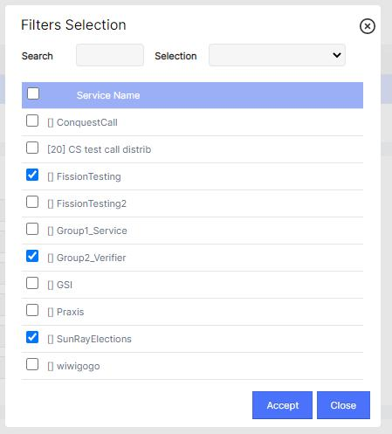

3. Advanced Analytics Reporting
Some reports have a graphic representation, but such presentation can be changed. The drop-down menu can be seen at the top, it allows selecting the report's data representation. By dragging the mouse over the pie graphic, the representation of the different elements and their absolute values will be seen. In the rest of representations, the element and percentage it represents within the total will be displayed.
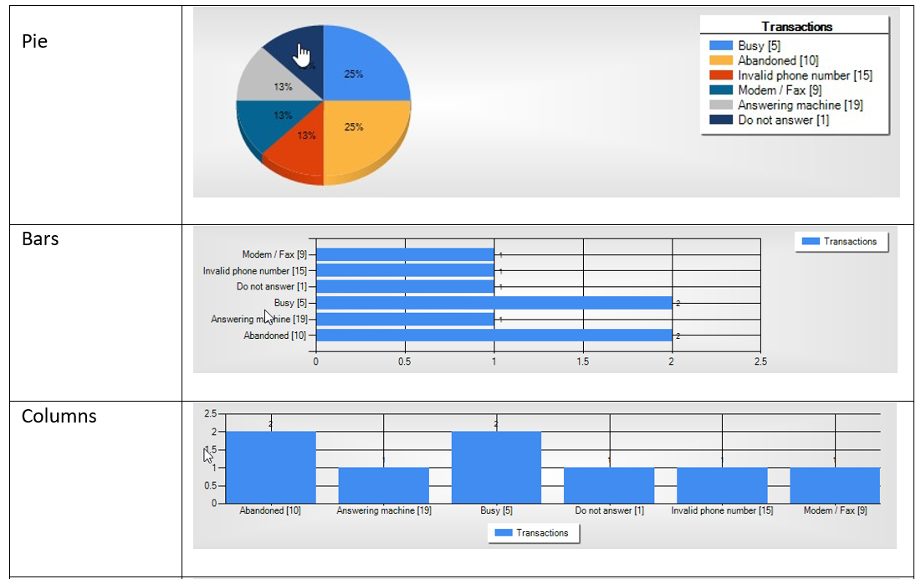
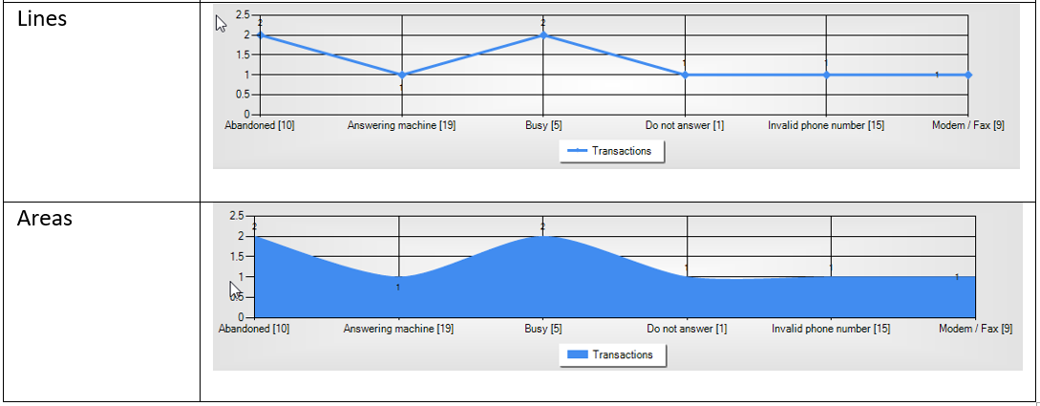

4. Interactive Realtime Dashboards

The first image below demonstrates the ability to click on a campaign, service or agent. The second image displays the data of the selected campaign, service or agent in real-time.

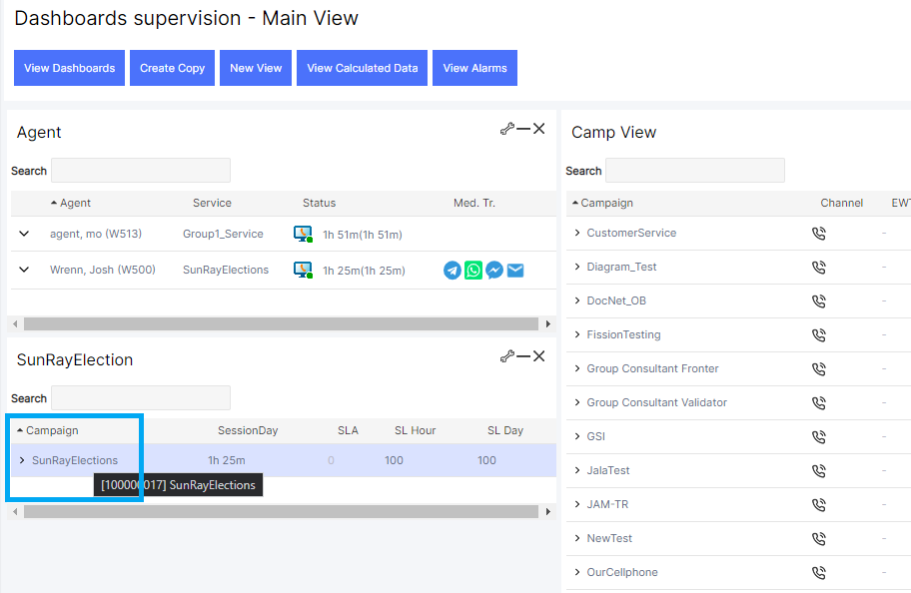

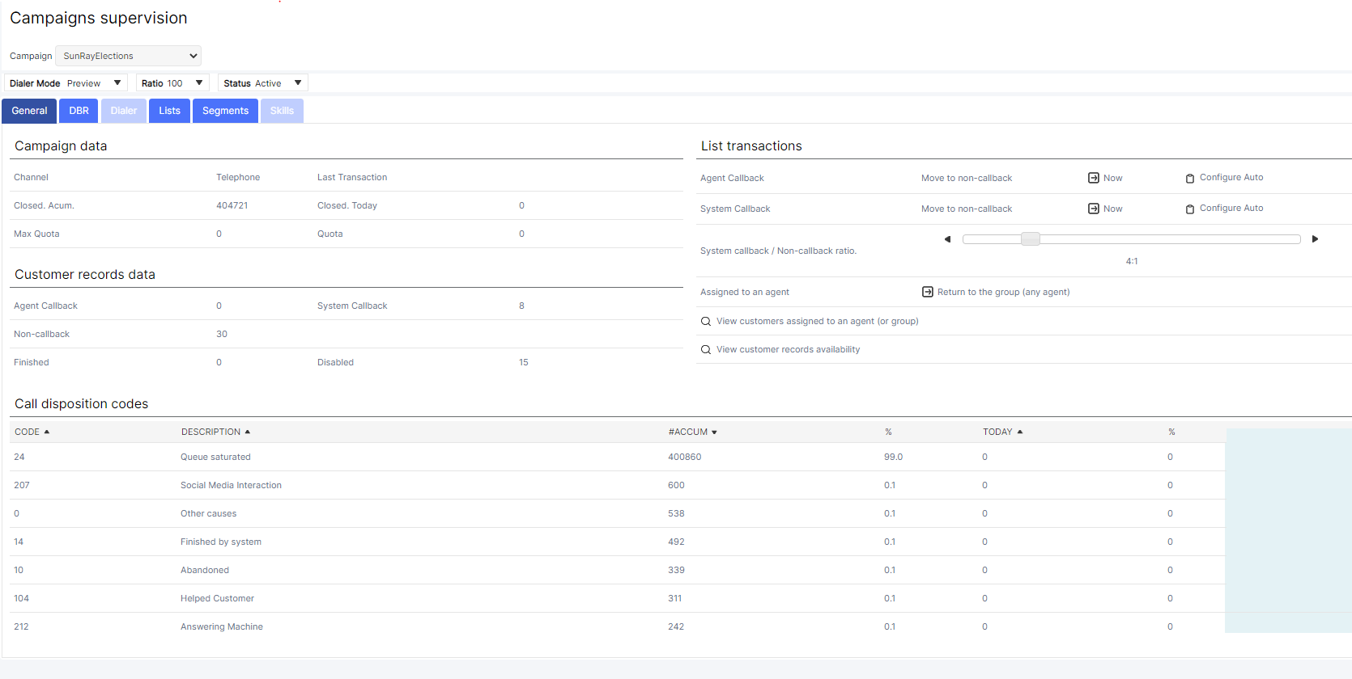

23. Minimum Report Requirements.

Service Level Report
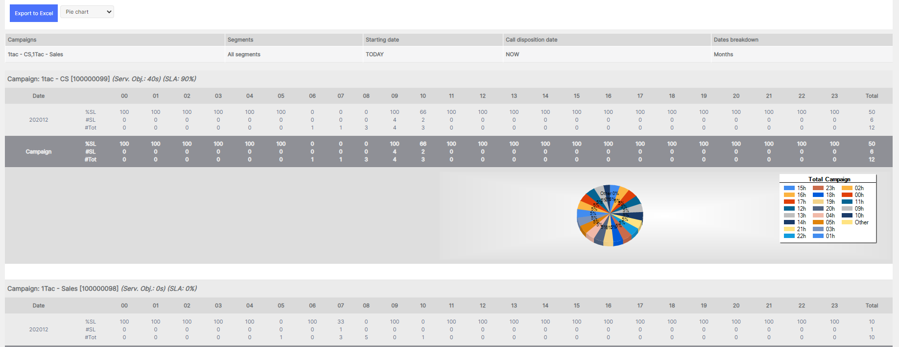

Disposition Report
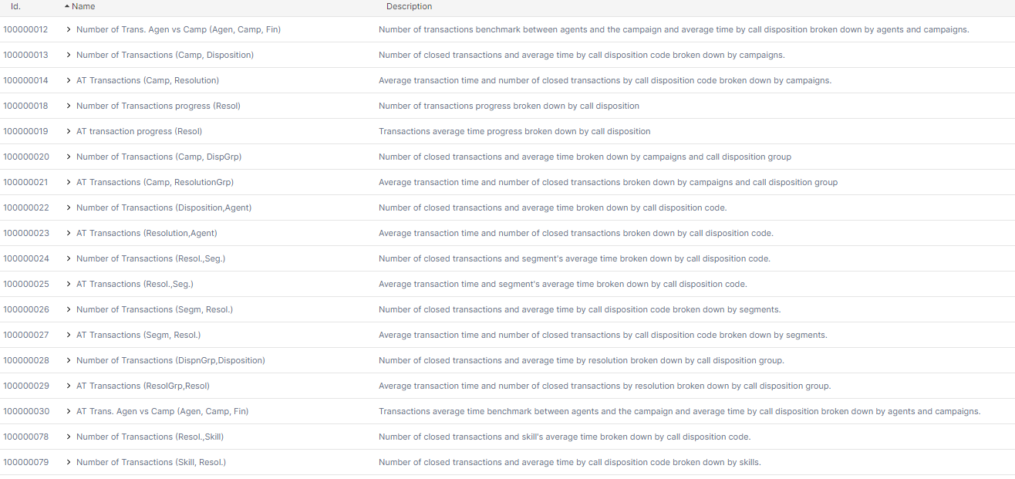

Occupancy reports
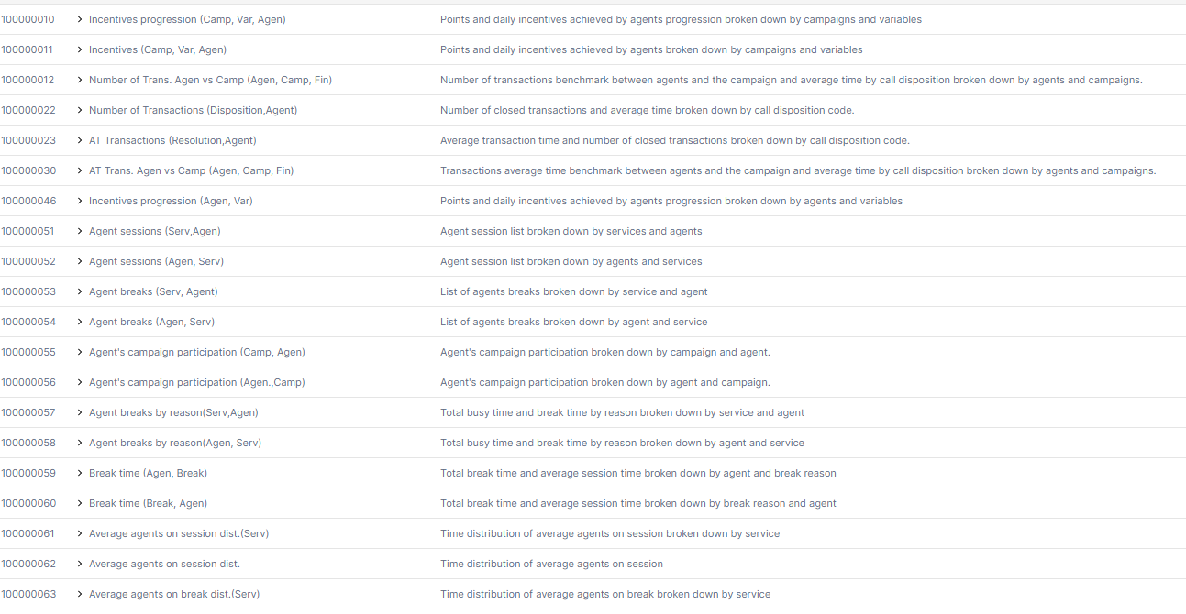

IVR reports, In Omni+ is called DBR (Dynamic Business Routing)
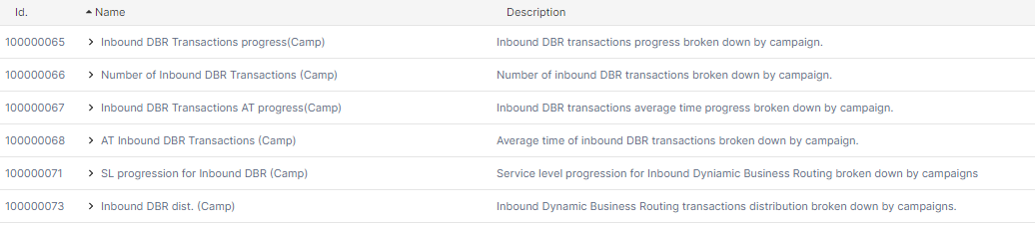

Outbound Reports
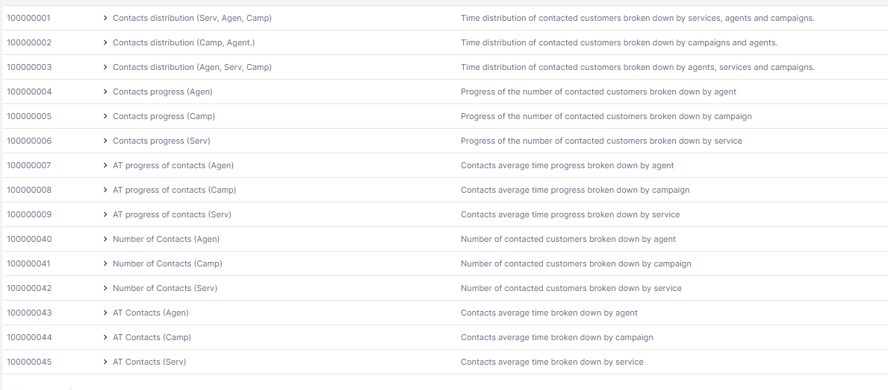

Queue Reports
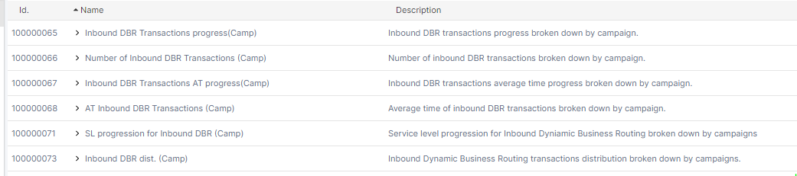

24. Day to Day Operation Reports

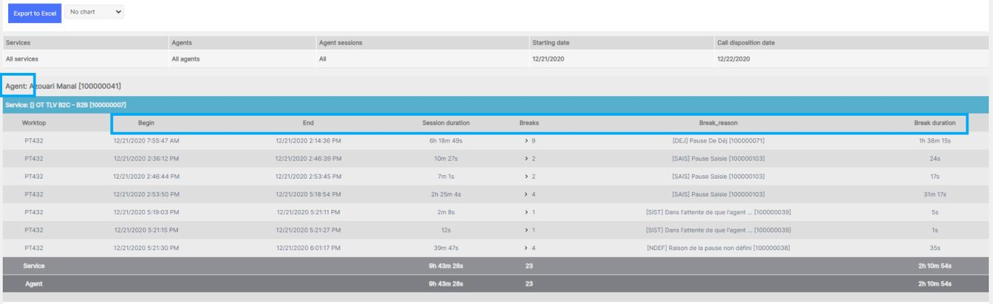

Report can be generated by date, month and hourly.
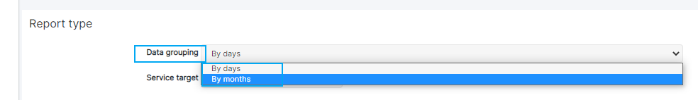

25. Omnichannel Reports

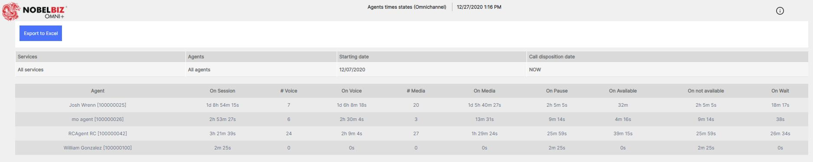

26. Remote Dashboard Access

Dashboard can be viewed remotely all you need is a PC, browser and internet connection. These can also be accessed on a table of smartphone.

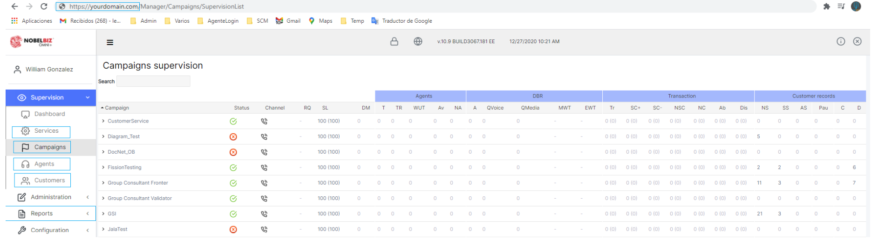

27. Different Database Formats
Data can be exported or imported via secure database connections or API. NobelBiz has API and integration methods. A proper scope of work will need to be performed to better understand the import and export requirements.

28. Reporting: KPI Reporting

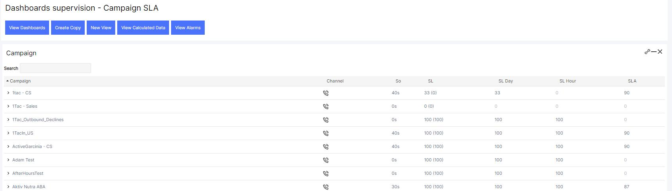
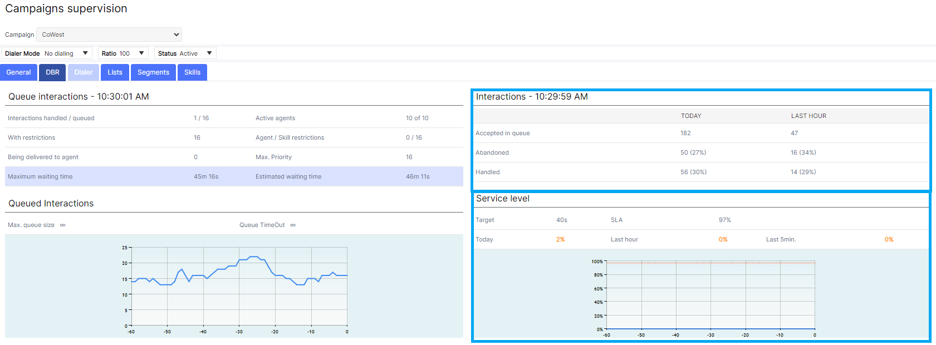
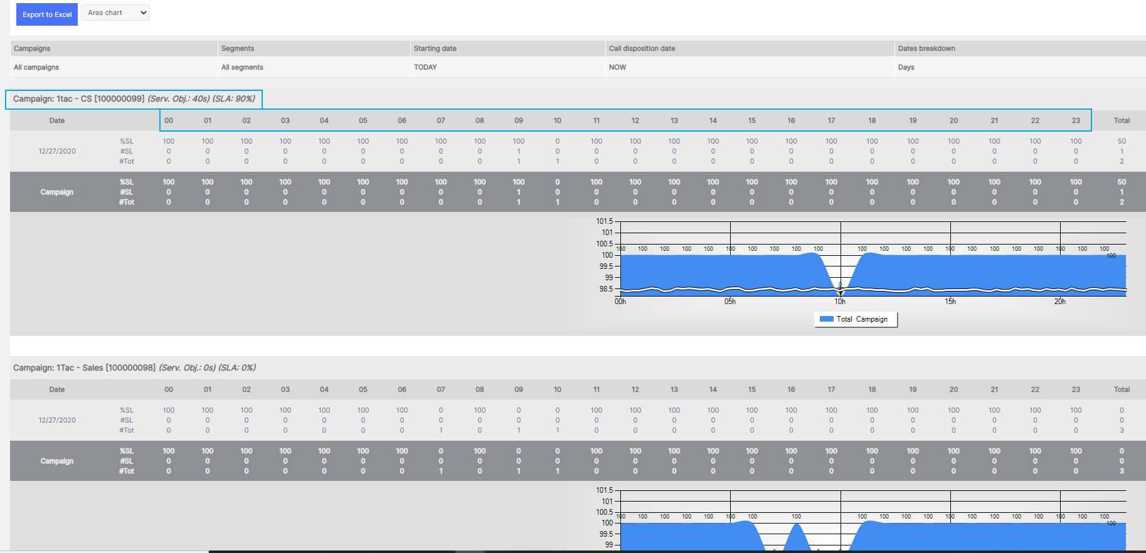

29. CC DATA Management
All customer data generated at call center will be integrate to MTN data warehouse on daily basis. The data can be exported in real-time or batch mode over a secure process defined by NobelBiz and MTN. Procedures can be set up to send data to customer warehouse either on an EOD process or sent intraday. Also, data can be retrieved via ODBC connections or by data replication.

RFP Reference: 2.3.1 Business Continuity and Disaster recovery
we recognize and will comply with MTN’s Class A disaster recovery policy defined below.
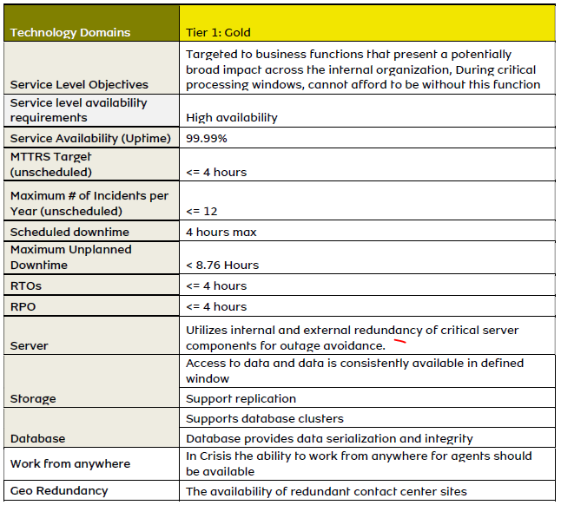

RFP Reference: 3.1 Security

NobelBiz Network Security Policy

Overall Network Security Guidance

- Access and use of Nobelbiz network must be consistent with Nobelbiz network security policies and standards at all times.
- Network security control measures are to be consistently applied to all employees, computer systems and communications systems
- Information must be protected based on confidentiality, value, and criticality; regardless of the media on which it is stored or the methods by which it is moved.
- Nobelbiz network security policies and standards will be reviewed on an annual basis, at a minimum, to ensure that they remain current. Security and Compliance Officer will review network security procedures and appropriate vendor guidelines on a semi-annual basis, at a minimum to ensure that the most current security measures are applied.
- All Nobelbiz network components should be at least annually audited to make sure they remain in compliance with the Nobelbiz network security policies.
- All employees must be provided with sufficient training and supporting reference materials to allow them to properly protect Nobelbiz network.
- Security and Compliance Officer is responsible for identifying variances against generally accepted network security policies, and also for promptly initiating corrective action.
- All current Nobelbiz employees as well as well the new ones should be trained at least annually regarding the network security policies. Nobelbiz management must ensure that all employees read, understand and sign the Nobelbiz network security policies.
- Accountability and responsibility for following Nobelbiz network security policies on a day-to-day basis is every employee's duty.
- Exceptions to network security policies and standards will only be made when the costs of implementing a standard exceed the security benefits or when the implementation will prohibit necessary Nobelbiz business activities.
- Requests for changes to these statements contained in Network Security policies should be presented to and approved by the Nobelbiz management and Nobelbiz security consultant.
- customer information (i.e., invoices) shall be treated with the highest level of sensitivity and any activities involving customer information shall be made in accordance with Nobelbiz security policies in the same way as confidential internal information.

Network security management
- Network security will be centrally managed and coordinated. The management will be coordinated by Nobelbiz CTO.
- Network security management reserves the right to monitor all systems and data for compliance with Nobelbiz security policies.
- All employees must be provided with sufficient training and supporting reference materials to allow them to properly protect Nobelbiz systems and data.
- Security and Compliance Officer must provide refresher courses and other such materials to regularly remind employee about their responsibilities with respect to network security.
- Users must be notified about the specific actions that constitute a security violation and the fact that such violations may be logged with an automated tool.
- All new employees shall complete a network security course appropriate to their level of privilege within the company.

External entities

- Outside consultants and equipment vendors support engineers must be subject to the same network security requirements.
- Proprietary information must be protected from disclosure to third parties unless the third party has a demonstrable need-to-know, and such disclosure has been authorized by management.
- All agreements dealing with the handling of Nobelbiz information by third parties must include clauses that allow Nobelbiz to audit the controls used for these handling activities and specify the ways in which Nobelbiz information will be protected
- Employees must not reveal Nobelbiz proprietary and confidential information to third parties unless they have written authorization from executive management. Every disclosure of Nobelbiz proprietary and confidential information to third parties must be recorded, and these records must be maintained for a minimum of 3 years
- All disclosures of customer information to a third party require appropriate written authorization from the customer prior to its release to the third party.
- Personnel will inform the legal department of any known violations by a third party of Nobelbiz network security policies.
- All customer information is the property of the customer and must be treated as a valuable asset to that customer. Nobelbiz has custodial responsibilities for the confidentiality, integrity, and availability of customer information.
- Nobelbiz personnel will create new accounts, disable existing accounts, or modify existing user privileges for a customer only after receiving a written (via e-mail is acceptable) request and authorization from the customer’s Technical or Business Contact. All such actions and documentation will be logged in the Nobelbiz tracking system.
- Nobelbiz must design system architecture, define user privileges, and implement other relevant technical safeguards such that customers cannot gain access to, view, or acknowledge existence of, or otherwise interfere with, either the activities or data of other customers.
- Nobelbiz employees including, but not limited to, operational employees will only initiate a remote-control session to a customer equipment/account with proper authorization from the customer (i.e. to impersonate a user account)
- All changes to customer information and equipment by Nobelbiz employees will be logged by the person making the change and monitored and reviewed as necessary
- If customer data is transferred between location the data must be encrypted
- If a customer has to cancel any services performed by Nobelbiz, Nobelbiz will preserve the customer’s data and release it to the customer. In addition, Nobelbiz will remove all former customer information from their equipment in a timely fashion.
- All demonstrations performed by Nobelbiz employees will not reveal end-customer names or accounts (unless they have given specific permission) and will not reveal any customer information or any Nobelbiz proprietary and confidential information.
- Any equipment used for a former customer will be thoroughly cleared to prevent the ability of recovery tools being used to retrieve data.
- Nobelbiz employees will not purposely destroy or tamper with customer information.

Network security organization

- Management must allocate sufficient resources and staff to adequately address network security.
- Management must ensure Nobelbiz network security policy and procedures are communicated to all employees throughout the organization.
- Management must ensure Nobelbiz data security policy and procedures are properly funded, supported, and enforced.
- The team of network security management will be comprised of: CTO, Operation Director, Security and Compliance Officer, Network Engineer and Security Consultant.
- Network security management team must establish minimum security baselines for the protection of information assets according to risk.
- Network security management team must establish and oversee a procedure for the investigation of known or suspected compromises of sensitive information.
- Network security management team must establish and manage a procedure to train employees and contractors in information security and to maintain awareness of network security policies.
- Network security management team must provide the direction and technical expertise to ensure that Nobelbiz information is properly protected.
- Network security management team must perform risk assessments, prepare action plans, evaluate vendor products, participate on in-house system development projects, assist with control implementations, investigate information security breaches, and perform such other activities that are necessary to assure a secure information handling environment.
- Network security management team must prepare, maintain, and distribute documentation that describes Nobelbiz network security policies.
- Users (employee, contractor, consultants, customers or vendor) must maintain confidentiality of logon password(s).
- Users must ensure security of information entrusted to their care.
- User must adhere to all network security policies.
- User must promptly report security incidents to the network security management team.

- Users must limit the use of information assets to authorized business purposes only.
- Security and Compliance Officer/Network Engineer is responsible for administrating user IDs and passwords for NobelBiz employees and NobelBiz customers
- Security and Compliance officer must understand the different data environments and the impact of granting access to them.
- Security and Compliance officer must ensure that access requests are consistent with the network security policies.
- Security and Compliance officer must monitor and analyze security alerts and information.
- Security and Compliance officer is responsible for creating and follow up on security violation reports.
- Security and Compliance officer/Network Engineer is responsible for sending passwords of newly created user IDs to the user ID owners.
- Security and Compliance officer/Network Engineer is responsible for resetting user ID passwords upon proof of account ownership
- Security and Compliance officer is responsible for control and monitor all access to all data on Nobelbiz systems and networks.

Network, systems and application security development

- The procurement and purchase of hardware and software must be reviewed by Network security management team. Development and users with elevated privileges must only use software that has been provided by a known and trusted person, supplier, or organization.
- Nobelbiz communications networks will be designed so that no single point of failure, such as a central switching or core router, could disrupt network service essential to the continuity of business. Any single points of failure that exist on networks given less priority should be documented.
- System designers and developers should always follow the network security policies for system designs
- Security will be a fundamental design criterion used in all data network designs. While it is understood that other factors can and will influence the final design whenever possible security considerations must be given the utmost consideration in any design exercise.
- Every system design must have provisions for error recovery and an audit trail. All computer-assisted processes must involve human intervention prior to initiating any action that could result in service interruption or sustained service downtime.
- Only one primary function shall be implemented per system component and in case of virtualization environment one function shall be implemented per virtual machine.
- All new system security controls must be tested prior to implementation.
- Software in development must be kept strictly separate from production software. This separation must be achieved via physically and logically separate computer systems and networks where possible.
- Test functions should be performed separately from production and development environments. The results of testing will be fully documented and securely maintained for a reasonable period.
- All changes to production systems must follow the change control policies.
- There shall be no restriction on use of open-source software and tools, provided appropriate legal review of the source code licenses has been granted, use is consistent with that license, and the software is appropriately tested.
- Nobelbiz employees must not possess or use code-breaking software or hardware that allows illegal copying of proprietary software, discovery of passwords, or cryptanalysis of encrypted data.
- The creation of any new network must be audited by Security and Compliance Officer and approved by the higher-level management.
- The network architecture must be clearly documented.
- Any changes to the existing architecture must follow the change control policies and procedures, and the relevant documentation must be updated immediately.
- Network systems documentation (network diagrams, routing tables, IP addresses) are very sensitive information that will be restricted to authorized employees only.

- All systems that store or process Nobelbiz or customers sensitive data will be protected using a firewall, or other approved network security devices, from public external networks.
- Only authorized personnel will be allowed access to network equipment.
- Different levels of access will be administered based on the job function, responsibility, and necessity of the employee's access.
- Remote access to network resources will require strong authentication mechanisms.

Firewall Controls

- All non-essential networking or system services must be eliminated or removed from the firewall.
- Any changes to the firewall configuration must be approved by CTO and should follow Change control policy.
- Security and Compliance Officer shall review the system logs generated from the firewall on a weekly basis in order to detect any unauthorized entry attempts or unusual behavior.
- Persistent or dangerous unauthorized access attempts through the firewall will be reported to the CTO.
- The configuration of all firewall systems will be reviewed semi-annually. This verification will be done through an approach approved by CTO (i.e., scanning tools, random audits of the system, etc.).
- Alarm or monitoring tools must be used to alert of security-related events originating from the firewall, routers, intrusion detection systems and other security related devices.

Identification, Authentication, and Access Control

User Identification Controls
- All users must be positively identified prior to being able to use any network resource.
- Each system must uniquely identify only one user. Shared or group user-IDs are not permitted for any IT resource (i.e., routers, firewalls, applications, operating systems, etc.)
- User IDs will have a standardized naming convention within a particular platform or application.
- If the system is not access using OTP (one-time password) systems must be configured to force users to change their passwords every 90 days.
- All User ID accounts and passwords must be distributed in separate transmittals

Password Controls
- Where technically feasible, systems must be configured to enforce a minimum password length of 8 alphanumeric characters. The length of passwords must always be checked automatically at the time they are chosen by users.
- All users must choose passwords that cannot be easily guessed, contain trivial words, or be associated with the user in any way. This standard must be enforced automatically by the system managing password changes at the time users choose new passwords. Passwords should be alphanumeric, and have a mix of cases (capital and small letters), and at least one number or special character in the sequence.
- Passwords must not be stored in readable form in batch files, in automatic login scripts, in terminal function keys, in computers without access control, or in other locations where unauthorized persons might discover them.
- Passwords must be encrypted at all times.
- All passwords must be promptly changed if they are suspected of being disclosed, or known to have been disclosed to unauthorized parties.

Change Control

- A formal change control procedure must be documented and used to ensure that all changes to production environments are implemented only after receiving proper authorization from the CTO. Change control procedures must be used for all significant changes.
- All changes must be tested prior of implementing into the production systems.
- All changes must be properly documented and if required training must be provided to the users.
- Periodic reviews must take place to ensure that only approved changes were implemented.
- Emergency Changes to production systems must be authorized by CTO
- . Documentation of an emergency change in production systems must be submitted within 24 hours of the emergency change.
- Emergency changes should undergo the standard design and testing process after the change has been implemented in the production environment to ensure that the change is an adequate long-term solution.
- Under no circumstances will Nobelbiz production systems be used for testing or development.
- All applicable security-related fixes, patches, scripts, and the like must be implemented in a timely fashion following appropriate testing.
- Maintenance activities should only be scheduled with the prior knowledge and consent of the CTO. If customer operations are affected, maintenance activities should be acknowledged and approved by customer.
- A record of all maintenance activities will be maintained and will include the date, incident, modifications, and name of the person or persons making the modifications.

Physical and Environmental Security

- All Nobelbiz production systems shall be located on any of the two Nobelbiz co-locations.
- Access to the production network is restricted by co-location security based on Nobelbiz provided access list.
- Access permissions lists to the co-location should be kept up to date.
- Preventive maintenance must be regularly performed on all production and other critical computer and communications systems such that risk of failure is kept to a reasonably low probability.
- Employees must not eat and drink, or bring items that may cause damage to the systems in co-location

RFP Reference: 3.1 Security

NobelBiz Incident Response Plan

Purpose
The purpose of this document is to provide the required steps to follow in the event of a security incident. The purpose is to ensure that all elements are in place, all parties are notified in timely manner, and the proper actions are taken to resolve the incident.
Scope
Incident Response Plan provides a process to react to any problem suspected to be happening into the Nobelbiz network.

Description
The identifying support engineer member who discovers the security incident is considered the owner of that incident. It is also possible that the incident is identified via the company installed monitoring tools.
Below is a list of procedural steps which must be followed in the event a security incident is suspected:
a. The owner will respond to the incident by immediately contacting the CTO or Operations Director and Information Security Compliance Specialist. Response notification shall be in the form of an email and followed up with a call and they will contain:
- The nature of the Incident
- What equipment are involved
- Location of equipment
- How was the incident detected?
b. The owner of the incident will also work to define the following:
- Is the incident real?
- Is the incident still in progress?
- What kind of data is exposed to the incident?
- What is the impact of the business if the security incident is successful (critical, medium, minimal)
- What system or systems are targeted?
- The source of the incident is from outside network or inside?
- What type of incident it is?
- Is the incident quickly contained?
- Is the response urgent and will the response alert the attacker?
c. An incident ticket will also need to be created via the ticketing system and will be categorized under one of the 3 categories:
- P1 - a threat to sensitive data
- P2 - a disruption of service
- P3 - a misuse/abuse of service
d. If a P1 category incident was detected, the following determination must be made:
- sensitive data was compromised
- sensitive data may have been compromised
- sensitive data was not compromised but the threat exists
e. If the first 2 determination are made the following procedures must be followed:
- Do not turn the compromised machine off. Instead, isolate compromised systems from the network
- Do not access or alter compromised systems
- Preserve logs and electronic evidence
- Be on “high” alert and continue monitor all systems
f. Team members will review system logs, looking for gaps in logs, reviewing intrusion detection logs to determine how the incident was caused.
g. Team members will recommend changes to prevent the occurrence from happening again.
h. Upon CTO approval, the changes will be implemented and systems affected restored
i. After the incident is resolved the documentation of the incident needs to take place. The following shall be documented:

- How the incident was discovered.
- The category of the incident.
- Where the attack came from.
- What the response plan was.
- What was done to respond?
- Whether the response was effective.
- Damage assessment.
- Copies of logs shall be attached to the documentation.
j. Policies and procedures shall be updated so similar incidents are avoidable in the future.

RFP Reference: 3.1 Security

Information Security Policy
Objective:
Our objective, in the development and implementation of this written information security plan, is to create effective administrative, technical and physical safeguards for the protection of all sensitive information.
Purpose:
The purpose of creating this policy is to:
- Ensure the security and confidentiality of any sensitive information;
- Protect against any anticipated threats or hazards to the security or integrity of such information;
- Protect against unauthorized access to or use of such information in a manner that creates a substantial risk.
Definition of Sensitive Information
All Nobelbiz information is classified into two main categories:
- Nobelbiz Public Information. Public information is information that has been declared public knowledge by someone with the authority to do so or is already in the public domain, and can freely be given to anyone without any possible damage to Nobelbiz.
- Nobelbiz Sensitive Information. Sensitive Information is all information that does not fall under the definition of Nobelbiz Public Information. There is a wide range of Sensitive Information with different levels of sensitivity as shown below.

Examples of Sensitive Information
The list below is not intended to be all inclusive, but rather to provide a wide range of examples of Sensitive Information. To improve the organization of this list, the information is divided into different sensitivity levels ranging from Most Sensitive to Sensitive. These levels are not intended to be formally defined terms, but rather are used to be descriptive about the different levels of sensitivity. Sensitivity levels are not black and white – employees must always apply good judgment when considering how sensitive something is and therefore, how to protect it from unauthorized access, disclosure or use.

Most Sensitive
- Protected Health Information (PHI) and Personal Information (PI) that is protected by HIPAA, Massachusetts 201 CMR 17.00, Payment Card Industry Data Security Standard (PCI), and other state, federal and international laws and regulations. A full list is provided in the Comprehensive Information Security Policy. Examples are:
  - Social Security numbers;
  - Credit or debit card numbers;
  - Driver’s license numbers or state or federal issued identification numbers;
  - Bank routing and/account numbers in conjunction with first and last name;
  - All other PHI as it applies to HIPAA;
  - Credit reports.

Extremely Sensitive
- Credentials used to access Nobelbiz systems, systems of Nobelbiz’s partners and their clients, and 3rd-party vendor systems;
- Other proprietary or confidential information that would enable an unauthorized person or entity to breach Nobelbiz’s security and therefore access Sensitive Information (for example, Nobelbiz firewall configurations);
- Any information governed by a legal contract or agreement;
- Communications regarding confidential business deals such as mergers and acquisitions and joint product development efforts;
- Information that could impact Nobelbiz’s ability to compete effectively in the market if the information were compromised or disclosed to competitors or other third-parties. Examples include:
- Trade secrets;
- Business plans and strategies;
- Investor presentations and financial reports/projections;
- New product plans or designs;
- Personnel files (e.g., performance reviews);
- Source code for Nobelbiz’s products and internally developed tools.

Very Sensitive
- Information Nobelbiz maintains or has access to about our partners such as employee contact information; configuration information (e.g., notification templates, patching configuration); and partners’ client information such as contact and site information; network configurations; IP addresses; firewall configurations.

Sensitive
- Internal telephone directories, email directories and general corporate information. (This information is still considered sensitive as inappropriate disclosure may aid external parties in attempting to compromise Nobelbiz’s security, perpetrate fraud or harass employees.)
Security Coordinator:
Nobelbiz will designate someone from the company to be Security Coordinator who will implement, supervise and maintain the information security policy. The Security Coordinator will be responsible for:
- Initial implementation of the Plan;
- Insuring employees are trained in security practices of the organization;
- Regular testing of the Plan’s safeguards;
- Evaluating the ability of each of our third-party service providers to protect, in the manner required by PCI/DSS, the sensitive information to which Nobelbiz has permitted them access; and taking the steps reasonably necessary to ensure that such third-party service provider is applying to such information protective security measures at least as stringent as those required to be applied to such information under PCI/DSS.
- Reviewing the scope of the security measures at least annually, or whenever there is a material change in our business practices that may implicate the security or integrity of records containing sensitive information.
- Conducting an annual training session for all owners, managers, employees and independent contractors, including temporary and contract employees who have access to sensitive information. All attendees at such training sessions are required to certify their attendance at the training, and their familiarity with the firm’s requirements for ensuring the protection of sensitive information.
The guidelines below require employees to apply good business judgment when deciding how to treat Sensitive Information. When in doubt, contact your manager, Compliance Security Officer, or a member of the IT Department for guidance.

- Employees should be aware that most of Nobelbiz’s Security Policies are designed to protect unauthorized or unintentional access to, disclosure or use of Sensitive Information. Employees must be aware of these policies and apply them when working with Sensitive Information.

- Sensitive Information must not be disclosed to other Nobelbiz employees unless there is a business purpose for that employee to have access to the sensitive information. For example, Nobelbiz firewall configurations must not be shared with Nobelbiz employees unless they have a specific need to know these configurations. Conversely, Nobelbiz telephone directories can be shared with all Nobelbiz employees, but must not be shared with third-parties.

- Sensitive Information must not be disclosed by any means (for example, by paper, orally, or electronically) to third-parties such as contractors, vendors, competitors, and other non-Nobelbiz entities without express permission from an eTeam member unless it is necessary to perform your specific job function. For example, business strategic plans must not be disclosed to third-parties without eTeam permission. Conversely, the head of Human Resources may disclose confidential employee compensation information to Nobelbiz’s payroll processing company since it necessary to perform the HR job function.

- Information received from third-parties under contractual arrangements including Non-Disclosure Agreements, Confidentiality Agreements, and general business contracts must not be shared with any Nobelbiz employee or any other third-party unless that employee or other third-party is covered by the agreement or contract.

- When sharing Sensitive Information with third-parties, mark it “Proprietary and Confidential” in a noticeable location whenever practical. Emails containing Sensitive Information sent to third-parties must also include “Proprietary and Confidential” in the body of the email.

- Many Nobelbiz employees have access to information about Nobelbiz’s partners such as contact information, configurations (for example, notification templates, patching configuration, AV software used). This is Sensitive Information and must never be shared with other third-parties unless express permission is received from the partner. This is an example of information that can generally be shared with other Nobelbiz employees who need this information to perform their normal job duties.

- Sensitive Information must not be left unattended in public places like conference rooms or cafeteria where it can be seen or taken by unauthorized personnel. Sensitive Information written on whiteboards or other public displays must erased or removed as soon as possible after use.

- Employees or others present in Nobelbiz facilities may sometimes find Sensitive Information, for example, if it is mistakenly left in a conference room. When this occurs, you are obligated not to read it and must either return the information to its owner or dispose of it in a secure manner immediately.

- Employees may mistakenly receive electronic information via email or other transmission method. When this occurs, you are obligated not to read it and must permanently delete it from your email or other electronic storage. You must also alert the sender that you received the information and have destroyed it.

Internal Risks:
To combat internal risks to the security, confidentiality, and/or integrity of any electronic, paper or other records containing Sensitive information, and evaluating and improving, where necessary, the effectiveness of the current safeguards for limiting such risks, the following measures are mandatory and are effective immediately.
Internal Threats
- A copy of the Information Security Policy must be distributed to each employee who shall, upon receipt of it, acknowledge in writing that he/she has received a copy.
- There must be timely training of employees on the detailed provisions of the Information Security Policy.
- Employment agreements must be amended to require all employees to comply with the provisions of the Information Security Policy, and to prohibit any nonconforming use of sensitive information during or after employment.
- Access to records containing sensitive information shall be expressly prohibited. Under no circumstances will any employee, not having a need to know or as part of their job duties, be allowed access to sensitive information.
- Electronic access to user identification after multiple unsuccessful attempts to gain access must be blocked.

- All security measures shall be reviewed at least annually, or whenever there is a material change in our business practices that may reasonably implicate the security or integrity of records containing sensitive information. The Security Coordinator shall be responsible for this review and shall fully apprise management of the results of that review and any recommendations for improved security arising out of that review.
- Terminated employees must return all records containing sensitive information, in any form, that may at the time of such termination be in the former employee’s possession (including all such information stored on laptops or other portable devices or media, and in files, records, work papers, etc.)
- A terminated employee’s physical and electronic access to sensitive information must be immediately blocked. Such terminated employee shall be required to surrender all keys, IDs or access codes or badges, business cards, and the like, that permit access to the firm’ s premises or information. Moreover, such terminated employee’s remote electronic access to sensitive information must be disabled; his/her voicemail access, e-mail access, internet access, and passwords must be invalidated. The Security Coordinator shall insure that a highly secured master list of all lock combinations, access control devices and keys is maintained.
- Current employees’ user-IDs and passwords must be changed periodically as per procedures.
- Employees are required to report any suspicious or unauthorized use of customer information.
- PAN information will never be sent via end-­-user messaging technologies under any circumstances.
- Whenever there is an incident that requires notification under PCI/DSS, there shall be an immediate mandatory post-incident review of events and actions taken, if any, with a view to determining whether any changes in Nobelbiz’s security practices are required to improve the security of sensitive information for which we are responsible.
- If employees are required to be away from their desk for an extended period of time, any sensitive work papers must be secured in lockers or locked drawers/file cabinets. At the end of the workday, all files and other records containing sensitive information must be secured in a manner that is consistent with the security polices rules for protecting the security of sensitive information.
- Re-login shall be required when a computer has been inactive.
- Visitors shall not be permitted to visit unescorted any area within our premises that contains sensitive information.
- Paper or electronic records (including records stored on hard drives or other electronic media) containing sensitive information shall be disposed of only in a manner that complies with PCI/DSS.
- Electronic media and other non-paper media containing sensitive information shall be destroyed or erased so that sensitive information cannot practicably be read or reconstructed.
External Risks:
To combat external risks to the security, confidentiality, and/or integrity of any electronic, paper or other records containing sensitive information, and evaluating and improving, where necessary, the effectiveness of the current safeguards for limiting such risks, the following measures are mandatory and are effective immediately:
External Threats
- There must be reasonably up-to-date firewall protection and operating system security patches, reasonably designed to maintain the integrity of the Sensitive information, installed on all systems processing Sensitive information.
- There must be reasonably up-to-date versions of system security agent software which must include malware protection and reasonably up-to- date patches and virus definitions, installed on all systems processing Sensitive information.
- All computer systems must be monitored for unauthorized use of or access to Sensitive information.
- There must be secure user authentication protocols in place, including: (1) protocols for control of user IDs and other identifiers; (2) a secure method of assigning and selecting passwords, or use of unique identifier technologies, such as biometrics or token devices; (3) control of data security passwords to ensure that such passwords are kept in a location and/or format that does not compromise the security of the data they protect; (4) restriction of access to active users and active user accounts only; and (5) blocking of access to user identification after multiple unsuccessful attempts to gain access.
- The secure access control measures in place must include assigning unique identifications plus passwords, which are not vendor-supplied default passwords, to each person with computer access to Sensitive information.

Top 15 Clients with contact details

Verizon UK Limited, Tony Kelly, Group Sales Director EMEA, tony.kelly@ae.verizon.com, +971561773506, USD 24 million, telecommunication services, Reading UK, since Feb 2010
Singapore Telecommunications Limited, Vernice Lau, Business Development Manager, vernicelau@singtel.com, +65 9710 5098, USD 2 million, telecommunication services, Singapore, since July 2019
Rostelecom, Yulia Biteleva, Key Account Manager International Wholesale, yulia.biteleva@RT.RU,
+7 (499) 999-81-09, USD 7 Million, voice services, Moscow, since 2008
ORANGE, Debbie Karns, Senior Director, Carrier Sales Americas debbie.karns@orange.com, +1-973-978-6520, telecommunication services, USD 7 Million/year, since 2015
Telus Communications Company, Mark Gilroy, Product Manager, mark.gilroy@telus.com, +1-647-462-7389, telecom/carrier services, $12 Million, Burnaby, BC, Canada, Dec 2012
Lumen Technologies, Beverly Clark, Account manager wholesale voice, beverly.clark@lumen.com, 1-470-226-2987, Mar 2002, telecom/carrier services, $9 Million, Atlanta, USA
BCE NEXXIA VOICE SERVICES CORP, Mouamar Arnous, Senior Manager Carrier Relations, mouamar.arnous@bell.ca, +1(514) 870-8058, Nov 2010, Telecom/carrier services, $25 Million, IL, USA
RESULTS TECHNOLOGIES, Mohammad Sabagh, Manager, Telecommunications, mohammad.sabagh@resultstel.com, +1(954) 926-4178, $6 Million, IT and Cloud Services, Florida, US, Jan-07
INFOCISION, Eric Keifer Manager, IT Dialer Operations, eric.keifer@infocision.com, +1(330) 670-5117, $1.5 Million, Marketing Consulting, Akron, Ohio, US, Jun-18
INFOCUS, Jake Bush, President, jake@infocu5.com, +1(805) 451-8076, $500K, Customer Support Software Solutions, Denver, Colorado, US, Dec-18
RDI, Dave Barker, VP of Telecom, dbarker@rdicorp.com, +1(513) 600-5323, $10 Million, Outsourcing Services, Cincinnati, Ohio, US, Dec-06
E-LEAD, Jeff​ Wickersham, Senior Product Manager, Jeff.Wickersham@eLeadCRM.com, +1(229)444-6300, $3.5 Million, Automotive Software and CRM North Valdosta, Georgia,US,Jun-15
ALLIED Global, Carlos Berganza, Telephony Manager, Carlos.b@alliedglobalbpo.com, +1(786)752-3754, $400k, Contact Center Services, Ciudad de Panama, Panama, Mar-18

SERVICE LEVEL AGREEMENT (SLA) Sample

- This support and service level agreement (SLA) applies to the NobelBiz platform and software identified in the Statement of Work and/or Agreement.
- Maintenance and Support Services - During the Subscription Term (as defined in the Agreement), NobelBiz will provide the following maintenance and support services for the NobelBiz platform software.
- Scheduled maintenance is performed with 48 hours notification to the customer and they will be performed during normal maintenance hours (03:00 – 07:00 am EST) or during customer agreed intervals. This includes updates, enhancements, bug fixes, upgrades or releases of the NobelBiz platform and software
- Availability
The NobelBiz Technical Support team is available 24/7/365 utilizing a shift system and a well-defined on-call system ensuring that personnel are always available to respond to any technical issues or inquiries received*.
All production systems and data connections are actively monitored for performance, threshold limits, alerts and faults. Automated reports indicating network and system performance are sent over e-mail for review to the engineering staff.
NobelBiz Technical Support team operates on a shift system and direct support contact is available during the below intervals (Normal business hours):
- Monday – Friday 4AM - 11PM, Eastern Time Zone
- Saturday – Sunday 8AM - 6PM, Eastern Time Zone

*Please note that outside normal business hours defined above, support is provided by on call support engineers. Contact should be made via phone for emergency situations outside business hours. Issues reported via e-mail or portal outside normal business hours will be responded the following day. We also encourage our customer to contact via phone as a preferred method in case of emergency even during normal business hours.
- Support Case Classifications
Support cases will have the following severity classifications:
- OUTAGE (P0) incident - a complete loss of service or a substantial loss of service affecting multiple customers. A network outage or a complete system failure.
- CRITICAL (P1) incident - a complete loss of service or a substantial loss of service provided to the customer. Service is down or unavailable.
- MAJOR (P2) incident - a disruption, degraded or partial loss of service provided to the customer, that intermittently affects performance, but still allows the customer to maintain business operations.
- MINOR (P3) incident - an incident that affects specific components of the service offered to the customer. Services are operational but partially degraded and immediate and acceptable solutions and workaround exist.
- SERVICE REQUEST (P4) - a service request it is defined as any request for additional service that was already agreed with the customer
- FEATURE REQUEST / CUSTOM DEVELOPMENT (P5) - a feature request is a request for a service that is not currently part of the agreed service with the customer

- Support Service Level Agreements
The below tables define the SLA agreements for technical support customer communication:
Severity Level | Response Acknowledgment | Delivery/Communication Updates
OUTAGE (P0) | Within 10 minutes | Within an hour  (depending on the complexity of the issue)
CRITICAL (P1) | Within 10 minutes | Within an hour  (depending on the complexity of the issue)
MAJOR (P2) | Within 15 minutes | Within 2 to 3 hours  (depending on the complexity of the issue)
MINOR (P3) | Within 20 minutes | Within 12 to 24 hours
SERVICE REQUEST (P4) | Within 1 business day | Delivery within 1-10 business days
FEATURE REQUEST (P5) | Within 1 business day | Delivery TBD  (based on business requirements)

- Support Contact Methods:
- Phone
800-601-7411 / 310-484-1598 Option 2 – Cloud Contact Center Services
France: +33973050334
Romania: +40312294674

- E-mail
supportccs@NobelBiz.com – Cloud Contact Center Services

- NobelBiz Service Desk Portal
https://nobelbiz.atlassian.net/servicedesk/customer/portals

- Escalation List
Customer will be able to escalate the support cases based on the below escalation list.
Escalation Level | Name | Position | Contact
0 | Engineer on Shift | Technical Support | 800-601-7411
1 | Stefan Dragan | Technical Support Coordinator | 619-354-5720
2 | Madalin Anghel | Director of Operation | 619-354-5740
3 | George Seroukas | COO | 514-806-1751
4 | Steve Bederman | CEO | 720-301-5325

Global Escalation List
Escalation Level | Position | Contact
0 | Technical Support | +40312294674  +33973050334
1 | Tier 2 Technical Support | +40752008527
2 | Technical Support Coordinator | +40755965985
3 | Director of Operation | +40722167244

NobelBiz Technical Support group is the control point for all customer updates and escalations. Escalations past Level 1 will occur at stated number of hours after initial ticket response, if issue is not resolved:
Escalation Level | P0/P1 | P2 | P3
Level 1 | 30 minutes | 1 hour | 2 hours
Level 2 | 30 minutes | 2 hours | 8 hours
Level 3 | 1 hour | 8 hours | 24 hours
Level 4 | 1 hour 30 minutes | 12 hours | 48 hours
Level 5 | 2 hours | 24 hours | 72 hours

- Term
The terms and provisions of this SLA shall commence on the date that the Agreement and Statement of Work are fully executed by authorized representatives of NobelBiz and Customer and shall continue for the duration of the contract Term as defined in the Agreement.
- Exclusions
NobelBiz maintenance and support services do not cover resolution of errors that result from: (i) third party software or hardware; (ii) any non-NobelBiz modifications to the NobelBiz platform and software; or (iii) use of the NobelBiz platform and software by Customer that is not in accordance with the documentation provided by NobelBiz. NobelBiz maintenance and support services do not cover modifications to the NobelBiz platform or software to work around the dysfunction or limitation of third-party software or hardware.

- Additional Services
Training, on-site support and application development work are additional services and can be made available to Customer for an additional fee. Maintenance for retired NobelBiz platform and software can be made available to Customer for an additional fee. The pricing and terms for all such additional services will be subject to mutual written agreement of the parties.

