Proposal of technical architecture

Physical configuration of agents' workstations

Based on the requirements of the OmniChannel production environment, the Group Media Contact operating fleet is equipped with computers with the following configurations:

Uc | Processeur | Intel core i7 processor (3.0 Ghz)
Uc | Memory | 16GB
Uc | Storage space | 250 SSD
Screen | Screen resolution | Full HD (1080p) 1920 x 1080 (DisplayPort: 75 Hz, VGA: 60 Hz
Screen | Interface | VGA (HD-15), DisplayPort, HDMI,
Screen | Size | 19 inches
Headphones | Features | flexible and rotating 340
Headphones | Features | Breathing noise filter
Headphones | Features | Cancellation of ambient noise
Headphones | Features | Acoustic insulation
Headphones | Cord | RJ9

Minimum software integration for workstations

Some applications are installed on these desktops. However, installations can also be carried out at the customer's request; depending on the needs of the company, and specific applications will be available.

Software | Editor | Describefor an
Microsoft  Windows 10 Pro | Microsoft | Lla
Firefox | Mozilla Foundation | Browser
Goo gle Chrome | Gogle | Browser
MicrosoftOffice  2019 | Microsoft | Office Suite (word, excel, power-poin,accesss, o-note, publisher, Sharepoint)
ESET Antivirus | Eset | Antivirus
Foxit Reader | Foxit | PDF reader
Microsoft  Silverlight | Microsoft Company
Microsoft .NET Framework 4.5.2 | Microsoft Company

PS: It should be noted that these software versions need to be updated based on the updates available to come from each vendor.

Solution Architecture

Redundant site solution

A set of precautionary measures to ensure continuity of activity in the face of technical failures, fires, health crises and natural disasters has been taken. The solutions are based on redundancy. Our approach takes into account redundant virtual and physical solutions.

Virtual redundancy
In this kind of situation, it is the production environment that is affected. The servers are running and accessible, but not fully accessible to staff to perform regular tasks (an example is the current health crisis, fire or political crisis) or physically be on site. In such cases, the continuity of the business is guaranteed by agents working remotely from their home or from an external site.
Therefore, it is essential to have the right tools to enable staff to work remotely from anywhere while ensuring that the same level of safety is maintained to protect the NED. The flexibility of our omnichannel CRM and its dual listening features, internal chat, call transfer, remote service indicator monitoring and allowing a supervisor to track and even guide the work of his team.

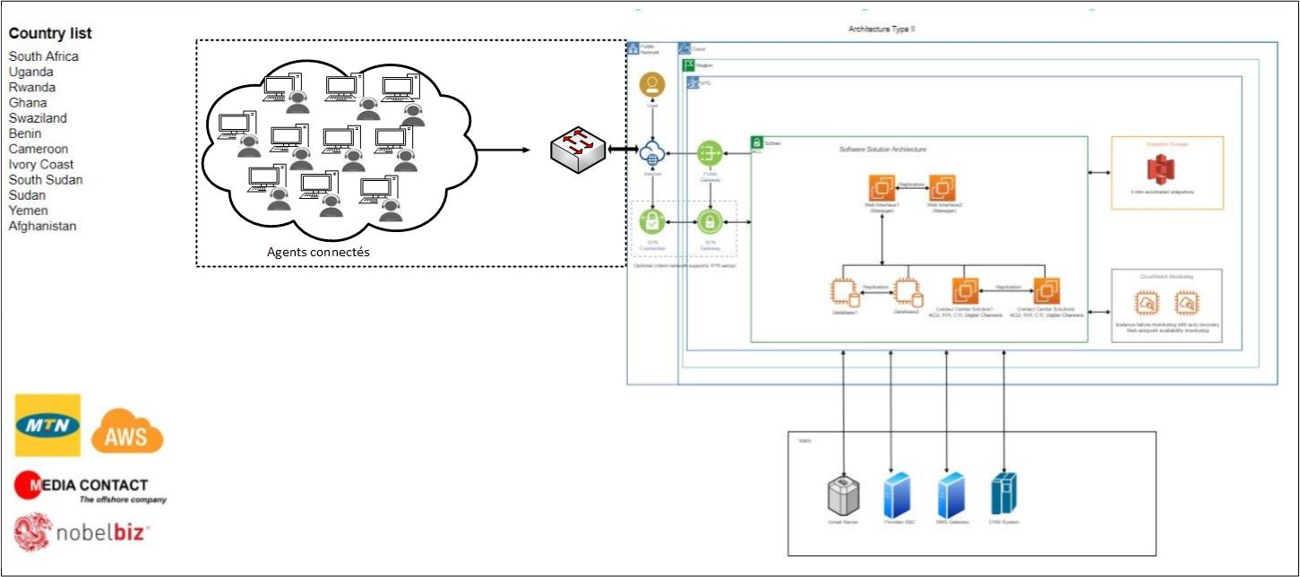
Figure 1:Simplified virtual redundancy scheme

The above architecture shows different components and processes put in place in case of virtual redundancy. This redundancy will only be activated when the production environment is not accessible. Our sites have a dedicated and redundant Internet connection of 30 Mbps. This connection arrives on a router switch configured with VLAC to continue serving various Internet service providers. Behind this switch, you'll find a security component configured with two types of VPN and all the necessary security configurations:
Our mobile users have unique, individual VPN access that allows them to connect to multiple sites to process customer calls and requests and access all available resources on a specific network as if they were on site. The VPN is managed through the Active Yearbook to provide access to agents or users and benefit from network policies implemented through the GPO.
The interconnection with the remote branch is done through a public IP address. This allows the administrator to grant access to the troubled site on the OmniChannel CRM and allow its agents to log in under the supervision of the team.

Physical redundancy
In this scenario, note that the main site is completely down or inaccessible (operating room and server room). In order to ensure continuity of service, we propose to use an interconnection of the SIP trunk between the MTN site and one of our subsidiaries closest to the country. In this way, we can guarantee at least 50% support to local languages because of the proximity of the two countries. The We propose the following architecture:
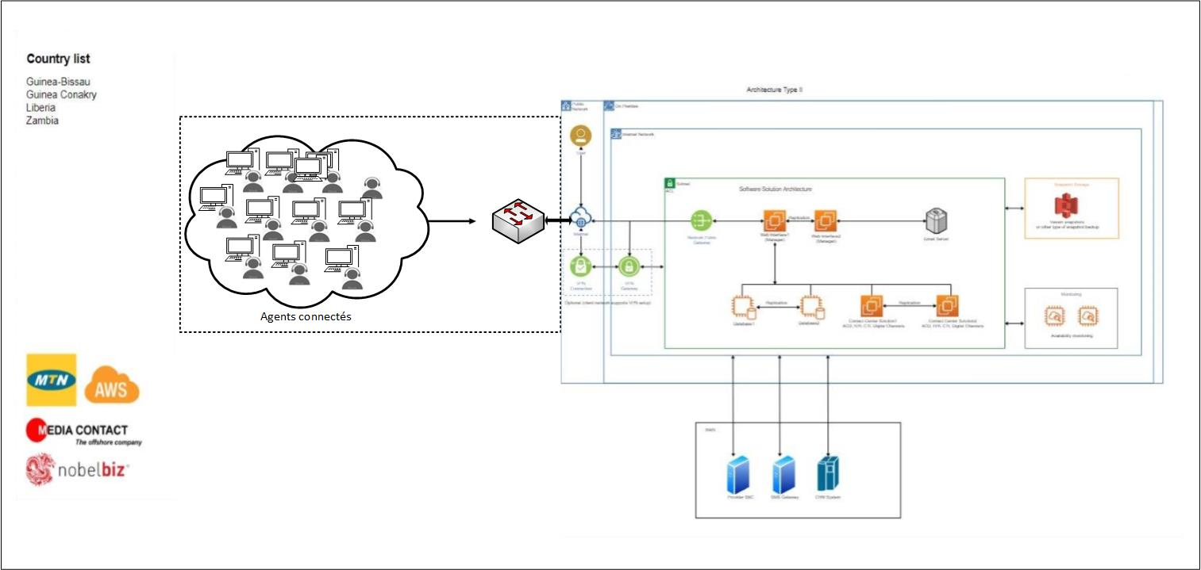
Figure 2:Simplified physical redundancy scheme
The architecture above outlines the plan to ensure continuity of services in the event of a disaster. It is important to remember, in this scenario, that the production site (the building) is out of service and that it may take hours or even days to get it back into service. Rerouting MTN calls to the newly identified site will be via a SIP trunk via a site-based VPN based on the SEC IP protocol. The routers and firewalls will allow us to guarantee a high confidentiality of the information (voice and data) shared between our two sites.

Facilities

Environmental energy
To ensure adequate lighting for workers and a continuous supply of electrical energy, the following arrangements have been made:
- Lighting with LED lamps (which allow good visibility);
- Generators (redundant) which act as relays in the event of a power cut ;
- Regulators which allows regulating the direct current;
- A PFC to correct the direct current ;
- Inverters to ensure the transition of the A / C current;

Wiring
Structured, reliable and robust wiring is the starting point for an exemplary computer network.
Our network wiring is based solely on the best grade cables and respecting a distance of less than 100 meters between the terminals (PC) and the patch panel. We make sure we follow a few rules:
- The lifespan of the cables to be observed;
- The length of the cables (which must not exceed 100 m);
- The choice of colors of the cable remains essential to the identification. The wiring of a computer network must be properly installed and identified using cables of different colors.
- Cable labelling and color coding: help you find your way in the event of a breakdown

Air conditioning
The ventilation and dissemination of workplaces play an essential role in limiting the concentration of pollution in the ambient air of workplaces and the time of exposure and thus in protecting the health of workers. They allow each employee to breathe air that does not harm their health.
According to international standards, the exclusive use of natural ventilation (by windows or other openings) is permitted only if the volume per occupant of the room is 15 m3 or more for offices and workplaces where light physical work is performed and 24 m3 for other workplaces.
As the Media Contact Group is not in either case, the ventilation of the workspace is carried out by mechanical ventilation devices (wall and standingair conditioners). These devices allow us to continuously ensure fresh air flow per occupant in our various premises and, above all, to cool the air to maintain a pure atmosphere, avoid rising temperatures and unpleasant odours, as well as condensations and evacuate pollutants.

Description of the server room
The server room is the part of the building designed to house the technical elements that allow the company to function properly. Our engine room meets the minimum standards recommended for this purpose.
A spacious room with impenetrable walls to prevent moisture is well equipped to house the technical command centre, providing shelter for communication equipment bays, server racks and network equipment all placed on a raised floor to conceal the arrival of network cables that pass through the false ceiling and are well serviced and stored to international standards. In our server room, we also have redundant inverters (dedicated only to servers and telecommunications equipment), which provide more than 120 minutes of battery life in the event of power outages and emergency central inverters. In addition, a voltage regulator that protects all equipment in the event of an electrical surge.
All this equipment generates a lot of heat, so we have an air conditioning system composed of standing air conditioners and wall air conditioners of very high power.
Access to the technical room is not given to everyone, which is why a card reader is installed at the door and only allows authorized persons.
The safety offered at nos technical roomcan be summed up in these points below:
- Well-locked part and controlled by a biometric device;
- The log files are stored and stored for audit purposes;
- Limited access only to IT staff;
- Well-ventilated room byairconditioning equipment;
- Room equipped with smoke and fire detection device;
- Room equipped with several fire extinguishers;
- Room under video surveillance;

Fire alarm protection
Fire is a threat that cannot be undermined. Therefore, the installation of fire alarm devices is mandatory in professional or commercial premises, considered to be open spaces to the public. It aims to signal a possible disaster through the combination of sensors and manual triggers. The fire alarm does not prevent the occurrence of a fire, but it can significantly limit the damage, allowing a rapid response such as the rapid evacuation of the premises. The alert alert alerts people on the scene to run to safety and to report a disaster to those affected to call for help. One of the main fire safety challenges is to detect the onset of a fire before it has fully started.
Our various production sites are equipped with fire alarm devices and emergency exits, as indicated by the evacuation plan of the production offices to allow the occupants to get to safety quickly.
The fire extinguishers are placed in strategic locations that are easily accessible to allow users in these areas to quickly neutralize the source in the event of a fire.

Security policy

Identification information and access management

User identification checks
- All users must be positively identified before they can use any network resource.
- Each system must uniquely identify a single user. Shared or group user IDs are not allowed for any it resources (i.e. routers, firewalls, applications, operating systems, etc.)
- User IDs will have a standardized naming convention within a particular platform or application.
- If the system is not accessible using OTP systems (single password) must be configured to force users to change their passwords every 90 days.
- All user ID accounts and passwords must be distributed in separate issuers

Password checks
- When this is technically feasible, systems must be configured to apply a minimum password length of 8 alphanumeric characters. The length of passwords should always be automatically verified when they are chosen by users.
- All users must choose passwords that cannot be easily guessed, contain trivial words, or be associated with the user in any way. This standard must be applied automatically by the system that manages password changes when users choose new passwords. Passwords must be alphanumeric, and have a mix of cases (capitals and small letters), and at least a number or a special character in the sequence.
- Passwords should not be stored in readable form in batch files, automatic login scripts, terminal function keys, untable access computers, or other places where unauthorized people can discover them.
- Passwords must be encrypted at all times.
- All passwords must be changed quickly if they are suspected of being disclosed or if they have been disclosed to unauthorized parties.

Controlling change

- A formal change control procedure must be documented and used to ensure that all changes to production environments are implemented only after receiving the appropriate authorization from the Technical Director. Change control procedures must be used for all significant changes.
- All changes must be tested before being implemented in production systems.
- All changes must be properly documented and, if necessary, training should be provided to users.
- Periodic reviews must be conducted to ensure that only approved changes have been implemented.
- Emergency changes to production systems must be authorized by the Technical Director
- . Documentation of an emergency change in production systems must be submitted within 24 hours of the emergency change.
- Emergency changes should be subject to a standardized design and testing process after the implementation of the change in the production environment to ensure that change is an adequate long-term solution.
- Under no circumstances will Nobelbiz production systems be used for testing or development.
- All security-related patches, patches, scripts, other fixes, and others, must be implemented in a timely manner after proper testing.
- Maintenance activities should only be planned with prior knowledge and the consent of the CCO. If customer operations are affected, maintenance activities must be recognized and approved by the customer.
- A record of all maintenance activities will be retained and will include the date, incident, changes and the name of the person or persons who will make the changes.

-Request for creation or suspension or reactivation of an identify
-Request for allocation or modification of access rights

Management of identified and access authorizations for human accounts

Management of non-human accounts

Management of special privileged accounts

Access profile

Authorizations repository (s)

Access management directive and procedures in force

Request for correction of deviations

Username created, reactivated, suspended or revoked

Updated log of access granted

Monitoring reports

Access rights granted, amendmentdor withdrawn

Figure 15:Identityand access authorisation management

User training
The goal of training users is to make them independent in the use of useful tools and applications for the execution of their tasks in the company. The goal is:
- Inform the user:
  - The establishment of activity logs to detect and trace any unauthorized activity and access;
  - In the absence of secure means at its workstation, it must refrain from transmitting sensitive data outside or outside the organization;
  - Sanctions to which it is exposed for non-compliance with the provisional regulations put in place in terms of access management.
- Make users aware of users' needs:
  - The importance of choosing a secure password, based on best practices in the field, and keeping it secret at all times;
  - The importance of locking your workstation when away from your desk;
  - The legal constraints and the means to obtain the information to which he accesses;
  - The obligation to report, without delay, any breach of the security of the information to which it has access.

Data security
An acceptable data security policy begins with an action plan in place.
- The first step in our data security policy is to assess risks and threats, consequences and vulnerabilities.
- We then define the scope of what is sensitive, i.e. what data is particularly essential or confidential and requires enhanced protection:
  - User files,
  - Servers' files Server files (restore points),
  - Legal documents (employees and clients),
  - Emails
  - production application databases (customer interactions with call centre),
  - Voice and video recordings, etc.
- Equipment used to protect information deemed sensitive and confidential:
  - Installing a firewall
  - Setting up a VPN for remote access;
  - Access control,
  - Backup server, etc.
- Finally, we communicate regularly with the relevant departments and company employees about information security rules and distribute to employees the procedures (best practices) and actions to take in the event of a problem. These rules deal with the use of software, websites, computer hardware, etc.
A data backup and restoration strategy is in place to enhance data security. It is detailed below:
- Support for 5 years of offline storage of customer interaction history
Scalable and elastic, Omni can store data in the cloud or on-site for an indeterminate period. The goal of elasticity is to match the resources allocated with the actual number of resources needed at a given time. Scalability manages the changing needs of an application within infrastructure limits by adding or statically deleting resources to meet application demands if necessary.
- Support for offline storage of one-year calls and videos
Scalable and elastic, Omni can store data in the cloud or on-site for an indeterminate period. The goal of elasticity is to match the resources allocated with the actual number of resources needed at a given time. Scalability manages the changing needs of an application within infrastructure limits by adding or statically deleting resources to meet application demands if necessary

Support for one-year online storage of all transactions
Scalable and elastic, Omni can store data in the cloud or on-site for an indeterminate period. The goal of elasticity is to match the resources allocated with the actual number of resources needed at a given time. Scalability manages the changing needs of an application within infrastructure limits by adding or statically deleting resources to meet application demands if necessary

Infrastructure security

Access to the security of production facilities
- All Nobelbiz production systems are located on one of the two Nobelbiz co-sites.
- Access to the production network is limited by co-location security based on the access list provided by Nobelbiz.
- Lists of permissions for co-location access must be kept up to date.
- Preventive maintenance must be carried out on a regular basis on all critical production and other computer and communication systems so that the risk of failure is maintained at a reasonably low probability.
- Employees should not eat and drink or bring items that can damage co-location systems

Software security

- The procurement and purchase of hardware and software must be reviewed by the network security management team. Development and users with high privileges should only use software provided by a known and trustworthy person, supplier or organization.
- Nobelbiz communication networks will be designed so that no point of failure, such as a central switch or central router, can disrupt the network service essential to business continuity. All failure points that exist on lower-priority networks need to be documented.
- System designers and developers must always follow network security policies for system design
- Security will be a fundamental design criterion used in all data network designs. While it is understood that other factors can and will influence the final design as much as possible, safety considerations must be considered in any design exercise.
- Each system design must have provisions for error recovery and an audit trail. All computer-assisted processes must involve human intervention before taking any action that could result in a service interruption or sustained downtime.
- Only one primary function must be implemented by system component and in the case of a virtualization environment, a function must be implemented by virtual machine.
- All new system security controls must be tested before implementation.
- Software in development must be strictly separated from production software. This separation must be done through physically and logically separated computer systems and networks where possible.
- Test functions must be performed separately from production and development environments. Test results will be fully documented and maintained safely for a reasonable period of time.
- All changes to production systems must follow change control policies.
- There will be no restrictions on the use of open-source software and tools, provided that an appropriate legal review of source code licenses has been granted, that the use is compatible with this license and that the software is tested appropriately.
- Nobelbiz employees must not own or use software or code-breaking hardware that allows illegal copying of proprietary software, the discovery of passwords or cryptanalysis of encrypted data.
- The creation of any new network must be verified by the security and compliance officer and approved by senior management.
- The architecture of the network must be clearly documented.
- Any changes to the existing architecture must follow change control policies and procedures, and relevant documentation must be updated immediately.
- The documentation of network systems (network diagrams, routing tables, IP addresses) is very sensitive information that will be reserved for authorized employees.

- All systems that store or process sensitive Nobelbiz or customer data will be protected using a firewall, or other approved network security devices, from public external networks.
- Only authorized personnel will be allowed access to network equipment.
- Different levels of access will be administered depending on the employee's professional function, responsibility and need for access.
- Remote access to network resources will require strong authentication mechanisms.

- Firewall controls

- All non-essential network or system services must be removed or removed from the firewall.
- Any changes to the firewall configuration must be approved by the CTO and follow the change control policy.
- The security and compliance officer must review the system logs generated by the firewall on a weekly basis to detect any unauthorized entry attempts or unusual behavior.
- Persistent or dangerous unauthorized access attempts through the firewall will be reported to the Technical Director.
- The configuration of all firewall systems will be reviewed semi-annually. This audit will be done through an approach approved by the Technical Director (i.e. scanning tools, random system checks, etc.).
- Alarm or surveillance tools should be used to alert security-related events from the firewall, routers, intrusion detection systems and other security-related devices.

Operational security
Measures put in place to ensure the safety of the equipment available to the operational team:
- User-given computer hardware management: Workstations are provided to the user, managed and configured under Media Contact's IT security team. The connection of uncontrolled, unmanased or uninsured equipment by the company (whether computers, telephones, mobile and fixed computer equipment or removable storage media) to LAN equipment and networks is prohibited.
- Recall of protective measures: educating officers about IT risks (best practices in place)
- Computer equipment reallocation: A procedure for managing positions and media as part of the departure or reassignment of staff to new users has been put in place. This defines the conditions for using data deletion.
- Remote access to the company's IS or telecommuting: mobility and remote work multiply the points of exchange and access to the company's sensitive data. Today, more than ever, companies are increasingly using telework, currently imposed by national containment linked to the Covid-19 pandemic or coronavirus. However, remote work, operated on the Internet, is not without risks to protect the company's sensitive data. As a result, we have revised our security policy and adapted it to the mobility of our managers and agents because, on the one hand, we tend to be less vigilant when we work from home, where our personal practice is less strict. Second, we are more vulnerable to phishing attempts or fraudulent emails. Third, personal networks are less well protected from cyber attacks than private corporate networks. Therefore, it is essential to minimize risk by putting in place the right tools and establishing safe practices.

Innovative customer project services

Omnichannel is not responding to customer communication preferences; it's about adopting a smarter way of working. Hence our next-generation customer experience management solution.

Our Omnichannel platform designed to stay in touch with the customer at all times, on any channel, wherever they are in their customer journey. Our CRM simplifies contact management by grouping conversations across different channels into a single inbox and maintaining the same look regardless of the channel. This reduces the training time of your agents and makes the use of the platform intuitive and direct. Our dynamic distribution engine assigns contacts to agents based on their skills and availability, maximizing your ALS.
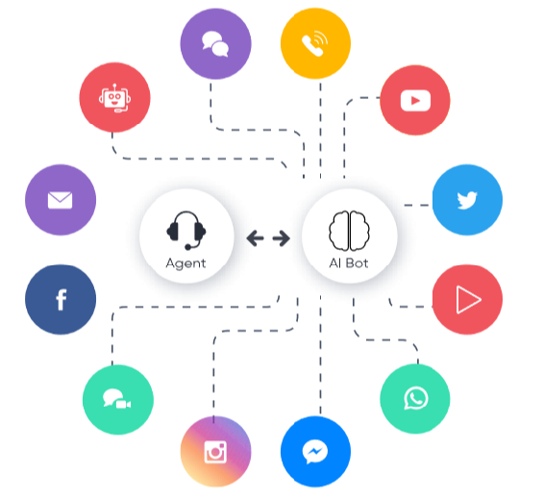
Synoptic of channels managed by our CRM

Receiving calls

Voice
The flexible and comprehensive Omnichannel CRM call center using a simple web browser provides access to all the functions of a contact center. It allows the customer to be tracked throughout the journey by allowing a complete and direct transition from a traditional call center to digital communication and automated interactions. Processing is done on a central server, with an internal bot that allows automatic distribution of calls to agents to manage a queue based on the subscriber's destination channel from the IVR.

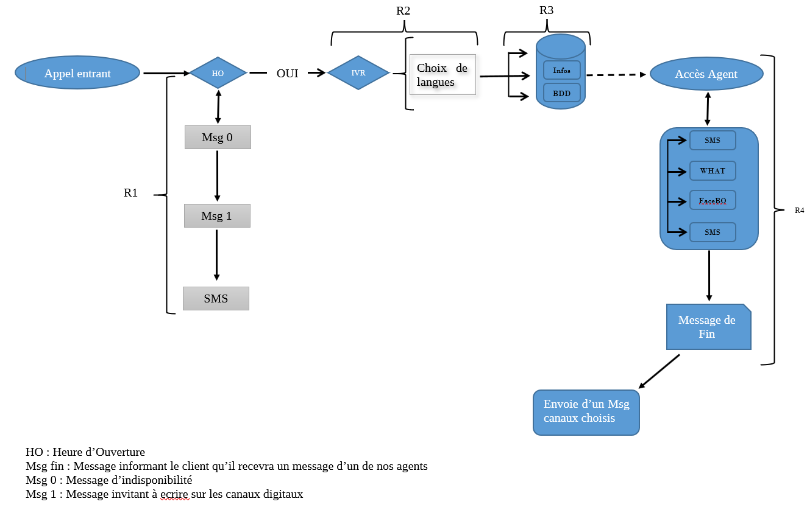

A1: During the call, the system verifies the availability of the IVR. Alternatively, send the limited availability message to the subscriber to contact us on our digital channels. At the end of the call, send an SMS inviting you to communicate on our channels with the numbers.
A2: If the IVR is accessible, check to see if the number has already contacted the call. If so, go directly to the previously chosen language menu. Otherwise, allow the choice of language (local or international).
A3: After choosing the language, the different menus are available to the customer to navigate the IVR for the right information. If the customer wants to interact directly or have specific information (such as their vomit code, history, etc.), the interaction of the databases can be done through the web service or SQL.
A4: If the customer is dissatisfied and wants to talk to an agent, the system offers him four choices to connect the call;
- Sms
- Whatsapp
- Messenger
- Voice
Suppose the customer's choice is among the top three. In this case, a message informs the customer who will receive a message from our agents in a matter of seconds. When the call ends, the system automatically sends a message to that customer depending on the channel chosen.
If it is Choice 4, the call is transferred to the agent's queue and following a segmentation (depending on which category the customer belongs to in the operator's database).

Digital
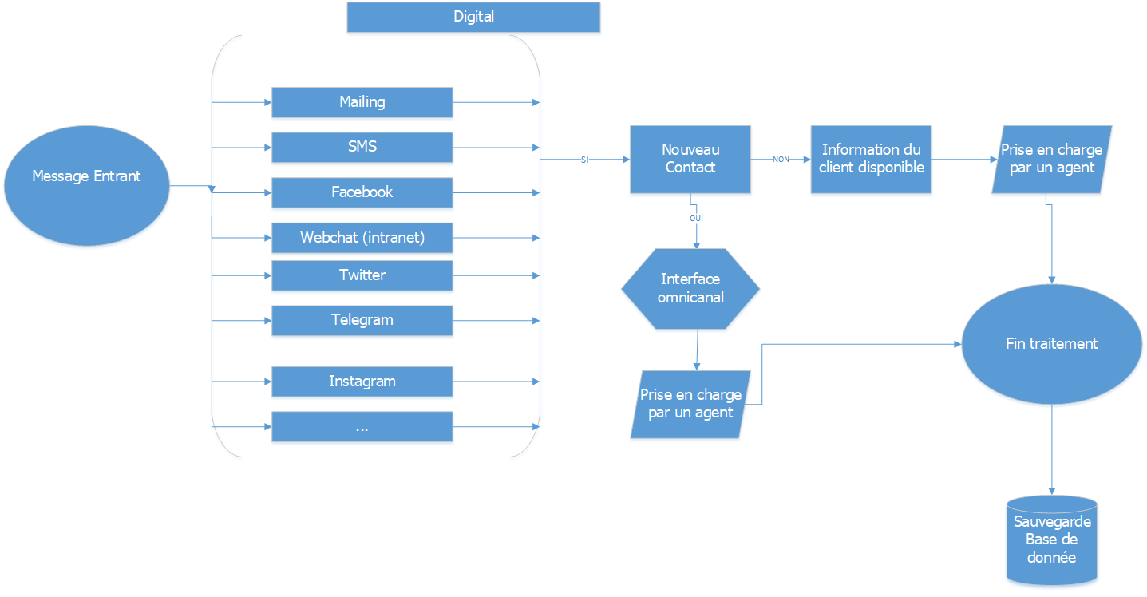
- Set up a campaign on these different channels to test previously sent features:
- Allow Omnichannel processing (having the history of the customer's interaction channels) to allow adequate support regardless of the channel used.
- Integration of chatbot and artificial intelligence to provide specific responses to the subscriber without the intervention of an agent.

Making calls

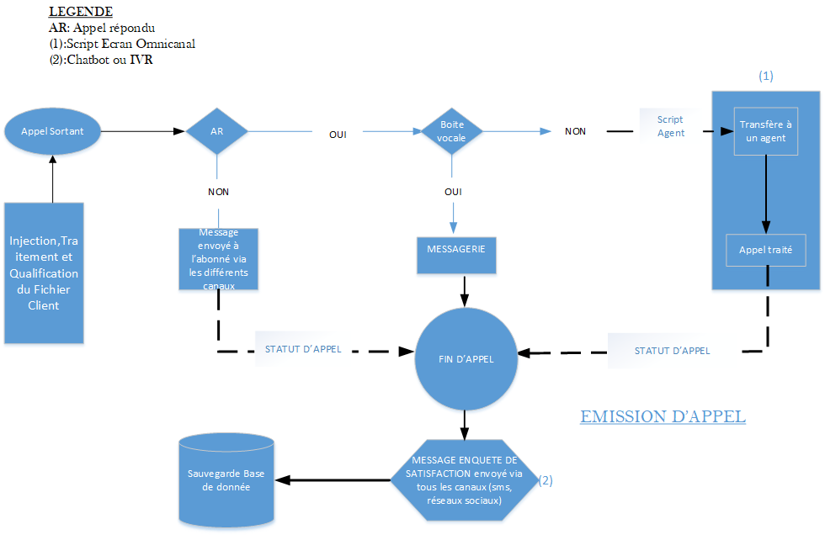

The administrator enters a group of numbers in the campaign
After dialing, the call is considered to be made if:
- Call without reply or voicemail, then a message is automatically sent to the party called via the various digital channels.
- The answered call then processes the conversation. At the end of the call, the status agent of the call and then a satisfaction survey message is sent automatically.

Back office

The backoffice will be managed from our tool by integrating a commercial application of a client X to be able to interact directly with the databases of the latter. Have statistics on status-based information to be able to quantify and measure the performance of CRM officers.

Service level Objective
RISK MAPPING | DETAILS | Impact | DEGREE | MEASURES/ / PROVISIONS | SLA (mn)
TECHNICAL / LOGISTICS | Power outage | Production shutdown | Low | Power Generator relay | 5
TECHNICAL / LOGISTICS | Equipment failure | Production shutdown | High | Technical intervention | 30
TECHNICAL / LOGISTICS | E1 Link Loss / Link Instability | Calls disruption | High | Customer alert | 15
TECHNICAL / LOGISTICS | unavailability of applications | Production in degraded mode (customer satisfaction deferred) | Low | Customer alert | 15
TECHNICAL / LOGISTICS | Poor audio quality | Crackle line | Medium | **** | 60
TECHNICAL / LOGISTICS | Server crash | Data loss | High | backup server | 60
TECHNICAL / LOGISTICS | Environmental risks (floods/fires) | Unreachable Site / Reduced production capacity | Critical | Commissioning of the virtual redundancy plan | 30 to 120
TECHNICAL / LOGISTICS | Environmental risks (floods/fires) | Unreachable site | Critical | Commissioning of the physical redundancy plan | 120 to 460

