Technical Architecture Proposal

Agents’ Workstation Hardware Configuration

Based on the OmniChannel production environment requirements, The Group Media Contact operation parc is equipped with computers having the following configurations below:

UC | Processor | Intel core i7 CPU (3.0 Ghz)
UC | Mémory | 16 Go
UC | Storage | 250 SSD
ECRAN | Screen resolution | Full HD (1080p) 1920 x 1080 (DisplayPort: 75 Hz, VGA: 60 Hz
ECRAN | Interface | VGA (HD-15), DisplayPort, HDMI,
ECRAN | Size | 19 inch
CASQUE | Features | Flexible and rotating 340 °
CASQUE | Features | Breathing noice filter
CASQUE | Features | Cancellation ambient noice
CASQUE | Features | Acoustic insulation
CASQUE | Cordon | RJ9

Minimum Software Configruation for Workstations

Some applications are installed on these workstations. However, installations can also be made at the client's request; depending on the needs of the business, and specific applications will be made available.

Software | Publisher | Description
Microsoft  Windows 10 Pro | Microsoft corporation | OS
Firefox | Mozilla Foundation | Browser
Google Chrome | Google | Browser
Microsoft Office  2019 | Microsoft corporation | Office Suite (word, excel, power-point, access, one-note, publisher, Sharepoint)
ESET Antivirus | ESET | Antivirus
Foxit Reader | Foxit  Corporation | PDF Reader
Microsoft  Silverlight | Microsoft corporation
Microsoft .NET Framework 4.5.2 (French or English) | Microsoft corporation

PS : It is noted that these software versions are to be made evolution according to the updates available to come from each supplier.

Solution Architecture

Redundant Sites Solution

A set of precautionary measures to ensure the business continuity in the face of technical faults, fire, health crisis and natural disaster have been taken. The solutions are based on redundancy. Our approach takes into consideration virtual and physical redundant solutions.

Virtual redundancy
In these kinds of situations, it is the production environment that is impacted. The servers are running and accessible but not fully accessible to the staff to perform regular tasks (an example is the current health crisis, fire or political crisis) or physically be on site. In such cases, the business continuity is guaranteed through agents working remotely from their homes or an external site.
Therefore, it is essential to have the right tools to allow the staff to work remotely from anywhere while ensuring the same security level is maintained to protect the LAN. Our omnichannel CRM's flexibility and its dual listening functionalities, internal chat, call transfer, monitoring of service indicators remotely and allowing a supervisor to follow-through the work of his team and even guide them.

Figure 1: Simplified Virtual Redundancy Schema
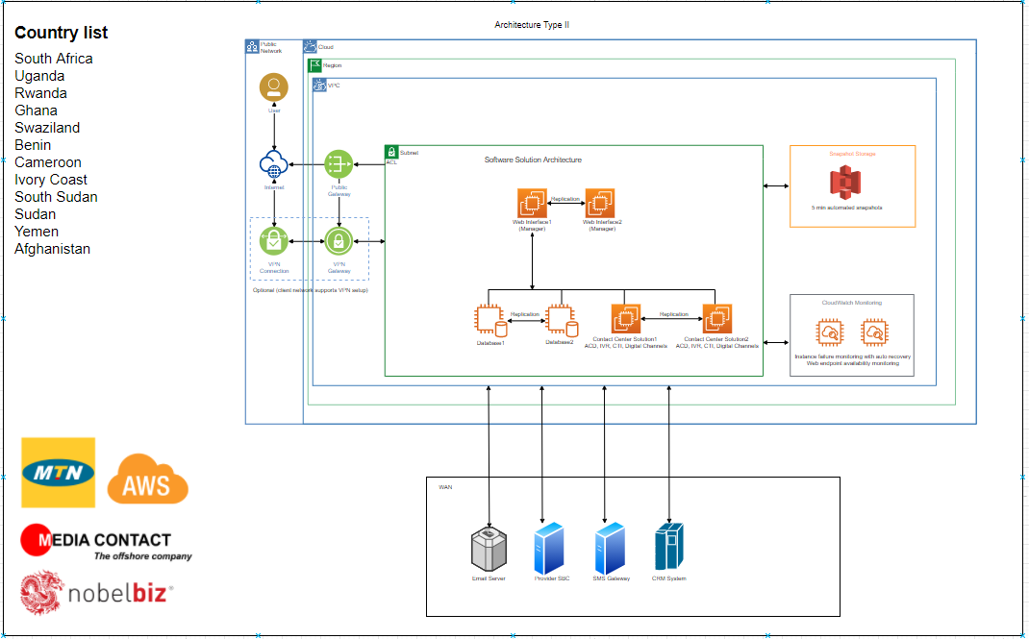
The architecture above shows different components and process put in place in case of a virtual redundancy. This redundancy will only be activated when the production environment is not accessible. Our sites have a dedicated and redundant 30 Mbps Internet connection. This connection arrives on a Cisco 2960 series switch configured with VLANs to continue servicing the different Internet service providers. Behind this switch, you will find a security component (Cisco ASA 5540) configured with two types of VPN and all the necessary security configurations:
- A mobile VPN to allow access to our mobile users ;
- Another site-to-site VPN to connect our various branches or subsidiaries.

Our mobile users have a unique and individual VPN access that allows them to connect to multiple sites to handle calls and requests from clients and access all the resources available on a specific network as if they were on site. The VPN is managed through the Active Directory to grant access to the agents or users and benefit from network policies implemented through the GPO.
The interconnection to the remote branch is done through a public IP address. This allows the administrator to grant access on the OmniChannel CRM to the struggling site and allow its agents to connect under the team's supervision.

Physical redundancy
In this scenario, note that the main site is completely down or inaccessible (operation room and server room). To ensure service continuity, we propose using a SIP trunk interconnection between the MTN site and one of our subsidiaries closest to the country. In this manner, we can guarantee at least 50% support local languages due to the proximity of the two countries. The We propose the following architecture:

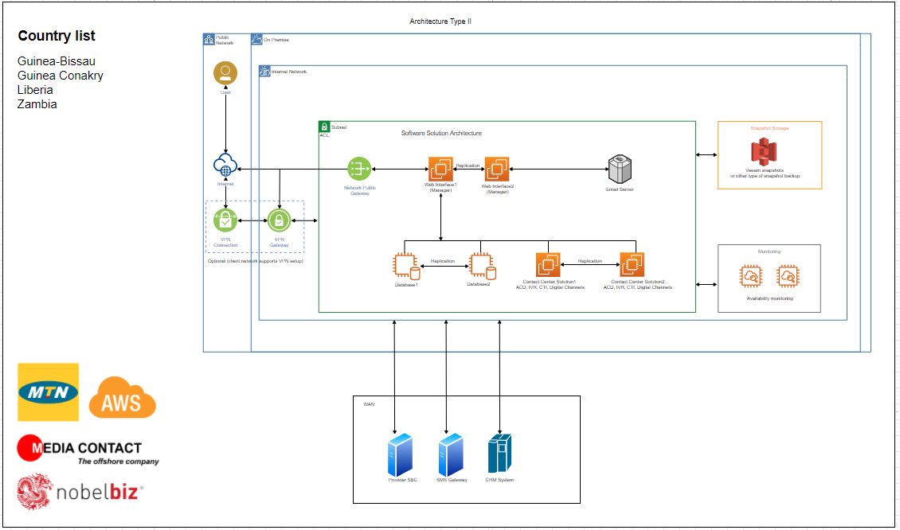Figure 2: Simplified Physical Redundancy Schema
The architecture above depicts the plan to ensure services continuity in the event of a disaster. It is important to remember, in this scenario, that the production site (the building) is out of service and it might take hours or even days to get it back in operation. The re-routing of MTN calls to the newly identified site will be done via a SIP trunk through a site-to-site VPN based on the IP Sec protocol. The routers and firewalls (Cisco ASA 5540) will allow us to guarantee high confidentiality of information (voice and data) shared between our two sites.
The restore of the necessary data (script, files, IVR, Campaigns, etc.…) from external backup storage will be possible because of the daily backup policy implemented on all our sites. This will allow to quickly set up the transactional IVRs and various campaigns used on the main site.

Facilities

Environmental energy
To ensure adequate lighting for workers as well as a continuous supply of electrical energy, the following provisions have been made :
- Lighting with LED lamps (which allow good visibility);
- Generators (redundant) which act as relays in the event of a power cut ;
- Regulators which allows regulating the direct current;
- A PFC to correct the direct current ;
- Inverters to ensure the transition of the A / C current;

Wiring
Structured, reliable and robust cabling is the starting point of an exemplary computer network.
Our network cabling is based only on best category cables and respecting a distance of less than 100 meters between the terminals (PC) and the patch panel. We make sure to respect a few rules:
- The lifespan of the cables to be observed;
- The length of the cables (which should not exceed more than 100 m);
- The choice of cable colours remains essential for identification. The cabling of a computer network must be correctly installed and identified using cables of different colours.
- Cable labelling and colour coding: help you find your way around in the event of breakdowns

Air conditioning
Ventilation and airing of workplaces play an essential role in limiting the concentration of pollution in the ambient air of workplaces and the exposure time and thus protecting workers' health. They allow each employee to breathe air that does not harm their health.
According to international standards, exclusive use of natural ventilation (through windows or other openings) is only authorised if the volume per occupant of the room is equal to or greater than 15 m3 for offices and workplaces where light physical work is carried out and 24m3 for other workplaces.
Since the Groupe Media Contact is not in any of these two cases, the ventilation of the workspace is carried out by mechanical ventilation devices (wall-mounted air conditioners and standing collimator). These devices make it possible to permanently ensure in our various premises minimum fresh air flows per occupant and, above all, refresh the air to maintain a pure atmosphere, avoid temperature rise and unpleasant odours, and condensations and evacuate pollutants.
Maintenance of installations: Parts of the installation requiring periodic maintenance and overhaul, such as filters, fans, humidifiers, heat exchangers, etc., will be quickly and safely accessible.
(See the appendix on evacuation plan)

Description of the server room
The server room is the part of the building intended to house the technical elements that allow the business's proper functioning. Our machine room meets the minimum standards recommended for this purpose.
A spacious room with impenetrable walls to prevent humidity is well equipped to house the technical command centre, thus making it possible to house the communication equipment bays, server racks and network equipment all placed on a raised floor to conceal the arrival of network cables that pass through the false ceiling and are well served and stored according to international standards. In our server room, we also have redundance inverters (only dedicated to servers and telecom equipment), which provide more than 120 minutes of autonomy in a power failure and central emergency inverters. Moreover, a voltage regulator that protects all equipment in the event of an electrical surge.
All these equipment generates much heat, so we have an air conditioning system consisting of two seven horsepower cabinets and two 3hp wall air conditioners. Our server room has several electrical outlets, and the power supply is centralised in an electrical box.
Access to the technical room is not given to everyone, which is why a card-reader is installed at the door and only allowing in authorised individuals.
The security provided to our different technical room can be summed up in these points below:
- Room well locked and controlled by a biometric device;
- The card access log files are saved and kept for audit purposes;
- Access limited only to IT staff ;
- Room well ventilated by air conditioning equipment;
- Room equipped with a smoke and fire detection device;
- Room equipped with several fire extinguishers ;
- Room under surveillance (camera) ;

Fire alarm protection
Fire is a threat that cannot be undermined. Therefore installing fire alarm devices is mandatory in professional or business premises, considered spaces opened to the public. It aims to signal a possible disaster through the combination of detectors and manual triggers. The fire alarm does not prevent a fire's appearance, but it can significantly limit the damage, by allowing a quick intervention such as the rapid evacuation of the premises. The alert makes it possible to warn those on the spot to run to safety and report a disaster to relevant people to call for help. One of the main challenges in fire safety is to detect the start of a fire before it has fully broken out.
Our various production sites are equipped with fire alarm devices and emergency exits as indicated on the production boards' evacuation plan to allow occupants to get to safety quickly.
Fire extinguishers are placed at strategic, easy-to-access locations to allow users of these areas to quickly neutralise the source in the event of a fire starting.

Interconnection and Call Routing Architecture

The interconnection of applications as well as the routing of calls between MTN and MEDIA CONTACT can be implemented through:
- The Fibre Optic (FO)
- Or Microwave
The choice of the type of link will be decided through a mutual agreement. The management of inbound and outbound calls and access to applications does not depend on the adopted type of link. Our description below is done based on the fibre optic link as it offers more flexibility.

Option 1: Managing incoming calls

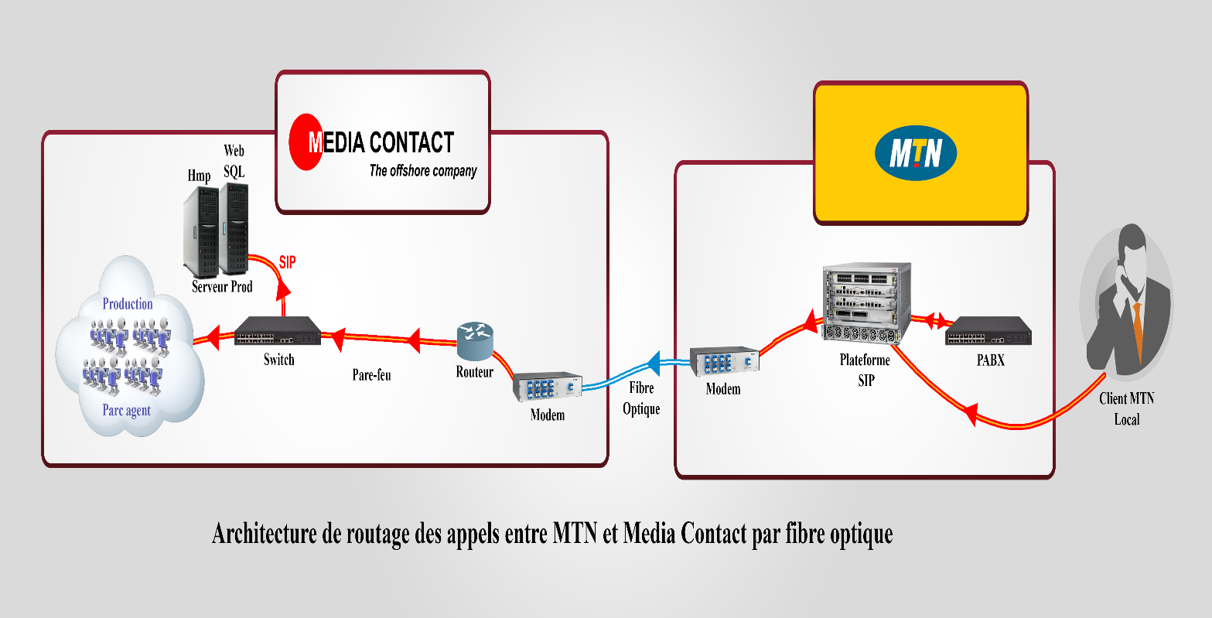
Figure 12:Call routing architecture
- MTN subscribers make a call to the customer service number
- The calls arrive on the MSC (Mobile Switching Services Center) or the operator's SIP platform who redirects them to the PABX.
- The subscriber calls are then directed to the call centre via a Fiber Optic link in SIP (Session Initiation Protocol) frame on the router configured for this purpose.
- The latter, thanks to its ACD function, then distributes calls randomly and automatically (according to an algorithm or rule in place) to the agents' IP Phones who will process requests from MTN subscribers. The CTC (Computer Telephony Coupling) function of the Omnichannel CRM allows the system to trace the caller's exact record to have his identity and call history.

(See appendix for Synoptic Diagrams of Receiving Calls Routing)

Option 2 :Management of outgoing calls

- A customer file is placed into the call database of the Omnichannel CRM;
- Using its powerful predictive function, the latter assigns a number to the call and route it to the MSC(Mobile Switching Services Center) of the operator who routes them to the various relay antennas until reaching the one in the subscriber’s zone. The MTN subscriber's phone rings and he is put in touch with the operator.
(See appendix for Synoptic Diagrams of Outgoing calls Routing)

Option 3: Access to customer business applications
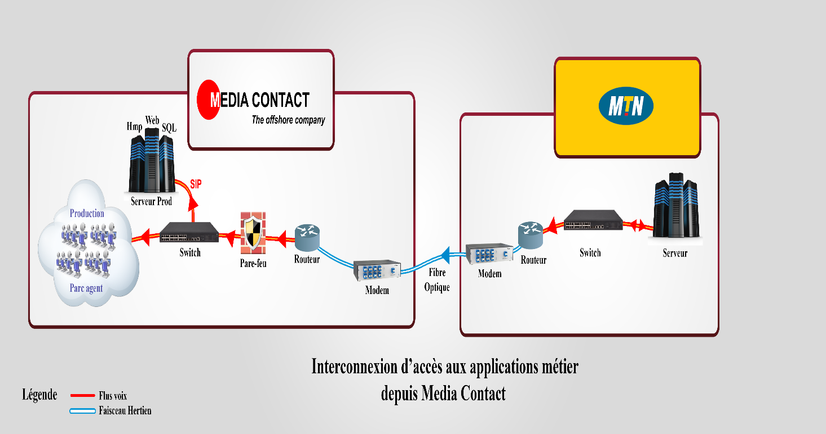
Figure 13:Data interconnection architecture Architecture
The above architecture illustrates the access to MTN subscriber contact processing tools. This link allows media contact call centre representatives to access the various business applications located at MTN. Security measures are taken on both sides to ensure confidentiality and integrity.

LAN and Architecture

Our network architecture has two parts: an internal network used locally to allow users to access resources and an external network to ensure interconnection with the outside (Our Customers, Subsidiaries).

LAN Architecture
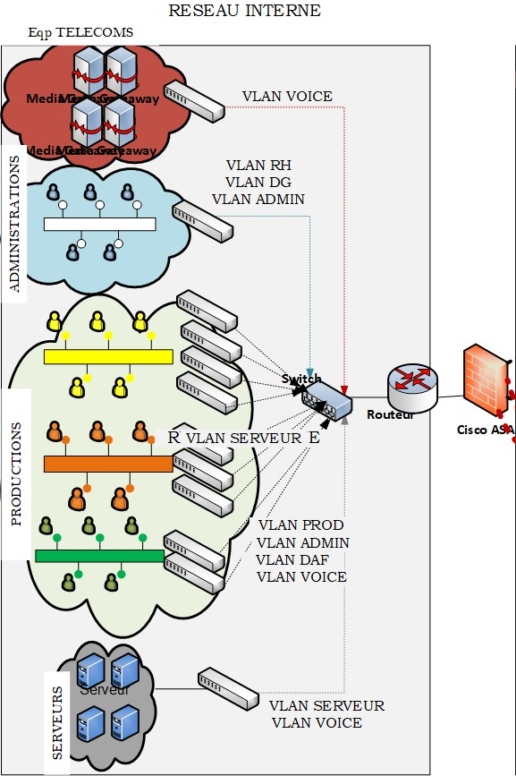
Our internal network is segmented into different VLANs (independent logical computer network: only computers in the same VLAN can communicate). All these VLAN forward their different packets through the SWITCH via trunk ports to finally be routed to the external network using the Cisco ASA. The latter is a security device with multiple functionalities such as firewall, antivirus, intrusion prevention and virtual private network (VPN). It provides proactive threat defence that stops attacks before they spread across the network
The segmentation created by VLANs reduces the size of broadcast domains and hence fewer collisions on those domains. Using VLANs will simplify network administration, isolate servers in the same broadcast domain and isolate them by the department. Therefore, VLANs will provide great flexibility in network management; users can be grouped according to their centre of interest

WAN Architecture
At this level, we have: :
- Our various subsidiaries and mobile agents;
Several means of communication are used: interconnection via VPN;
- The technical equipment of our customers;
The traffic from our customers' equipment is filtered by Cisco ASA equipment. Our mobile agents (working remotely) and the various sites' users must connect to the VPN (a function of CISCO ASA) to access our applications locally. An end-to-end secure virtual circuit will, therefore, be created to allow communication.

Telecom Architecture

To allow good communication with MTN subscribers, we opt for software PBX with a call distribution PLC and a CRM for receiving and monitoring calls in real-time. Below are the telecoms architecture and the calls flow diagram from the MTN site to the production agents.
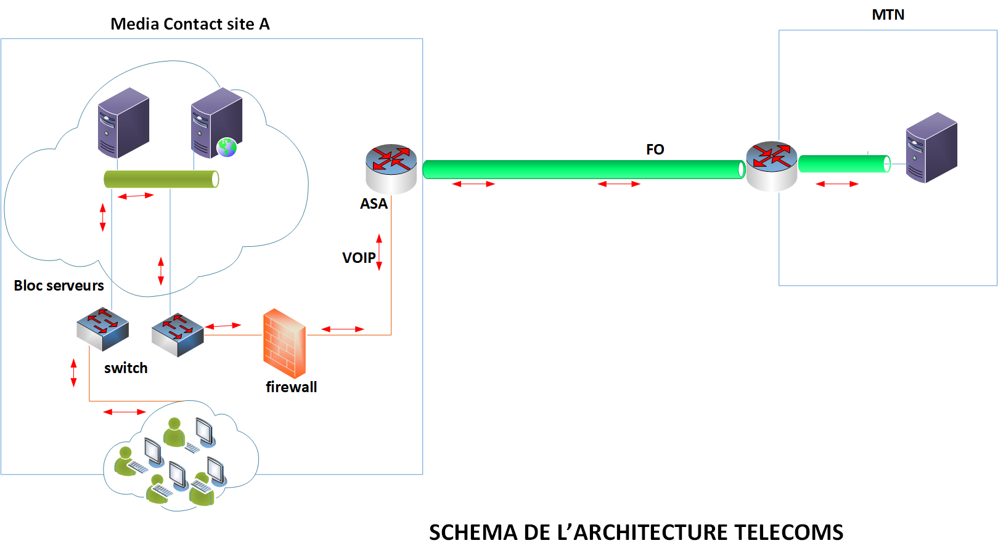
Figure 14: Telecoms Architecture Schema

Security Policy

Credentials and Access Management

To ensure good security administration, the systems must keep track of all significant actions and record the event initiator's identity. The identity of the user determines his privileges and rights of access to data. The user identification and authentication procedures are necessary before any protection strategy. It is also necessary to apply the principle of separation of privileges, only assigned the user's needed privileges.

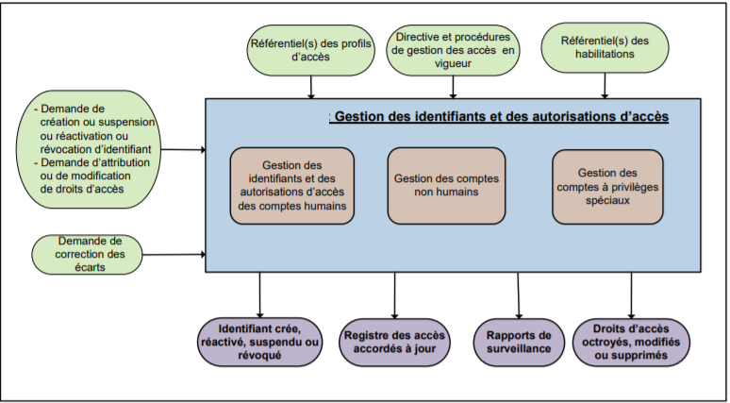Figure 15:Identity and access authorisation management

As illustrated in the figure above, our policy for managing identities and access authorisations covers:
- The management of identities and access authorisations for human accounts, which consists of:
- Create, modify, save and terminate the logins associated with each account, at the request of the manager;
- Grant, modify, revoke authorised access to each login, at the manager's request;
- Check whether a request for granting access authorisation does not create a conflict of separation of duties;
- Ensure with the manager that an access authorisation request is justified when it does not comply with the authorisations repository;

User training
The objective of training users is to make them independent in using tools and applications that are useful for performing their tasks in the company. The aim is:
- Inform the user:
  - The establishment of activity logs to detect and trace any activity and any unauthorised access;
  - in the absence of secure means at his workstation, he must refrain from transmitting sensitive data to or from outside the organisation;
  - Sanctions to which he is exposed in non-compliance with the provisional regulations put in place in terms of access management.
- Raise user awareness around:
  - The importance of choosing a secure password, according to best practices in the field, and keeping it secret at all times;
  - The importance of locking his workstation when he is away from his office;
  - Legal constraints and means of securing the information to which he accesses;
  - The obligation to report, without delay, any security breach of the information to which he has access to.

Data security
An acceptable data security policy begins by putting in place an action plan.
- Our data security policy's first step is to assess the risks and threats, consequences, and vulnerabilities.
- We then define the scope of what is sensitive, i.e. which data is particularly essential or confidential and requires enhanced protection :
  - User’s files,
  - Servers’ files Fichiers serveurs (restore points),
  - Legal Documents (employees and clients),
  - Emails,
  - Production Applications databases(clients’ interactions with the call centre),
  - Voice and video recordings, etc.
- Equipment used to protect information deemed sensitive and confidential :
  - Installation of a firewall (Cisco ASA),
  - Setting up a VPN for remote access ;
  - Access control,
  - Backup server, etc.
- Finally, we communicate regularly with concerned departments and employees of the company regarding information security rules and distribute to employees the procedures (best practice) and the action to be taken in a problem. These rules deal with the use of software, websites, computer hardware, etc.
A data backup and restore policy is in place in order to strengthen data security. It is detailed below:
- Frequency and retention:
- Differential backups are performed every day from 1 a.m. (when the calls flow and network traffic are minimal).
- A full backup is performed every two weeks in parallel with the daily backup.
Specific backups can be carried out in parallel for sensitive data such as company and production financial data and kept following legal obligations (ensure that the applications that generated this data are also accessible and that all the data is identified, such as small financial management tools developed locally).
- Backup storage location :
We have opted for a redundant backup because of the critical nature of the information we process. All backups are performed on high capacity local servers and also on the Dropbox cloud (space where we have unlimited space) for a long time. Data on local servers is kept for one (1) year unlike data on the cloud, which can be kept for a very long period. This allows us to have them available and accessible at all times (to meet the 5-year retention requirement).

File server
Sensitive data flow
Sensitive data flow
Sensitive data flow
s
DVD
EXTERNAL HARD DRIVE

Internal server
OVH
Internet (FTP link)

Infrastructure security

Access security to the production facilities
In order to provide safety to people and the entire infrastructure, certain precautions are taken :
- Access controlled by card readers (inside and outside doors) ;
- The building is monitored 24 hours a day by security guards ;
- All the buildings are monitored through surveillance cameras 24 hours a day, and the data is stored on a large capacity disk
- Installation of smoke/fire detection system
- Installation of a fire extinguisher device
- Staff evacuation diagrams in the event of a fire, as well as the persons to contact, are displayed
- The building is equipped with two redundant generators
- Building monitored by automatic regulators;

Security Access to the server room
- Room well locked and access controlled by a biometric device;
- The access log file is saved and kept for audit purposes ;
- Access limited only to IT staff;
- Room well ventilated by air conditioning equipment;
- Room equipped with a smoke and fire detection device;
- Room under surveillance (camera) ;
- The servers are power supplied by several inverters;
(See appendix, physical access control policy)

Software security
Logon credentials ensure access to basic resources (read-only), and they do not guarantee the required access to applications needed to perform duties. Access rights are used to define, locate and limit user actions on well-defined functionalities in an application.
Other security measures are taken, among which we can note :
- Management of antivirus security events: Antivirus security events are sent to a central server for statistical analysis and management of problems posteriori (examples: server infected continuously, virus detected and not eradicated by the antivirus, etc.). The anti-virus databases and engines updates are automatically deployed to servers and workstations by a device prescribed by the DSI.
- Browser configuration: The browsers deployed on the campus computers do not have access internet access unless specified by the local IT team and workstations requiring Internet or Intranet access and are configured securely (deactivation of unnecessary services, cleaning of the certificates cache, etc.).
- User Awareness of the fight against malicious codes : users of Media Contact's IT Systems are made aware of and made responsible of issues around malicious codes. They are informed about:
  - Best practices and guides on how to be protected against malicious attacks;
  - Watchful behaviours to adopt ;
  - What to do in the event of such type of incident.
- Systems and Software update: maintaining the security level over time requires organised and appropriate management of security updates. A patch management process specific to each system or application is defined and adapted according to the constraints and the system's level of exposure. Security patches for local IT resources are deployed based on the recommendations and tools offered by security standards.
- Ensure the migration of obsolete systems: all the software used on the information system is in a version supported by the publisher and kept up to date.
- Isolate the remaining obsolete systems: it is necessary to isolate obsolete systems, kept voluntarily to ensure that projects are maintained in operational condition, and that migration is not possible. Whenever possible, this isolation is carried out at the network level (strict filtering), authentication and applications (no resources shared with the rest of the IT systems).

Operational security
The measures put in place within MEDIA CONTACT to ensure the security of the equipment made available to the operational team:
- Management of computer equipment given to the user: The workstations are provided to the user, managed and configured under the IT Security team of Media Contact. The connection of equipment not controlled, not administered or not updated by the company (whether it is computers, phones, mobile and fixed IT equipment or removable storage media) to equipment and LAN networks is prohibited.
- A reminder of protective measures: make agents aware of IT risks (putting in place of best practices)
- Reassignment of IT equipment: A procedure for managing positions and supports in the context of staff departure or reassignment to new users has been put in place. This defines the conditions for using data deletion.
- Remote access to the company IS or teleworking: mobility and remote work multiply exchange and access points to sensitive company data. Now more than ever, companies are increasingly using teleworking, currently imposed by national containment linked to the Covid-19 or coronavirus pandemic. However, remote work, operated on the Internet, is not without risks for protecting sensitive company data. Therefore, we have revised our security policy and adapted it to our managers and agents' mobility because on the one hand, we tend to be less vigilant when working from home, where our personal practice is less strict. Second, we are more exposed to phishing attempts or fraudulent emails. Third, personal networks are less well protected against cyber attacks than private corporate networks. Therefore, it is essential to limit risks as much as possible by putting in place the right tools and establishing secure practices.

There are three significant risks associated with remote work:
- The inability of our call centre agents to have access to the resources necessary to work;
- Infection of the corporate system through a security breach of the computer used by the employee (and vice versa);
- Loss or data loss.
In light of this risk analysis, here are the main actions implemented to protect our data:
- Provide a dedicated work computer and phone to employees.
- Open a secure VPN for each employee (Virtual Private Network).
- Set up two-factor authentication to access workspaces (sending a code by SMS to connect).
- Use of online collaboration tools (Google Drive and Dropbox for files).
- Restrict access to sensitive data to as few people as possible.
- Provide a list of direct and reliable contacts to reach for each security question.
- Establish a guideline to follow in a cyber attack (whom to contact, emergency procedures, etc.).

Innovative Services Of The Client's Project

Omnichannel is not about responding to customer communication preferences; it is about adopting a smarter way of working. Hence our Next Generation Customer Experience Management solution.

The Groupe Media Contact for customer management uses an Omnichannel CRM. It is an Omnichannel platform designed to stay in touch with the customer anytime, on any channel, wherever they are in their customer journey. Our CRM simplifies contact management by grouping conversations across different channels in a single inbox and maintaining the same appearance regardless of the channel. This reduces the training time of your agents and makes the use of the platform intuitive and straightforward. Our dynamic distribution engine assigns contacts to agents based on their skills and availability, maximizing your SLA.

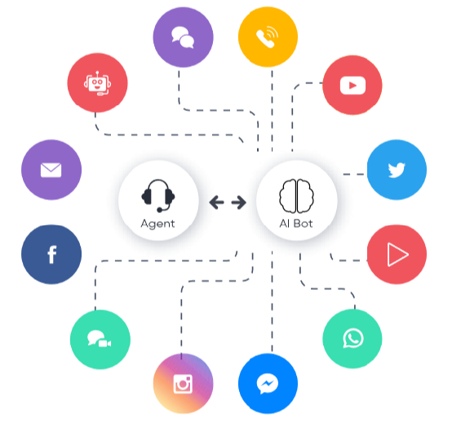
Synoptic of channels managed by our CRM

Receiving calls

VOICE
Flexible and complete Omnichannel call centre CRM using a simple web browser provides access to all the functions of a contact centre. It allows the customer to be followed throughout the journey by enabling a complete and straightforward transition from a traditional call centre to digital communication and automated interactions. The processing is carried out on a central server, having an internal bot that allows the automatic distribution of calls to agents to manage a queue according to the subscriber's destination channel from the IVR.

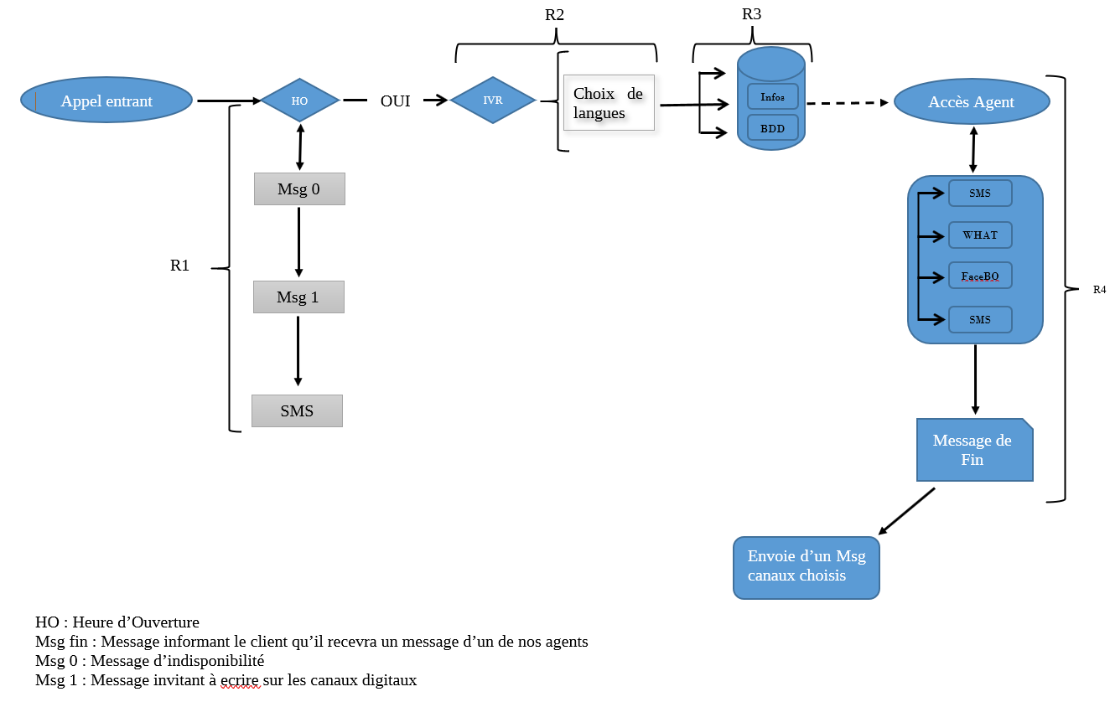

R1: During the call, the system checks the availability of the IVR. Otherwise, pass the message of limited availability to the subscriber to contact us on our digital channels. At the end of the call, send an SMS inviting to communicate on our channels with the numbers.
R2: If the IVR is accessible, check if the number has already contacted the call. If so, go directly to the language menu chosen previously. Otherwise, allow the choice of language (local or international).
R3: After choosing the language, the different menus are available to the customer to navigate in the IVR for the right information. If the client wishes to interact directly or have specific information (such as his puk code, history, etc.), the databases' interaction can be done by web service or SQL.
R4: If the customer is dissatisfied and wishes to speak to an agent, the system offers him four choices to connect the call;
- SMS
- Whatsapp
- Messenger
- Voice
Suppose the customer's choice is among the first three. In that case, a message informs the customer who will receive a message from our agents within seconds. When the call ends the system automatically sends a message to this client according to the chosen channel.
If it is choice 4, the call is transferred to the agent queue and following a segmentation (depending on the category to which the customer belongs in the operator database).

DIGITAL
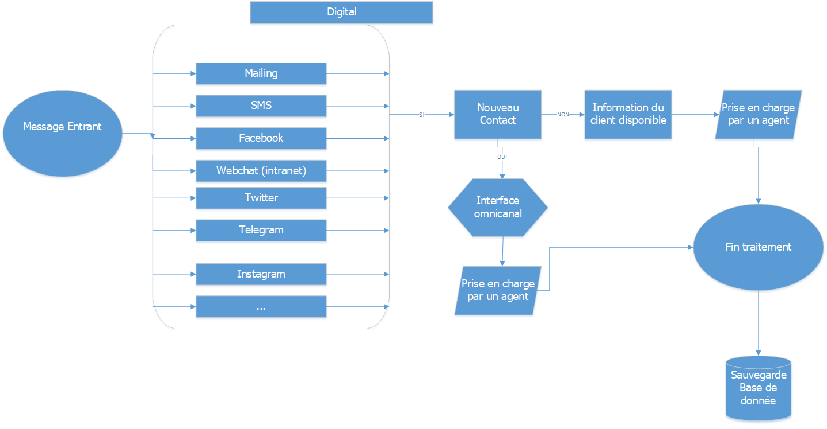
- Set up a campaign on these different channels in order to test the functions previously sent:
- Allow Omnichannel processing (have the history of the customer's interaction channels) to allow adequate support regardless of the channel used.
- Integration of chatbot and artificial intelligence to provide specific answers to the subscriber without an agent's intervention.

Making calls

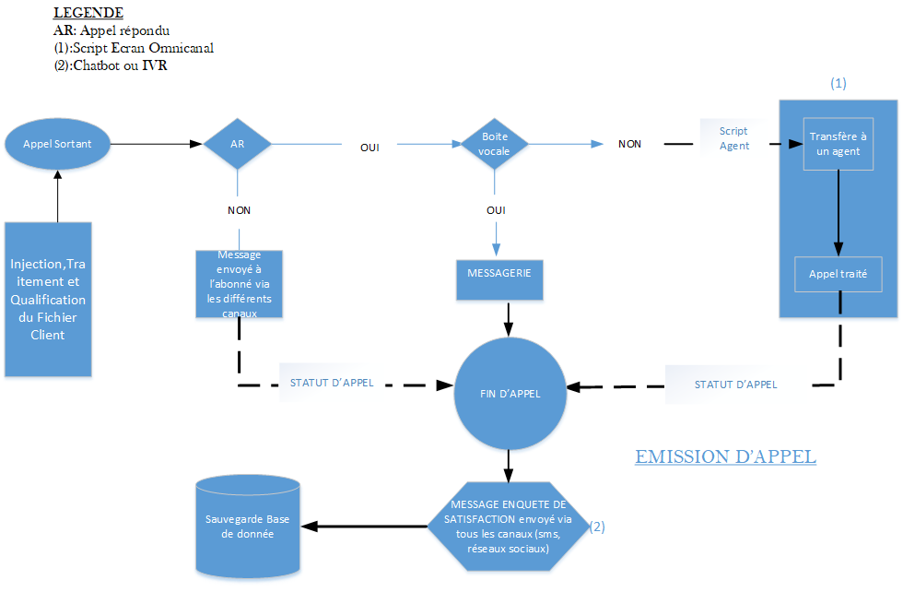

The administrator enters a group of numbers into the campaign
After dialling, the call is considered made if:
- Unanswered call or voicemail box, then a message is automatically sent to the called party via the various digital channels. Then the agent statuts the call;
- Answered call then processes the conversation. At the end of the call, the agent statut the call then a satisfaction survey message is sent automatically.

Back office

The management of the Backoffice from our tool will be done by integrating a business application of an X client to be able to interact directly with the latter's databases. Have statistics on the information recorded according to the statuses in order to be able to quantify and measure the performance of agents from the CRM.

The tools


Itinerant Agent (mobile)
Access to CRM
Network Group Media Contact
CRM

Internet
Agent home

1st case: Mobile Agent
In this scenario, the itinerant agent (mobile without a fixed position) must access the CRM in connected mode from his mobile phone device from his geographical location and work on the various campaigns. The CRM must be able to locate his geographical position.
2nd case: Remote work agent
This scenario is based on agents with a laptop terminal from a fixed position (home). This agent should be able to access CRM and work on any type of campaign.

INFORMATION SYSTEMS DEPARTMENT
Synoptic diagram Routing of incoming calls
MTN Subscriber Call
IVR MTN
Choice leading to a call center agent
Media Contact Call Center
Navigation in the tree structure
Self-care solution in IVR
MSC

Diagram description
- Step 1: the subscriber dials one of the customer service numbers (i.e. 111);
- Step 2: the call is routed to the MSC of the telephone operator;
- Step 3: The MSC routes the call to the service provider's call switching equipment using the existing transmission link between the two.
- Step 4: the call enters the IVR MTN. (If IVR is implemented);
- Step 5: the subscriber navigates through the IVR. If he makes a choice requiring him to be put in touch with a client advisor, his call is routed to the CTI otherwise the call ends in the IVR.
- Step 6: the customer is received by the Media Contact customer advisor as soon as the latter picks up his call.
Synoptic diagram Routing of outgoing calls
MTN subscriber
Return of the file to the Media Contact Call Center
MSC
NUMBERING in the CTI
The Telephone advisor and the customer start Communicating if the subscriber picks up
If the customer does not pick up the Call center status the form

Diagram description
- Step 1: the CTI system in which a subscriber database is implemented numbers and routes calls to the MSC using the existing transmission link between the two.
- Step 2: the MSC routes the call to the subscriber ;
Step 3: the card goes back to the Call centre which indicates that the customer's handset is ringing; if the customer picks up the call centre Advisor enters into communication with the customer; otherwise return to step 1

The physical access control procedure
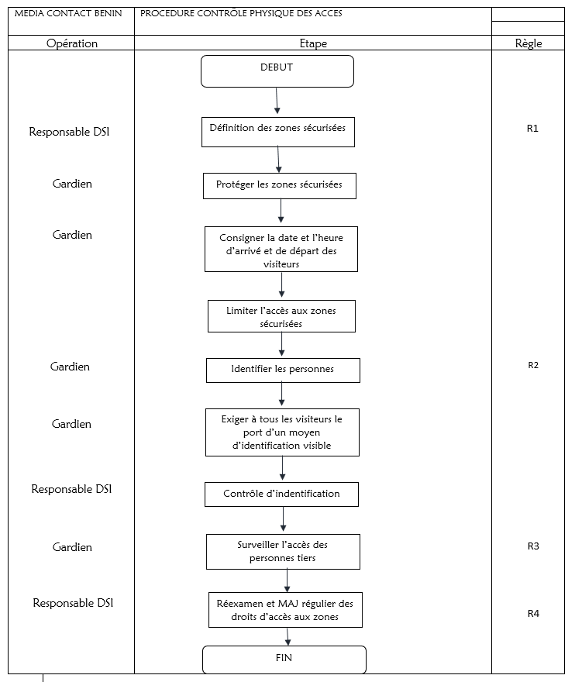

SLA
RISK MAPPING | DETAILS | IMPACT | DEGREE | MEASURES/ / PROVISIONS | SLA (mn)
TECHNICAL / LOGISTICS | Power outage | Production shutdown | Low | Power Generator relay | 5
TECHNICAL / LOGISTICS | Equipment failure | Production shutdown | High | Technical intervention | 30
TECHNICAL / LOGISTICS | E1 Link Loss / Link Instability | Calls disruption | High | Customer alert | 15
TECHNICAL / LOGISTICS | unavailability of applications | Production in degraded mode (customer satisfaction deferred) | Low | Customer alert | 15
TECHNICAL / LOGISTICS | Poor audio quality | Crackle line | Medium | **** | 60
TECHNICAL / LOGISTICS | Server crash (server failure) | Data loss | High | backup server | 60
TECHNICAL / LOGISTICS | Environmental risks (floods/fires) | Site inaccessible / Reduced production capacity | Critical | Commissioning of the virtual redundancy plan | 30 to 120
TECHNICAL / LOGISTICS | Environmental risks (floods/fires) | Site inaccessible | Critical | Commissioning of the physical redundancy plan | 120 to 460

Evacuation plan for a site in Benin
